**Comparison of Carbon Dynamics**

**in two Icelandic Glacial Rivers:**

**Vestari-Jökulsá and Virkisá**

Submitted in partial fulfilment of the requirements

for the degree of Master of Science in Physical Geography

Submitted by: **Sophia Kokkas**

Student ID: **2654520**

Supervisor: Prof. Dr. Peter Chifflard

Second Supervisor: Ann-Kathrin Wild

Submission Date: 10.09.2025

**Philipps University Marburg**

**Department 19 – Geography**

Abstract

Comparison of Carbon Dynamics in two Icelandic Glacial Rivers: Vestari-Jökulsá and Virkisá

Acknowledgments

**Structure of Acknowledgments:**

* Thank your **supervisors/advisors**.
  + Chifflard (weil mans halt so macht, dass er so nen nettes Forschungprojekt hat) für die große Freiheit und den guten Geschmack an Forschungsprojekten
  + AK und Alicia
  + RG Hot Pot, RG Gletscher (Gruppenfoto)
* ~~Mention~~ **~~funding sources~~** ~~(if applicable).~~
* Appreciate **collaborators and colleagues**.
  + Jonas
  + Maria for the English help
  + AI: getting to utilise working in the future and scraping their incapacities.(See Appendix)
* Express gratitude to **friends and family** (optional but common).
  + Family and friends
    - My brother for paying for chatgpt prime
* Keep it professional and concise.

For the final English, which is a language more complicated as I thought, I want to thank Rita and Maria

I did scientific work and used AI, which, even with the premium (thanks, Konsti, for letting me use your Pro-account), while the AI isn’t as clever as it seems. I mainly used it for inspiration and coding help. Glaciers will have gone, and some water will have gone down the glacial rivers. Glaciers will be lost until they fully replace humans, and for sure not for field work.

I'd like to say a big thank you to Alicia and Juji from "Reisegruppe Hot Pot" (left) and AK and Jonas from "Reisegruppe Gletscher" (right). Even though the Icelandic summer is pretty harsh, it was great to join you and explore your rivers.

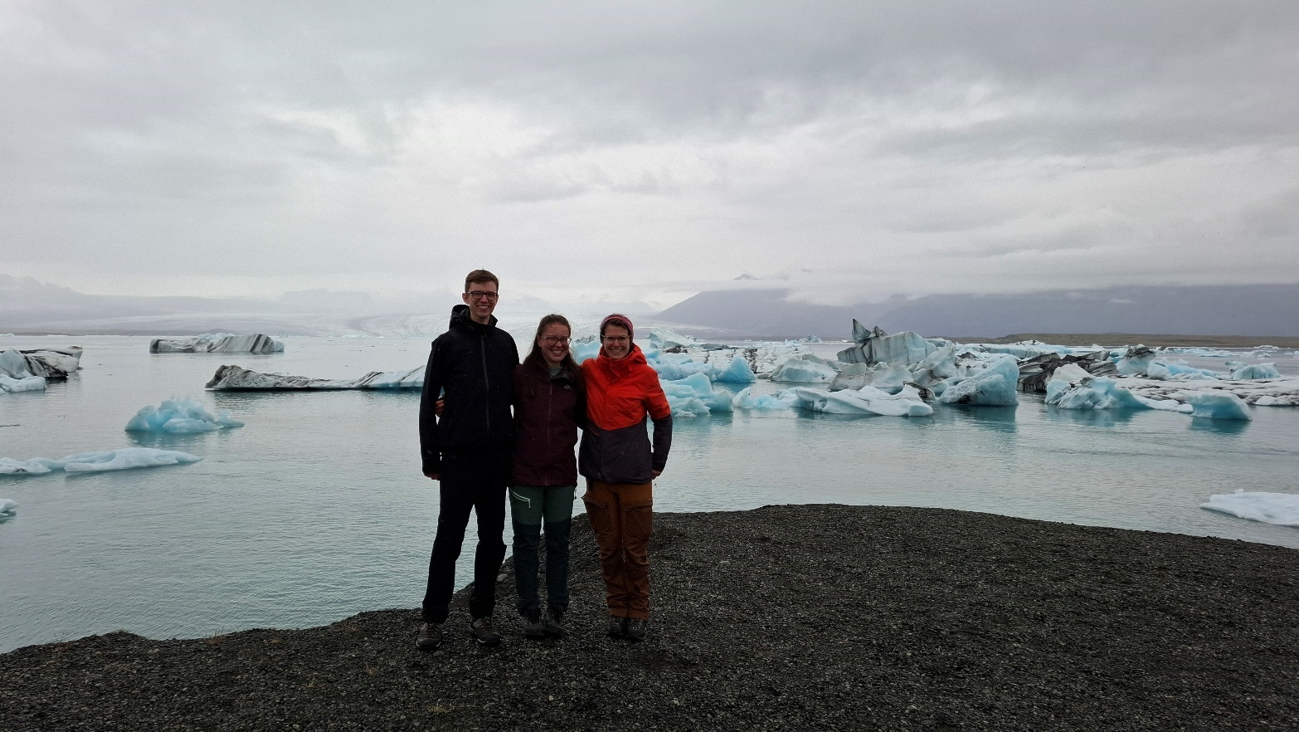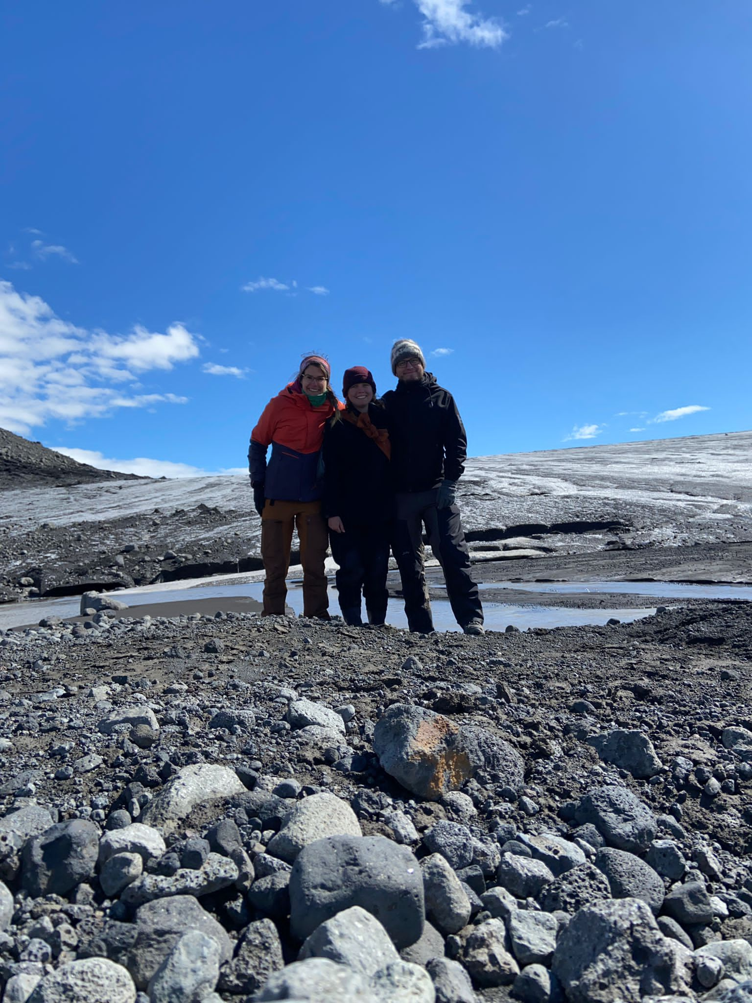

Table of Contents

**1.** Introduction 1

1.1. Background and Context 1

1.1. Significance of the Study 1

1.2. Research Objectives and Questions 2

**2.** **Literature Review** 3

2.1. Dissolved Organic Carbon (DOC) 3

2.2. Biodegradable dissolved Organic Carbon (BDOC) 3

2.3. DOC and BDOC in Glacial Rivers 3

2.3.1. Sources of DOC in glacial rivers 3

2.3.2. DOC in glacial rivers around the world/in different locations 4

2.4. Analysing DOC and BDOC in Glacial Rivers 4

a) Different fluorescence indices 5

b) Analysing the EEMs 7

2.5. Overview of Icelandic Glaciers and glacial rivers 9

2.6. Study Sites 11

2.6.1. Vestari-Jökulsá River 11

2.6.2. Virkisá River 12

2.6.3. Comparative Characteristics 14

**3.** Methodology 15

3.1. Sampling sites 15

3.1.1. Vestari-Jökulsá River 15

3.1.2. Virkisá River 16

3.2. Sample Collection and Data Analysis 17

3.2.1. Water sampling 17

3.2.2. Laboratory analyses 18

3.2.3. CO2 sensor and Calculation of CO2 Fluxes 18

3.2.4. Complementary data 20

3.2.5. Statistical analyses 20

**4.** Results 22

4.1. Descriptive Overview of Carbon Parameters 22

4.2. Spatial and Temporal Variations 25

4.3. Correlation analysis 30

4.4. Fluorescence Indices and Composition 36

4.5. Principal components analysis 40

4.6. Summary of Key Differences Between Rivers 52

**5.** Discussion 53

5.1. Interpretation of Results 53

5.2. Comparison with Existing Literature 53

5.3. Factors Influencing DOC and BDOC 53

5.4. Implications for Carbon Cycling 53

5.5. Limitations of the Study 54

**6.** Conclusion 55

6.1. Summary of Key Findings 55

6.2. Answers to Research Questions 55

6.3. Recommendations for Future Research 55

6.4. Final Remarks 55

**7.** References / Bibliography 56

**8.** Appendices 58

I. Supplementary Code and Data 58

II. List of instruments, materials and software 59

a. Instruments 59

b. Software 59

c. Artificial Intelligence (AI) and Large Language Models (LLM) 61

III. Impressions sampling sites 62

a. Vestari-Jökulsá River 62

b. Virkisá River 62

IV. Co2-Logger Result 63

a. Vestari-Jökulsá River 63

b. Virkisa River 63

V. Weather station Data 64

a. Sáta (17.07 - 23.07.2024) 64

b. Skaftafell 64

VI. Master table 65

VII. Correlation Analysis Data 66

VIII. Correlation Analysis Heatmaps 67

IX. DOM Fluorescence Indices and Composition 70

**9.** Declaration of Independence 74

List of Figures

Fig. 1: location of the two rivers with the respective sampling sites 1

Fig. 2: Vestari-Jökulsá river with the sampling sites 16

Fig. 3: Sample location at the Viskria river 16

Fig. 4: Violin and Boxplots of DOC, BDOC and CO2 Flux by river 23

Fig. 5: Virkisá carbon parameters before and after the rainfall event across sampling sites 24

Fig. 6: Carbon parameters of VJR and VR in relation to distance from respective glacier 25

Fig. 7: chlorophyll a, dissolved oxygen, turbidity in the VJR and VR 26

Fig. 8: pH, specific conductivity, and temperature in the VJR and VR 26

*Fig. 9: DOC concentrations along VJR left and VR right, morning and afternoon* 27

*Fig. 10: Carbon parameters per site, VJR left, VR right, morning and afternoon* 28

*Fig. 11: Correlation heatmaps of carbon variables with weather parameters (VJR and VR)* 29

Fig. 12: Correlation BDOC vs. air temperature (VR) 30

Fig. 13: Correlation heatmap of carbon variables & environmental parameters (VJR and VR). 30

Fig. 14:Correlation DOC vs. fDOM (both rivers) 31

Fig. 15: BDOC vs. Chlorophyll, both rivers 32

Fig. 16: BDOC vs. Phycocyanin, both rivers 32

Fig. 17: Correlation DOC/BDOC vs. specific conductivity (VR) 33

Fig. 18: Correlation heatmaps of carbon variables with fluorescence parameters (VJR and VR). 33

Fig. 19: Correlations DOC vs. Components (VR) 34

Fig. 21: Excitation-emission model of the five components 35

Fig. 22: Component composition DOC and BDOC (+14days) Vestari-Jökulsá 36

Fig. 23: Component composition DOC and BDOC (+14days) Virkisá 37

Fig. 24: distributions of fluorescence indices across rivers and rain phases 38

Fig. 25: Scree plot illustrating the optimal choice of number of components 41

Fig. 26: Contribution plots for the three components 42

Fig. 27: unrotated PCA biplot PC1 & PC2, coloured by DOC quantities 44

Fig. 28: unrotated PCA biplot PC1 & PC2, coloured by BDOC quantities 45

Fig. 29: unrotated PCA biplot PC1 & PC2, coloured by CO2  quantities 45

Fig. 30: varimax-rotated PCA biplot PC1 & PC2, coloured by DOC 47

Fig. 31: varimax-rotated PCA biplot PC1 & PC2, coloured by BDOC quantities 47

Fig. 32: varimax-rotated PCA biplot PC1 & PC2, coloured by CO2 48

Fig. 33: Factor score by river (unrotated PCA) 50

Fig. 34: Factor score by river (varimax rotated PCA) 50

List of Tables

Table 1: detected fluorescence peak areas 5

Table 2: BIX-Index 6

Table 3: Humification Index 6

Table 4: Fluorescence Index 7

*Table 5: Descriptive statistics results of carbon variables by river* 22

Table 8: excitation - emission of the components, their assignment to Coble peaks, fluorescence and other studies (i.a. OpenFluor*) 35

Table 7: VJR components per site: Relative change from day 0 to day +14 (% of day 0) 36

Table 8: VR components per site: Relative change from day 0 to day +14 (% of day 0) 37

Table 9: Matrix of correlation coefficients among the variables examined (parameters) 39

Table 10: table with the eigenvalues of the components 40

Table 11: Correlation coefficients (factor loadings) of each factor with each of the examined variables 41

Table 12: Variables that belong to the respective factor, that can be represented by the 3 factors. 42

Table 13: Variances of parameters examined in their standardised form before / after factor extraction of the 3 factors 43

Table 14: Variables that can be well represented by the three factors after applying Varimax rotation. 46

List of Abbreviations (in logical/order of appearance)

UMR University of Marburg

OM organic matter

POM particulate organic matter

DOM dissolved organic matter

~~SOM solid organic material~~

OC organic carbon

DOC dissolved organic carbon

POC particulate organic carbon

BDOC bioavailable dissolved organic carbon

VJR Vestari-Jökulsá River

AJR Austari-Jökulsá River

VR Virkisá River

TOC

Research projects (UMR 2025)

Longitudinal variation of macroinvertebrate assemblages in Icelandic arctic glacier-fed and snow-fed streams: changes and their environmental drivers – a comparison after 26 years

PhD student: Alicia Knauft

*Funded by the German Research Foundation; Duration: 2021-2024; Project and cooperation partners: Prof. S. Pálsson (University of Iceland), J. S. Ólafsson (Marine and Freshwater Research Institute, Reykjavik), Dr C. Fasching (University of Marburg)*

Elucidating the temporal variability of glacial organic carbon concentration and composition toward determining carbon export via discharge separation and machine learning techniques (Falljökull, Iceland)

PhD student: Ann-Kathrin Wild

*Funded by the German Research Foundation; Duration: 2021-2024; Project and cooperation partners: Prof. Dr G. Gíslason, (University of Iceland), Prof. Dr A. Hartmann (TU Dresden), Þ. Þorsteinsson (Icelandic MET Office)*

# Introduction

# Background and Context

- Overview of the importance of studying dissolved organic carbon (DOC) and biodegradable dissolved organic carbon (BDOC) in glacial rivers.

- The role of glacial meltwaters in global carbon cycles.

- Introduction to Vestari-Jökulsa and Virkisa rivers.

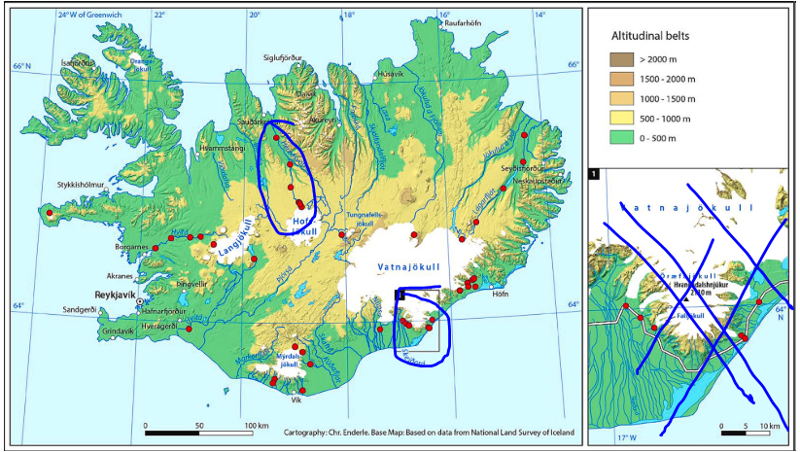

Fig. 1: location of the two rivers with the respective sampling sites

topographical map of Iceland.

<https://gatt.natt.is/geonetwork/srv/eng/catalog.search#/metadata/e6712430-a63c-4ae5-9158-c89d16da6361>

Coordinate system EPSG:3057 - ISN93 / Lambert 1993

# Significance of the Study

- Discuss the contribution to physical geography and environmental sciences.

- Implications for understanding carbon dynamics in glacial environments.

Iceland’s glaciers are under-studied in terms of DOC and BDOC dynamics, with little focus on regional river systems like Vestari-Jökulsá and Virkisá.

Structure of the Thesis - Briefly outline the content of each chapter.

In addition, both the Hofsjökull and Vatnajökull ice caps are among the best studied and have the longest running mass balance monitoring programmes in Iceland. So, despite their relatively modest contribution to the global glacier and ice cap volume - which stands at only a few per cent - glaciers in Iceland are of significant scientific interest due to being very well-monitored and the insights they offer into the response of glaciers in maritime climate zones to climate change. (Aðalgeirsdóttir et al. 2006)

Projections indicate that within a century, the ice caps will have diminished by half and will have fully disappeared within two centuries if the warming rate remains constant. It is also notable that the reduction in volume will be qualitative comparable for the two ice caps, exhibiting a gradual initial decrease that will accelerate with a greater increase in temperature. (Aðalgeirsdóttir et al. 2006)

# Research Objectives and Questions

- Clearly state the aims of the study.

- Formulate specific research questions or hypotheses.

Compare DOC and BDOC between two Icelandic glacial rivers, investigating how catchment features affect carbon dynamics.

Pex.

* How do carbon fluxes (DOC loads) from each catchment compare when normalized by catchment area?
* What landscape or glaciological factors might explain any observed differences?

# **Literature Review**

The study of glacial DOC represents a relatively recent area of research. The dynamics of DOC and BDOC vary geographically, and the present review will mention studies conducted in Greenland, Svalbard, Alaska, Canada, Asia, Antarctica, the Alps, and Iceland. Glacial DOC contributes to the global carbon cycle, and this research aims to add to the understanding Icelandic glacial DOC export.

# Dissolved Organic Carbon (DOC)

In water, organic material (OM) is present in dissolved (DOM) form, which originates i.a. from decaying plants, soil and microbial biomass, as well as leachate, but also in the *solid phase of soils and sediments* (SOM). While the alterations in SOM composition take time (p.ex. ageing

of sediments), chemical properties and composition of DOM are subject to faster change and are influenced by hydrology with snowmelt for example (Gabor et al. 2014).

OM in natural waters has been classified as either, dissolved or particulate organic carbon by filtration (typically with 0.2-1.2 μm filters). This distinction is a practical/ operational rather than a natural one. (Aiken 2014)

# Biodegradable dissolved Organic Carbon (BDOC)

* how BDOC differs from total DOC.
* Discuss microbial processing of DOC and how its composition affects **biodegradability**.

**Lutz et al. (2015)** – Microbial influence on DOC bioavailability in Icelandic glacial environments​

**Stibal et al. (2008)** – Microbial primary production in Svalbard glaciers and its impact on DOC cycling- wants further studies

**~~Holt et al. (2024)~~** ~~– Microbial preference for young carbon in glacial DOC​​~~

- Definition and its role in aquatic ecosystems.

- Methods of measuring BDOC.

# DOC and BDOC in Glacial Rivers

DOC in glacial rivers is impacted by different factors i.e. hydrology, temperature, microbial activity and seasonal discharge variations. That way, DOC varies not only seasonally in glacial fed rivers (Spencer et al. 2014; Chifflard et al. 2024) but also diurnal (Chifflard et al. 2024).

# Sources of DOC in glacial rivers

Externally derived (allochthonous) sources include the deposition of organic material from the atmosphere, such as anthropogenic aerosols (Fossil fuel combustion byproducts / biomass burning byproducts), or natural organic materials (poles, soil particles and plant residues) transported by wind. In addition, wind-borne material from proglacial soils and vegetation in proximity to glaciers has been identified. (Holt, Kellerman et al., 2023; Holt, McKenna et al., 2024)

Internal derived (autochthonous) sources are microbial production (supraglacial and subglacial) as well as glacier overrun and leaching of subglacial organic material. (Holt, Kellerman et al 2023; Holt, McKenna et al 2024)

Another process is photochemical degradation, where ultraviolet radiation converts aromatic organic compounds into simpler, aliphatic compounds (Holt, Kellerman et al. (Holt, Kellerman et al. 2021)

The relative interaction of these different sources and processes determines the concentration, composition and age of the DOC pool in glaciers. Regional differences in the sources of anthropogenic emissions and in-situ production lead to global diversity in the composition of glacier DOM. (Holt, McKenna et al 2024), (Behnke et al. 2021; Holt, Kellerman et al. 2021; Holt, Kellerman et al. 2023; Holt, McKenna et al. 2024; Hood et al. 2009; Musilova et al. 2017; Smith et al. 2017; Spencer, Vermilyea et al. 2014; Stubbins et al. 2012; etc.)

# DOC in glacial rivers around the world/in different locations

As elaborated above, there exists a global diversity in the composition of glacier DOM. That’s why various studies on DOC and BDOC in glacial rivers did not only focus on different aspects like the composition, sources and exports but were also centred on different geographical locations:

Hood et al. (2009, 2020) and Behnke et al. (2021) focused on **Alaskan** glaciers as DOC sources.

Like Bhatia et al. (2010, 2011, 2013), Kellerman et al. (2020, 2021) concentrated on the molecular composition and the seasonal dynamics of the DOC fluxes of the **Greenland Ice Sheet**. And Lawson et al. (2014) identified the Ice Sheet as a significant DOC source.

Kulinski et al. (2014) addressed the DOC transport into Arctic fjords on **Svalbard**, while Zhu et al. (2016) researched the high bioavailable properties of the exported DOC there.

Yu et al. (2021) compared glacial and permafrost DOC fluxes from the **Tibetan Plateau**, while Zhang et al. (2018) noted the anthropogenic influences on the DOC depositions there.

Smith et al. (2017) studied DOC in **Antarctic** glaciers.

Concerning **Alpine** glaciers, Singer et al. (2012) studied the bioavailability of DOC, while Boix et al. (2019) focus on climate-driven DOC shifts.

For **Iceland**, Chifflard et al. (2019, 2024) elaborated on DOC flux estimates (2019) with distinct seasonal/diurnal variability in DOC composition (2024).

# Analysing DOC and BDOC in Glacial Rivers

The DOC concentrations in various studies mentioned above, were mainly determined by high-temperature combustion in different models of Total Organic Carbon Analyser. For the characterisation of the DOM quality Fluorescence spectroscopic methods were also used in some studies which will be the subject of this chapter.

Most of the compounds of DOM and SOM can be differentiated by their light absorbing, chromophoric, or also light emitting, fluorophoric properties. To the chromophoric fractions of organic material count the humics: yellow to brown colour influenced by the content of aromatic carbon moieties, from plant litter and soil and to a lesser extent microbial biomass. Another one is the proteinaceous material, frequently including fluorescent amino acids, to be precise, tryptophan and tyrosine, from decomposition of plant material and extracellular microbial products (Gabor et al. 2014).

DOM composition influences the location of excitation and emission peaks. The excitation spectrum of DOM fluorescence ranges from 250 to 400 nm, with a corresponding emission spectrum ranging from 350 to 500 nm. (Stedmon & Bro 2008)

Fluorescence, recorded across a range of emission wavelengths while exciting the sample at various wavelengths, results in three-dimensional scans known as excitation–emission matrices (EEMs) (Gabor et al. 2014).

### Different fluorescence indices

By analysing the wavelength ranges of absorption and emission most chemical information on the origin and the chemical quality of DOM can be obtained. For this reason, **different fluorescence indices** have been developed (Gabor et al. 2014):

Generally, concerning the humic-like fluorescence signal (peak C), these indices assess either the location or the magnitude or compare its intensity to that of a microbially derived, or protein-like, peak (peak T and/or M). (Gabor et al. 2014)

For marine environments, the fluorescence properties of DOM proved valuable for its characterization, even at low DOC levels (Coble, 1996). **Coble** identified typical fluorophores found in both marine and coastal waters, categorizing five distinct fluorescence peaks as either protein-like or humic-like (Table 1) (Gabor et al. 2014). Building on this research, aquatic scientists developed fluorescence indices to help interpret changes in the quality of (DOM) in natural waters (Gabor et al. 2014).

Concerning the age of DOM, Parlanti et al. (2000) established the “**freshness index**” (Gabor et al. 2014) and demonstrated that fluorescence can be applied to measure the level of biological activity but also to identify its various stages (Parlanti et al. 2000) and renamed the **peaks of Coble** (1996) (detected fluorescence peak areas in an excitation–emission spectrum of aquatic DOM, Table 1).

Table 1: detected fluorescence peak areas

|  |  |  |  |  |
| --- | --- | --- | --- | --- |
| **Component** | **ex (nm)** | **em (nm)** | **Coble (1996)** | **Parlanti et al. (2000)** |
| Humic-like | 330–350 | 420–480 | C | α |
| Humic-like | 250–260 | 380–480 | A | α’ |
| Marine humic-like | 310–320 | 380–420 | M | β |
| Tyrosine-like, protein-like | 270–280 | 300–320 | B | ɣ |
| Tryptophan-like, protein-like/phenol-like | 270–280 | 320–350 | T | δ |

With: em = emission wavelengths, ex = excitation wavelengths, (Parlanti et al. 2000)

From there, Huguet et al. 2009, concerning riverine, or more specifically estuarine environments developed the **β/α,** thenrenamed **BIX Index,** (Gabor et al. 2014) the “index of recent autochthonous contribution (BIX)” (Huguet et al. 2009), to identify the β fluorophore which indicates biological activity is occurring (Huguet et al. 2009). High BIX values (>1) indicate that dissolved organic matter (DOM) primarily originates from local biological processes and represents recently produced organic material. Conversely, lower BIX values (0.6–0.7) reflect reduced DOM generation within natural aquatic systems (Table 2). (Huguet et al. 2009)

Table 2: BIX-Index

|  |  |
| --- | --- |
| **BIX values** | **DOM characteristics** |
| 0.6–0.7 | Low autochthonous component |
| 0.7–0.8 | Intermediate autochthonous component |
| 0.8–1 | Strong autochthonous component |
| >1 | Biological or aquatic bacterial origin |

(Properties of DOM linked to the variability in BIX values (from the Mediterranean Sea, Huguet et al. 2009 after Parlanti et al. 2006)

Zsolnay et al. (1999) introduced a **humification index**, **HIX index** which links greater humification to longer emission wavelengths and lower H/C ratios, and reflects how extensively the organic matter was humified (Gabor et al. 2014 :311) The HIX is a reliable method for evaluating how humified organic matter is (Ohno 2002) and assess how extensively DOM in soil has matured (Table 3) (Huguet et al. 2009).

Table 3: Humification Index

|  |  |
| --- | --- |
| **HIX values** | **DOM characteristics** |
| >16 | Strong humic character/ important terrigenous contribution |
| 6–10 | Important humic character and weak recent autochthonous component |
| 4–6 | Weak humic character and important recent autochthonous component |
| <4 | Biological or aquatic bacterial origin |

Properties of DOM linked to the variability in HIX values (from the Seine, Loire and Gironde estuaries, Huguet et al. 2009 after Vacher 2004)

In natural water bodies, DOM is largely made up of aquatic fulvic acids which are heterogenous and organic. McKnight et al. 2001 established a **fluorescence index (FI)** to qualify the original source and chemical characteristics of dissolved fulvic acid. (In contrast, concerning the origin of the nonhumic components of DOM, the FI is possibly not of use and other data is needed.) The emission peak of fluorophores in fulvic acids of microbial origin appear at shorter wavelengths then the one of fluorophores in fulvic acids of terrestrial origin. The FI is based on the ratio of fluorescence emission intensities measured at 450 nm and 500 nm wavelength (with excitation at 370 nm), to differentiate the origins of aquatic fulvic acids. (McKnight et al. 2001 :39:47). In their study, McKnight et al. 2001 obtained ~1,9 as value for fulvic acids originating from microbes, and of ~1.4 for terrestrial origin (Table 4).

Table 4: Fluorescence Index

|  |  |
| --- | --- |
| **FI value** | **DOM characteristics** |
| ~1,9 | microbially derived fulvic acids |
| ~1.4 | terrestrially derived fulvic acids |

McKnight et al. (2001) also pointed out that the range of index values would vary depending on the instrument used.

Additionally is mentioned here the chromophoric index, the Specific UV absorbance (SUVA). It is defined as the UV absorbance of a water sample at a given wavelength normalized for dissolved organic carbon (DOC) concentration. SUVA254, (L mg⁻¹ m⁻¹), is calculated by dividing the water sample's absorbance at 254 nm by its DOC concentration (mg L-1). It reflects the overall aromatic character of the sample. (Gabor et al. 2014 :304, Weishaar et al. 2003)

### Analysing the EEMs

A common way of presenting DOM fluorescence data is with excitation–emission matrices (EEMs). Statistical multivariate data analysis techniques like the **parallel factor analysis (PARAFAC;** Stedmon et al. 2003, 2008), analyse the entire EEM datasets to pinpoint spectral features and assess how different excitation/emission regions contribute to the overall fluorescence profile. (Aiken 2014) PARAFAC assists in analysing fluorescent DOM by breaking down the fluorescence matrices into distinct, independent components. (Stedmon et al. 2003)

The advantage of PARAFAC is if the model is accurate, it will produce results that have real chemical significance. (Murphy et al. 2014)

canonical decomposition or CANDECOMP

PARAFAC is one of the multi-dimensional methods designed to work with data arranged in three or more dimensions as for example, fluorescence EEMs—which are structured by sample, excitation wavelength, and emission wavelength. (Murphy et al. 2013)

PARAFAC yields a model that captures both the quantitative and qualitative aspects of the dataset, unravelling the complex fluorescence signal into its constituent components—each defined by its own excitation and emission spectrum. (Stedmon & Bro 2008)

It serves as a powerful method for profiling and measuring shifts in DOM fluorescence, thereby allowing different fractions to be tracked in natural environments. (Cory & McKnight 2005)

Concerning the interpretation of the data, it is impossible to convert the fluorescence of every component into a concentration, as the component identity is not known. The peak fluorescence intensity of each component can be determined and expressed in the same calibration units—such as Raman units. The greater fluorescence signal in one component, may indicate higher fluorescence, not concentration, as fluorescence depends also on unknown molar absorptivity and quantum efficiency. Quantitative and qualitative differences among samples are revealed by comparing the relative fluorescence intensities of each component and their ratios. (Stedmon & Bro 2008)

Lawson

# Overview of Icelandic Glaciers and glacial rivers

Despite its high latitude, Iceland experiences a relatively mild climate, largely due to a branch of the Gulf Stream that flows along its southern and western shores. Precipitation levels vary widely across the country, with the southern regions being generally warmer and wetter. The greatest amounts of precipitation are typically recorded on the island’s glaciers. (Helgason & Nijssen 2024 :2743). So, due to high precipitation and low evaporation, Iceland’s annual river runoff is estimated to be nearly four times the global average (Gíslason, 2008).

The central highlands make up around 40% of the island’s total area, while glaciers and ice caps cover approximately 10%. Vatnajökull, Europe’s largest ice cap outside the polar regions (~7700 km²), lies in the island’s southeast. Two additional ice caps, Langjökull (~835 km²) and Hofsjökull (~810 km²), are situated in the central highlands, while Mýrdalsjökull (~598 km²), is situated near the central southern coast of Iceland. (Helgason & Nijssen 2024 :2743; Hannesdóttir et al. 2020)

Being two largest of the four major icecaps in Iceland, **Hofsjökull** (900 km2) and **Vatnajökull** (8100 km2) cover ca. 10% of the country. Hofsjökull, situated in Iceland’s central highlands, spans elevations from 600 to 1800 meters above sea level and covers an active central volcano that features a caldera filled with ice (Björnsson & Pálsson 2008). While Vatnajökull stretches along the southeastern coast, with a peak elevation of over 2000 meters. (Aðalgeirsdóttir et al. 2006).

Glacial meltwater contributes to at least one-third of Iceland’s total runoff, supplying the country’s major rivers (Björnsson & Pálsson 2008).

By the end of this century, river runoff in the region is expected to rise by approximately 50%; however, it will decline thereafter as the ice caps continue to shrink. This anticipated surge in glacial runoff represents one of the most significant hydrological impacts of future climate change in Iceland. (Aðalgeirsdóttir et al. 2006)

As far as the outlet glaciers of the two glacier rivers that are the subject of this study are concerned, the northern outlet glacier at Hofsjökull will generally be less susceptible to climate warming than the southern outlet glacier at Vatnajökull ice cap, as it reaches lower altitudes. Projections indicate that both the ice caps and the outlet glaciers are set to disappear over the course of the next two centuries, with the climate warming, first retreating slowly and then faster. (Aðalgeirsdóttir et al. 2006).

Not only are glacier-fed rivers the most extensive ones but also the ones with the greatest discharge, marked by dark, cloudy waters rich in suspended sediments, while other types of rivers have generally clear water. These glacial rivers start to swell in June, with summer floods transporting large volumes of sediment. (Louvat et al. 2008 :682)

Glacier rivers are characterised by specific biotic and abiotic conditions, such as no primary organic production, with inputs originating exclusively from allochthonous sources. Moreover, there is extremely low temperatures with minimal diurnal temperature range. They also exhibit high water velocity, substratum instability and a considerable abundance of transported material, including gravel, sand and stones. (Steffan 1971: 485) These eroded sediments from the glaciers present a significant challenge to the accurate measurement of hydrological data. In addition to the corruption of sensors by burying and jamming, the formation of braided channels and highly erodible riverbeds further complicates the processes. (Bergur 2012: 8)

Kjartansson (1945) grouped Icelandic rivers into three categories according to their origin: glacial, direct-runoff, and spring-fed rivers, with many rivers representing a combination of these types. (Helgason & Nijssen 2024 :2744)

Rist (1990) also introduced a classification system, categorizing them by the extent of their origin and source of their runoff; with D - direct runoff, J - glacial runoff, L - groundwater and S if they flow through a lake. The first letter is indicating the primary source of runoff (Jónsdóttir et al. 2008 :428)

Petersen et al. (1995 :329) classified lowland rivers in Iceland as alpine, noting that their environmental conditions are like those found in alpine regions of central Europe, or as arctic.

# Study Sites

The selection of the two glacial rivers, Vestari-Jökulsá and Virkisá (Fig. 1) combines the study sites of two research projects currently being conducted by the Soil and Water Ecosystems working group at the University of Marburg's Department of Geography:

At the Vestari-Jökulsá river (VJR), located in the northern region of Iceland, longitudinal changes in macroinvertebrate assemblages are studied[1] (Fig. 2). Concerning the Virkisá River (VR) in the south of the island, the variability of the concentration and composition of organic carbon is being assessed and modelled[2] (Fig. 3). (UMR 2025)

# Vestari-Jökulsá River

The Vestari-Jökulsá River (or West-Jökulsá) originates from the Sátujökull Glacier, a surge-type outlet glacier north-west of the Hofsjökull Ice cap, in the central highlands of Iceland (Fig. 1) (Evans et al. 2010, Ingólfsson et al. 2017).

The VJR is formed by three branches, eastern-, middle- and western branch (see Fig. 2).

This area's cut by a fissure zone, linked to a volcano under the glacier (Adalsteinsson et al. 2000). The distinguished variations in the mineral concentration of the three branches (Adalsteinsson et al. 2000), indicates, that in the western and middle branch, the glacial melt water interfered with the volcanic area where carbon dioxide upwelling takes place (Sigurdsson 1990). The easter branch, with the first sampling sites (see Fig. 2) is separated from the other branches by a hyaloclastite mountain ridge (Krókafell, 966 m a.s.l.) (Gislason et al. 2000).

Regarding the middle reaches (sampling point WJ10, see Fig. 2) groundwater inflow contributes to a high mineral content. The lower mineral content in summer therefore is ascribed to the influence of melt water by Adalsteinsson et al. in the year 2000.

While, for the middle reaches of the VJR, that glacial meltwater constitutes approximately 50%, and 20% in the lower reaches (Adalsteinsson et al. 2000), groundwater constitutes at least 50% of the discharge. For other Icelandic glacial rivers, groundwater contributes only 10% (general mean) (Sigurdsson 1990). Most recently the positive significant trend in annual mean streamflow is related to increased glacier melt due to rising temperatures (Helgason et al. 2025).

The decrease in glacial downstream components in the lower VJR reaches is balanced by high water speed which keeps suspended sediment levels high. After Adalsteinsson et al. (2000) this may affect primary production more than the chemical composition or the origin of the water. (:739)

The river's course, from the glacier, on ca. 900m.a.s.l., to its confluence with the Austari-Jökulsá River (AJR) (on ca. 160m.a.s.l.) (Free Map Tools 2024), is characterised by a slope that ranges from 5-10 ‰ for most of its journey (in the upper, middle and lowland reaches (below 200m.a.s.l.)). Except for the transition between the Highland plateau and the lowland valley, where the slope increases to approximately 20 ‰ (Gislason et al. 2000).

It is possible that some topographic activity under the ice cap of Hofsjökull before the beginning of the Holocene caused the river to be diverted from its traditional course in Vesturdalur valley, the valley it originally carved out, into the Goðdaladalur valley, where it now flows in a deep canyon (Hjartarson 2003 :182) while it traverses first late Pleistocene hyaloclastites, late Pleistocene lavas and then tertiary bedrock (Hjartarson & Saemundsson 2014).

For most of the river's course, the banks and surroundings are barren and are only covered (grasses, sedges and mosses) when the river flows through the lowlands (Gislason et al. 2000 :414). The drainage area is 850 km2  at the lowest gauging station (VHM-145) which is located shortly before the conjunction with the AJR, at 45km from the glacier in the lowland valley (coverage: 63% little or no vegetation, 15% grassland, 9% moss and 11% glacierized area) (Crochet 2013 :73).

As the area lies within the glacier's precipitation shadow, the climate is relatively mild by Icelandic standards (Hjartarson 2003 :8)

Concerning the degree of anthropogenic impact, (degree of gauge impact) the catchment attribute is u - no influence (Helgason et al. sup. 2025 :28, adapted from Klingler et al., 2021)

After the classification by Rist (1990, see above), the origin of the VJR is D+J+L (Crochet 2015), with D - direct runoff, J - glacial runoff and L – groundwater.

# Virkisá River

The Virkisá River (VR) originates from the Virkisjökull-Falljökull glacier, a high-mass-turnover outlet glacier (Bradwell et al. 2013), draining the Öræfajökull ice cap covering the Öræfajökull stratovolcano (Everest et al. 2017 :937; Mackay et al. 2019) The accumulation of ice at the summit (∼2000m.a.s.l.) is predominantly drained by this channel in its west (Mackay 2019). The Öræfajökull ice cap itself constitutes the southern part of the Vatnajökull ice cap (Phillips et al. 2013)

Virkisjökull-Falljökull can be described as a double glacier, splitting at approximately 1200m.a.s.l., comprising the northern arm, Virkisjökull, and the southern arm, Falljökull. (Everest et al. 2017; Mackay et al. 2018; Flett 2016), encircling Rauðikambur Nunatak (ca. 600m.a.s.l) (Bradwell et al.2013: 961; Phillips et al. 2013: 1546).

Both glaciers exhibit a considerable quantity of debris-laden ice at their fronts. (Everest et al. 2017: 937) Only Falljökull glacier still visibly reaches the lake, even though rapidly deglaciating, draining directly into the lake, while on its eastern side, a glacier terminus drains via the proglacial foreland surface forming an unconsolidated bed, into the lake (*Fig. 3*) (Flett et al. 2017)

The headwater of the Virkisá river is formed by this proglacial lake (Mackay et al. 2019: 1835) with the lakebed composed of buried ice. (How fast the buried ice will melt is not known but will have a significant impact on the catchment hydrology and the bathymetry of the lake (Flett 2016; Everest & Bradwell 2003)).

The low permeability of the bedrock on the opposite side of the lake results in a restriction of discharge within a relatively stable riverbed of the Virkisá river. (Flett et al. 2017: 1667)

The river initially flows southwards between push moraines and predominantly bedrock and then crosses unconsolidated, highly permeable glacial outwash plain, Skeiðarásandur, covering about 30 km before reaching the sea (Flett 2016 :60).

The catchment area has an extent of roughly 31 km² (Flett et al. 2017: 1667; MacDonald et al. 2016: 152).

The thin soils that may have developed in these conditions are unable to support other vegetation than mainly mosses, grasses and shrubs. (Mackay 2019: 1836; Mackay et al. 2018: 2178) This area, the surrounding sandur and slopes are used for sheep pasture. Virkisjökull is also a significant tourist destination. (Flett 2016 :79).

The Öræfi region has a relatively mild maritime climate, marked by a small annual temperature range of about 11°C and approximately 150 days of precipitation in the form of rain or snow each year (Einarsson, 1984; MacDonald 2016). Annual precipitation on the eastern side can reach up to 3000 mm. Although there is no distinct seasonal trend, the months of October, December, and January tend to be the wettest at sea level in this area. (Flett, 2016)

Melting at the glacier terminus can occur at any time of the year, but most mass loss happens during the summer, with the ablation season generally lasting from May to late September. (Flett 2016 :70)

Due to the prevailing North-Northeast winds over the ice cap, the Virkisjökull catchment may lie within a pronounced rain shadow, leading to substantial local variation in conditions around Öræfajökull. Therefore, caution is needed when using precipitation data from areas directly east or west of the Virkisjökull catchment. (Flett 2016 :79)

As it is the case with other glaciers in Iceland, the Virkisjökull-Falljökull is retreating (MacDonald 2016: 152), though not dynamically but by different geomorphological processes it is irregularly reducing in size, deteriorating and collapsing (Bradwell et al. 2013: 972; Phillips et al. 2013: 1545).

# Comparative Characteristics

*AK - Comparison of the two rivers in terms of size, glacial input, and environmental settings.*

*Maybe a little table extra ? oder ist das schon abgehandelt da ich die rel genau beschreibe ?*

Vergleiche:

Icecaps verschiedene

Länge der Flüsse

Kurzer Fluss, langer Fluss

Einfluss Tidenhub ??

Könnte Tabelle:  
 mit der Zusammenfassung der Unterschiede und der **Gleichheiten**.

# Methodology

This chapter outlines the methodological framework applied in this study, including the selection of sampling sites, fieldwork procedures, laboratory analyses, and statistical evaluations.

To ensure consistency and comparability with previous work, the research design was closely aligned with established projects within the working group (UMR 2025). As described below, the sampling sites at the VJR followed a PhD project, and at the VR a preceding master’s thesis. The data collection and analytical procedures are commonly used in PhD projects as well as various Bachelor and Master theses and were, moreover, shaped by the available equipment and established workflows in the soil laboratory of the department of geography at the University of Marburg (see chapter 3.2).

# Sampling sites

In the following chapters the location of the respective sampling sites at each river are presented while the rivers itself have been described above.

# Vestari-Jökulsá River

While the first sampling site WJ00 is being located on the glacier snout (Fig. 2), the following, sites WJ01-WJ05, are located on the eastern branch in the first 5km of the river, on approximately 900m.a.s.l. to 820 m a.s.l. (Free Map Tools 2024).

Due to the difficult accessibility of the river in certain parts (i.a. deep riverbed), limited infrastructure (few roads in the highlands, prohibition to drive off-road (EAI, 2023)) and for logistical reasons, the sampling sites correspond the sampling sites of the current PhD thesis there (Knauft UMR, to be published). Therefor the next sampling site, WJ10 is located ca. 23km from the glacier. Approximately 7km after this sample point, the VJR is first joined from the east by the non-glacial Midhlutará river. Then, almost 1km after the sampling site WJ11 and 2,5km before the last sampling site WJ12, is the confluence with the Hofsá river located (which partly also originates from the Sátujökull glacier). These last sampling sites WJ11 and WJ12 are located at ca. 200 m a.s.l. (Free Map Tools 2024)

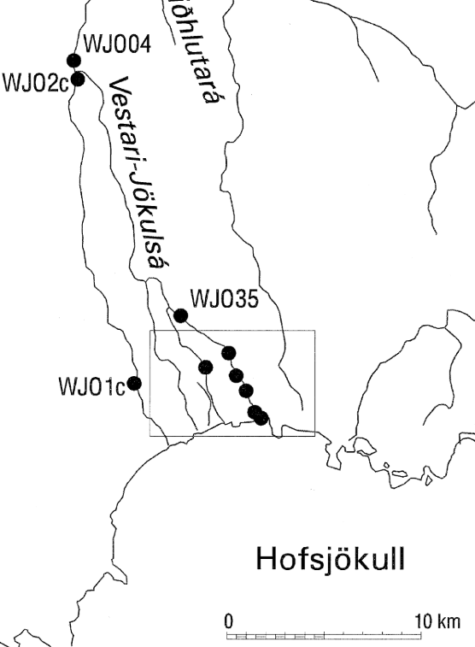

Fig. 2: Vestari-Jökulsá river with the sampling sites

# Virkisá River

At the Virkisá River, the sampling points (Fig. 3) were placed at approximately equal intervals of the river, based on previous master thesis. Two sampling points, S1 and S2, are located between the glacier and the lake (at 288 meters a.s.l. (Free Map Tools 2024)., the other sites, S3 – S7, are found along the river, behind the lake, starting from 940 meters distance from the glacier snout, on 194m a.s.l., on average around 500 metres apart. The sampling site S7 is located next to the bridge of the ring road over the Virkisá in more than 3km (3070m) from the glacier at 74m a.s.l.

For the sampling period after the rain, DOC and BDOC data for site 8 were taken which is located at more than 6km distance (6180m) on 50m a.s.l. shortly before the VR is joined by river from the Svínafellsjökull Glacier.

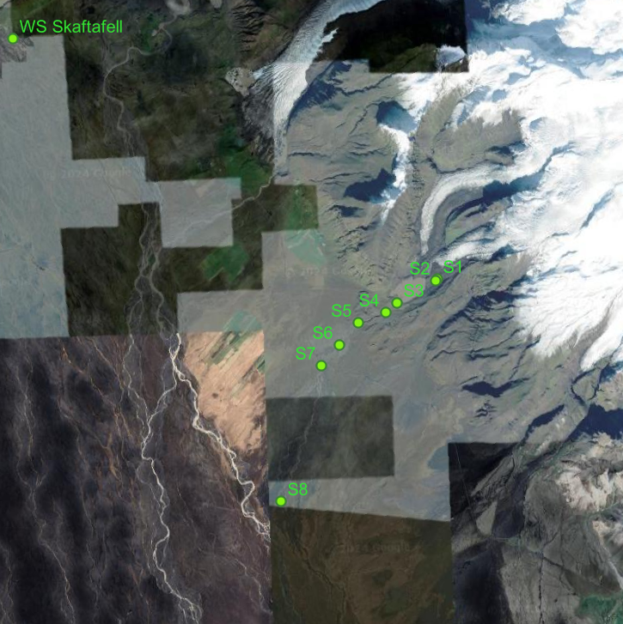

Fig. 3: Sample location at the Viskria river

# Sample Collection and Data Analysis

This section describes the procedures applied for water sampling, preparation, and subsequent laboratory analyses, as well as the complementary data collection that forms the basis for the statistical evaluation.

# Water sampling

At the VJR river sampling took place in July 2024, from the 17.07.2024 to the 23.07.2024 (Appendix III).

The samples at the VR were taken shortly after that period, the 27.07.2024 and the 28.07.2024 (Appendix IV). This period was followed by a relatively heavy rainfall event in the region, which also caused the Virkisá river to rise visibly. As part of a student seminar, from the 6.- 9. August 2024, further water samples were then taken from Virkisá. In the following, these samples will be referred to, as samples “after the rainfall event”; while the samples taken during the first period, in July, will be referred to, as samples taken before the rainfall event.

The sampling locations are visible in figure 2.

Due to the length of the VJR, the resultant distance between the sampling points (see *Fig. 3*)and above all the distinct diurnal discharge behaviour of glacier rivers (cf. above) a distinction was made between samples taken in the morning (VM) and afternoon (NM) at both rivers. At the period of the sample collection, the sun was at its zenith (solar noon) in the Icelandic sky at ca. 13:10 – 13:20 local time (Time and date, 2025), thus delineating the boundary between the morning and afternoon sampling periods.

For statistical relevance and due to logistical restrains 2 bottles (DURAN® Laboratory Bottle, 500ml) of **water samples** were collected. (before collection, each time, they were rinsed three times thoroughly with river water at the new sampling location). Either on-site or in the field laboratory (see Appendix I, in the evening of the same day, depending on weather conditions), the water samples were prepared, as described in the following paragraph:

For the **DOC samples**, ca. 40 ml of water was filtered through two Whatman® 934-AH glass microfibre filter discs with a pore size of 0.7 μm, following Fasching et al. (Chifflard et al. 2024: Fasching et al. 2016, Fasching and Battin 2011, Hood et al. 2015, Singer et al. 2012).

The filters were combusted in advance at 450°C in the muffle stove. (After filtration, these filters will be used for the determination of particulate organic carbon POC. These results will not form part of the present work.)

Muffling and acid cleaning (with 0.1 N HCl) was also performed on the 40 ml vials. Due to the specific conditions in Iceland (low temperatures and the associated possible freezing of the samples), the vials are filled with headspace.

For determination of the bioavailable DOC, **BDOC** samples were prepared as follows: 4 ml of unfiltered water, as inoculum, was filled up to approximately 40 ml vial with filtered water. After a period of 14 days, these samples were again filtered through 2 glass fibre filters (as described above, Whatman GF/F, pore sizes 0.7 μm). (These filters are being disposed of.)

All samples were stored in a cool and dark place (kitchen refrigerator or, in the highlands outside) to minimise biological activity (Zhu et al. 2024).

For the analysis, the samples were brought to the Soil Laboratory at the University Marburg.

# Laboratory analyses

At UMR, the filtered samples' DOC concentration was determined using a **Total Organic Carbon Analyser** (TOC, Shimadzu 2021, Appendix IIa)), which combusts the organic matter at high temperatures and then thermally detects the resulting CO2. (Chifflard et al. 2024) The TOC was set up and calibrated using distilled water after approx. every 10 samples, in accordance with the standard operating procedures of the laboratory at the UMR soil lab.

Bioavailable DOC (BDOC, %) was calculated as the relative change in DOC concentration during the 14-day incubation period, expressed as a percentage of the initial DOC concentration. (Fasching and Battin, 2012; Fellman, Spencer et al. 2010)

Fluorescence measurements were carried out with the **Spectrofluorophotometer** Shimadzu RF-6000 (2024, Appendix IIc)). Measurements were performed at a scan rate of 12,000 nm per minute with a 1 cm quartz cuvette (following the methodology described by Singer et al. 2012). Fluorescence intensity data were collected to construct excitation-emission matrices (EEMs) using excitation wavelengths covering 200 to 450 nm, with 5 nm intervals, and emission wavelengths between 250 and 700 nm with 2 nm intervals. The corresponding absorbance data was used for correcting the inner filter effect. (Chifflard et al. 2024)

For Absorbance measurements, the **Spectrophotometer** (Thermo Fisher 2013, Appendix IIb)) with 1 cm quartz cuvettes was employed (Appendix IV). (Chifflard et al. 2024)

Both, the Spectrofluorophotometer and the Spectrophotometer were calibrated with distilled water, meaning the emission peak of distilled water was taken as the reference value. (Chifflard et al. 2024)

# CO2 sensor and Calculation of CO2 Fluxes

To obtain data on CO2 a sensor (constructed and borrowed from Annika Feld-Golinski, following Bastviken et al. 2015) was placed in the water at each sampling location for at least one hour. For these measurements, no differentiation in the daytime was made.

Prior to each measurement, the concentrations of air and CO₂ within the chamber were homogenized—either by manually agitating the chamber or allowing ambient wind to circulate the air. This step also served as a visual marker in the resulting curve to indicate the beginning of the measurement.

Due to the high discharges and flow velocities of the two rivers, care had to be taken to ensure that the measuring sonde did not break loose during the measurement. Consequently, it was flexibly secured with a rope, near the riverbank, often positioned behind rocks in the river, where the level of turbulence and wave activity was typically lower but the water still flowing for minimising the sedimentation of POC as these could bias the measurement (Lorke et al. 2015).

Following Boodoo et al. (2017) by using the ideal gas law (cf. Jablonka 2017 after Clapeyron 1834; Clausius 1857; Kronig 1856) and treating CO₂ as an ideal gas without corrections for non-ideal behaviour (Lorke et al. 2015) CO2 evasion fluxes (*f*CO2) were calculated:

First, the molar gas volume Vm was determined using the universal gas constant R (8.314 J mol−1 K−1), the absolute temperature T (in Kelvin) and the standard atmospheric pressure p of 1013.25 hPa was assumed for the calculations of the Fluxes at all sample sites.

$$V_{m}=\frac{\left(R⋅ T\right)}{p}$$

Based on the chamber volume Vchamber (in L), the molar CO2 concentration [CO2]mol was calculated as:

$${{[CO}_{2}]}_{mol}=ΔCO_{2 (ppmv)}⋅{10}^{-6}⋅\frac{V_{chamber}}{V_{m}}$$

Here, ΔCO2 (ppmv) is derived from the linear change in CO₂ concentration over a 10-minute period, which appeared appropriate for both rivers.

To ensure objectivity and reproducibility, for this work the appropriate period was chosen by script. For that, the linear regression was applied to the best-fitting segment of the measurement (most linear section with the highest R²), selected automatically by script (cf. supplementary data, Appendix I):

A sliding-window search over the CO₂ time series is implemented (sampling interval of the sensor: every 10 seconds). Windows of increasing length tested (50, 60, 70 etc measuring points—while advancing the window start with 5-point increments, i.e., every 50 s, for practicability reasons). The window with the highest R² is selected; (in the case of same lengths, the longer window is preferred to favour stability). To standardize the analysis duration (and to minimise the possible influence of the sun by further heating the chamber) only the first 10 minutes (60 points) were chosen, and all subsequent calculations were executed with the data in this segment.

The relative molar mass of carbon RMMC (12.011 g · mol−1), the incubation time T (in hours), and the surface area A (in m2) covered by the chamber, the CO2 evasion fluxes *f*CO2 was calculated as:

$$f_{CO2}={{[CO}_{2}]}_{mol}⋅{RMM}_{C}⋅\frac{1000}{A⋅T}$$

# Complementary data

A calibrated **EXO2 Multiparameter Sonde** (YSI Inc. / Xylem Inc.)was used in-situ to obtain additional data on the water, like water temperature, concentration of dissolved oxygen and chlorophyll, specific conductivity, pH and turbidity (Appendices IId),VI).

**Hourly** **meteorological data** was obtained from the Icelandic Meteorological Office for two stations: the Sáta weather station, near the VJR, and the Skaftafell station, near the VR (see Figure 2, Appendix V).

For each river, meteorological conditions for the exact hour of water sampling were considered to best represent the immediate environmental conditions during data collection. However, as the weather stations are located at some distance from the sampling sites, and Icelandic weather patterns can vary considerably over short distances due to complex topography and rapid atmospheric changes (Crochet et al., 2007), the data may not fully capture the local conditions.

The **distance** of the individual sampling stations (Appendix IV) along the rivers to the respective glaciers was determined using the QGis software (QGIS Development Team, 2022) Appendix II.b.

The data from the laboratory as well as the data obtained in the field or from external sources (see the Chapters a),b) and c), Appendix VI), was compiled in a Master file (Appendix VI) and evaluated as described in the following chapters.

# Statistical analyses

As in the previous chapter, the coding, as well as all statistical analyses and visualizations, described below, were conducted in R (R Core Team 2025) within JupyterLab (Kluyver et al. 2016) using the R kernel (IRkernel project).

1. Descriptive statistics

(R packages: readxl, dplyr, tidyr, ggplot2, ggalluvial)

(R packages: readxl, dplyr, tidyr, ggplot2, readr)

1. Correlation analysis & Heatmaps

To evaluate the relationships between carbon parameters and collected variables, a correlation analyses in R was applied. Before the selection of the appropriate correlation measure, the distribution of each variable was examined with the Shapiro–Wilk test of normality (1965; Zar 2010). The resulting correlation matrices were visualized as heatmaps to highlight patterns of association across variables with the significance levels indicated by asterisks corresponding to the p-values (* p < 0.05, ** p < 0.01, *** p < 0.001).

*(R packages: readxl, dplyr, tidyr, Hmisc, reshape2, ggplot2, tools, openxlsx, purrr, tibble, knitr)*

1. Fluorescence Data Processing and PARAFAC Modelling

Fluorescence excitation–emission matrices (EEMs) were preprocessed (blank and scatter subtraction, inner filter effect correction and Raman normalization) and optical indices (BIX, HIX, FI, a254, a300, E2/E3, E4/E6, S275–295, S350–400, SR) were calculated.

To decompose the DOM fluorescence signal, a Parallel Factor Analysis (PARAFAC) model with five components was fitted using the R package staRdom (version 1.1.28, Pucher et al. 2019). The five extracted components represent independent fluorophore groups within the DOM pool and were validated following established guidelines (split-half validation, comparison to the OpenFluor database (Murphy et al. 2014)).

For each sample, component scores were expressed as relative contributions (in %) to enable comparison between treatments (DOC vs. BDOC) and across rivers.

*(R packages: staRdom, dplyr, tidyr, stringr, ggplot2)*

1. Principal Component Analysis

A Principal Component Analysis (PCA), (unrotated and varimax-rotated) was performed on selected environmental variables (using Pearson correlation matrices (Leyer & Wesche, 2008), Kaiser-Meyer-Olkin index (KMO index) of at least 0.70 and component number determination with Kaiser criterion, eigenvalues > 1 (Field et al. 2012). The carbon variables DOC, BDOC, and CO₂ flux were treated as supplementary variables (Graffelman & Aluja-Banet, 2003) and displayed in the biplots. These biplots showed sample scores (coloured by carbon concentrations and river identity) and variable loadings. Ellipses (95% CI, based on t-distribution) were added for the visualisation of groupings.

Furthermore, the contribution of each variable to the extracted components was assessed.

Finally, to test for systematic differences between the two rivers (Vestari-Jökulsá vs. Virkisá), MANOVA was applied to the factor scores of the selected components, univariate ANOVAs were performed for each factor separately to identify which factors contributed to between-river differences.

*(R packages: MVN, broom, dplyr, ggnewscale, ggplot2, ggrepel, psych, stringr, tidyr)*

# Results

In the following chapter, the results for the two study rivers, Vestari-Jökulsá and Virkisá, are presented. The analysis focuses on the key carbon parameters: DOC concentrations, BDOC (see 3.2.2) and the CO₂ fluxes (see chapter 3.2.3).

The data are evaluated with respect to spatial patterns along longitudinal transects and temporal variations between morning and afternoon sampling. Furthermore, statistical approaches are applied to relate the carbon parameters to physical, chemical, and biological variables: correlation analysis is used to assess pairwise associations, fluorescence indices provide insights into the quality and origin of dissolved organic matter, and a principal component analysis (PCA) summarizes and visualizes the main gradients within the dataset.

# Descriptive Overview of Carbon Parameters

This section provides a descriptive overview of the measured carbon parameters (DOC, BDOC, and CO₂ flux) in both study rivers. Descriptive statistics and graphical representations are used to illustrate the overall distribution of values and to highlight differences between the rivers, including conditions before and after the rainfall event in the VR.

Descriptive data for the measured carbon parameters (DOC, BDOC, and CO₂ flux) in the Vestari-Jökulsá and Virkisá are summarized in table 5. These values include minimum, maximum, median, mean, and standard deviation for each parameter. For the VR, the dataset is further divided into measurements taken before and after a rainfall event that occurred between the two sampling periods (see chapter 3.2.1).

*Table 5: Descriptive statistics results of carbon variables by river*

|  |  |  |  |  |  |  |  |
| --- | --- | --- | --- | --- | --- | --- | --- |
| Group | Variable | **Minimum** | **Maximum** | **Median** | **Mean** | **Standard.**  **Deviation** | **N** |
| **Vestari-Jökulsá** | DOC | 0.07 | 0.28 | 0.14 | 0.15 | 0.05 | 18 |
| BDOC (%) | -37.4 | 62.98 | 27.46 | 23.09 | 25.93 | 14 |
| CO2 Flux | -13.19 | 12.27 | -5.84 | -1.47 | 9.99 | 16 |
| **Virkisá** | DOC | 0.1 | 0.59 | 0.22 | 0.26 | 0.13 | 43 |
| BDOC (%) | -32.23 | 69.68 | 31.35 | 26.97 | 28.26 | 43 |
| CO2 Flux | -108.84 | -17.59 | -56.82 | -58.55 | 30.46 | 17 |
| **Virkisá,** | DOC | 0.1 | 0.17 | 0.13 | 0.13 | 0.02 | 14 |
| **before rain event** | BDOC (%) | -32.23 | 25.46 | -1.66 | -4.54 | 17.67 | 14 |
| CO2 Flux | -107.41 | -17.59 | -49.16 | -57.56 | 37.26 | 8 |
| **Virkisá,** | DOC | 0.16 | 0.59 | 0.29 | 0.32 | 0.12 | 29 |
| **after rain event** | BDOC (%) | 1.51 | 69.68 | 41.17 | 42.18 | 17.8 | 29 |
| CO2 Flux | -108.84 | -31.83 | -56.82 | -59.43 | 25.27 | 9 |

The corresponding distributions are also presented as violin and boxplots, Fig. 4, for DOC, BDOC and CO₂ flux for the VJR and data of the VR before and after the rain event, enabling a direct visual comparison between the two rivers ant the pre- and post-rainfall conditions at the VR.

Overall, ***DOC concentrations were lower and more narrowly distributed in the VJR, clustering around a median of***0.14 mg L⁻¹, with a narrow distribution and limited variability. For the VR, values before the rainfall event show an even narrower distribution with a slightly lower median, whereas values at the VR after the rainfall event displayed higher values with a higher median, with stronger variability.

**BDOC values showed considerable variability in both rivers, including negative as well as high positive percentages. In the VJR, values centred around a median of ~ 27 %. In contrast, pre-rainfall values in the VR were close to zero and exhibited moderate variability. After the rainfall event, however, both the median and spread increased substantially, with the median shifting to ~ 40 % and a distribution extending toward higher values.**

For *CO₂ flux*, VJR was characterized by low values that were partly positive but mostly negative, with a median of about −6 mg C m⁻² d⁻¹ and a relatively narrow spread. The VR, in contrast, exhibited consistently negative fluxes with substantially lower mean values and greater variability. In both cases, before and after the rain event, the median was around - 50 mg C m⁻² d⁻¹.

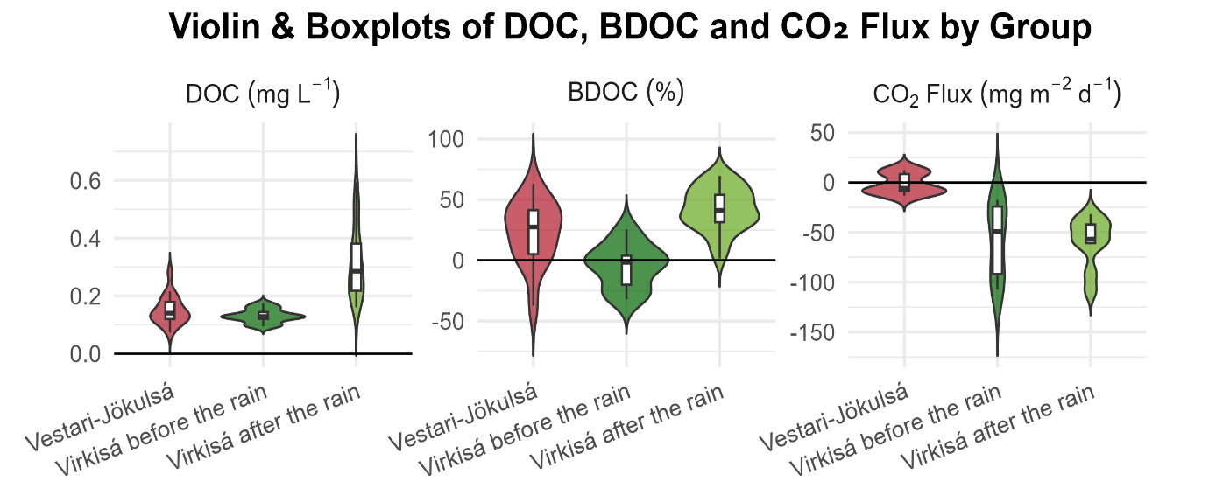

Fig. 4: Violin and Boxplots of DOC, BDOC and CO2 Flux by river

Concerning the VR, the pronounced differences before and after the rainfall event justify a separate consideration of the results of the carbon parameters, which are examined along the different sampling sites (site 1–7, visualised in Fig. 5). For comparison, results prior to the rainfall event are also shown as box plots, even though only two samples per site were available.

DOC concentrations were generally higher after the rainfall event, with the most pronounced increases observed at sampling sites 3, 4, and 5. Before the rainfall, DOC values remained lower and relatively uniform across sites. After the rainfall event, DOC concentrations ranged between 0.16 and 0.59 mg L⁻¹, whereas pre-rainfall values were between 0.10 and 0.17 mg L⁻¹ (see Table 5)

BDOC values were also higher in the post-rainfall samples compared to pre-rainfall conditions. Prior to the rainfall, BDOC values were lower across all sites and even negative (site 2, 4 and 6), whereas after the rain, several sites showed higher values.

CO₂ fluxes were negative at all sites, both before and after the rain event, with the most pronounced differences observed at the sampling sites 2 and 3. In contrast to the other values, in site 2 and site 6 the fluxes were lower after the rain than before the rain.

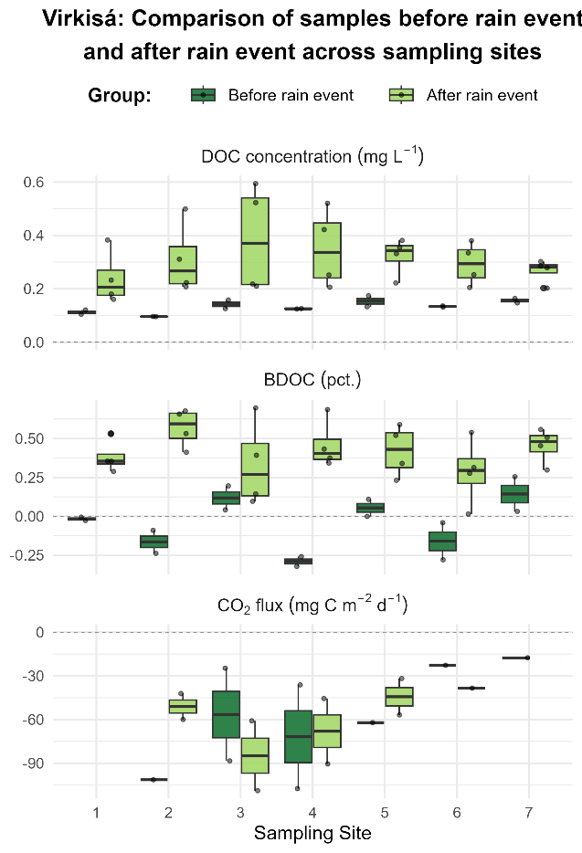

Fig. 5: Virkisá carbon parameters before and after the rainfall event across sampling sites

# Spatial and Temporal Variations

Spatial and temporal variability in carbon dynamics was assessed by analysing DOC, BDOC, and CO₂ fluxes along longitudinal transects of the rivers as well as between morning and afternoon sampling.

# Longitudinal Patterns along the Rivers

The following results describe longitudinal patterns of DOC, BDOC, and CO₂ fluxes and some environmental variables along the study rivers.

In the distance of approximately 3 km, DOC, BDOC and CO₂ fluxes of the two rivers, VJR (site 1-4) and VR (site 1-7), were plotted against the distance from the respective glacier in a single diagram (see Fig. 6). For the VJR, the two measurements are shown as points, while for the VR, with multiple datasets (before and after rainfall event), the data are shown as boxplots.

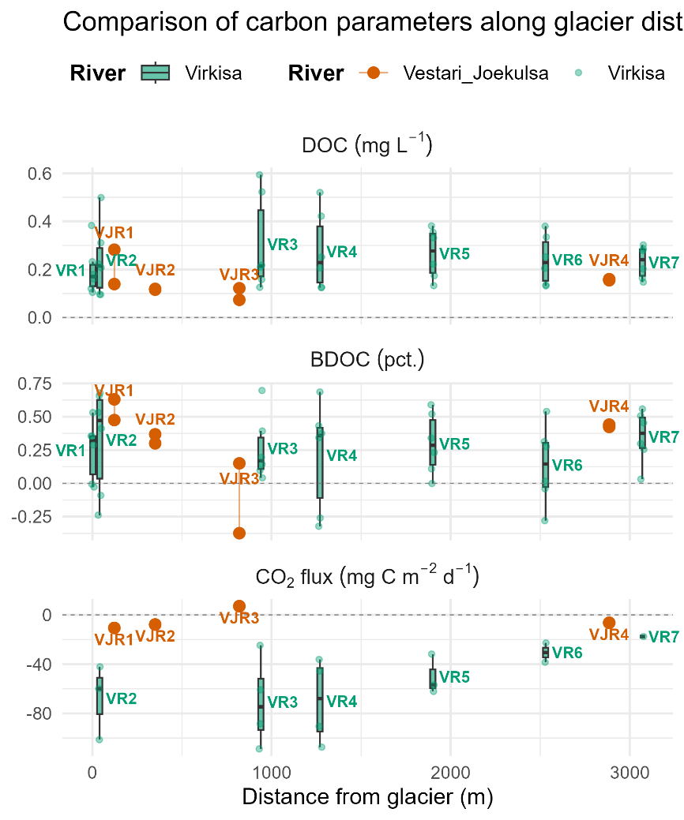

Fig. 6: Carbon parameters of VJR and VR in relation to distance from respective glacier

DOC concentrations (upper panel) of the VR exhibited a broader range across all sampling sites, with several sites exceeding 0.4 mg L⁻¹. In contrast, DOC values in the VJR remained lower and more uniform, with concentrations typically below 0.25 mg L⁻¹.

BDOC concentrations (middle panel), in the VR displayed notable variation between sites and replicates with several sites exceeding 0.25 mg L⁻¹. For the VJR, BDOC concentrations were generally lower and, in some cases, close or below zero.

The CO₂ fluxes (lower panel), were consistently negative in both rivers. The VR data showed considerable variability between replicates and sites, while the VJR exhibited slightly less variation and consistently lower magnitudes of flux across sites.

Concerning the environmental variables, values of chlorophyll a, dissolved oxygen, specific conductivity, turbidity, pH, and temperature measured at the VJR and VR are presented below (Fig. 7 and Fig. 8) and plotted against the distance from the respective glacier. As there are multiple values for the VR (before and after the rainfall event) as boxplots (in green) and the two values of the VJR as points (in orange). Extreme values indicating a measurement error were removed (one value at Turbidity and one at pH).

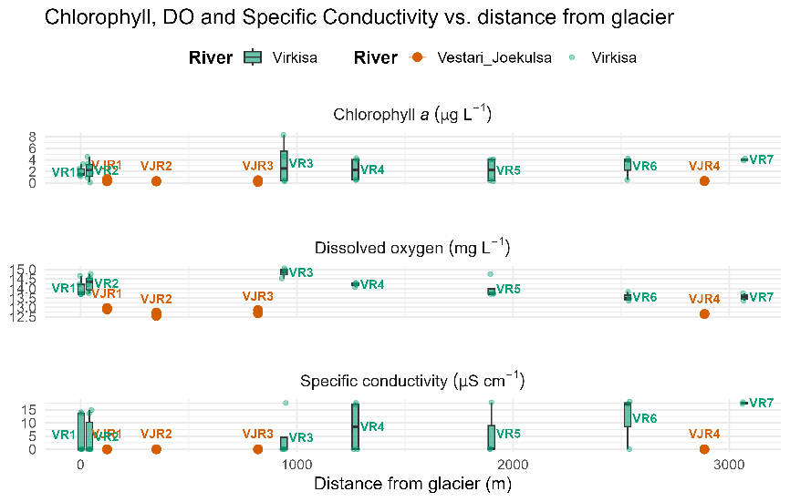

Fig. 7: chlorophyll a, dissolved oxygen, turbidity in the VJR and VR

Chlorophyll *a* values (Fig. 7) in the VJR were generally low across all sampling sites, with most values below 2 µg L⁻¹. In the VR, values were generally higher, particularly at VR3.

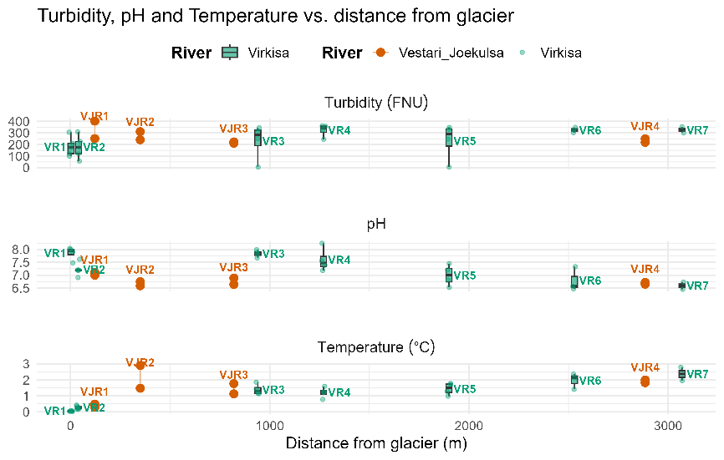

Fig. 8: pH, specific conductivity, and temperature in the VJR and VR

For the VJR, dissolved oxygen concentrations ranged between approximately 12.5 and 13 mg L⁻¹, with little site-to-site variability. These values were generally lower than those measured in the VR .

Specific conductivity showed overall low values, typically below 15 µS cm⁻¹. Values in the VJR were close to zero, while those in the VR were higher and displayed a broader distribution.

Turbidity values (Fig. 10) varied substantially among sites but were within a comparable range for both rivers.

PH values (see Fig. 9) were near neutral to slightly alkaline across most sites, ranging between ~6 and 8, with minor fluctuations between sites and similar values in both rivers.

Water temperatures were generally low, ranging from 0 near the glacier to about 3 °C. In both rivers, temperatures generally increased with distance from the glacier. At site 2 for VJR, a relatively high temperature of almost 3 °C was observed.

# Time of Day and Sampling Site

This section describes temporal variability in DOC, BDOC, and CO₂ fluxes based on descriptive comparisons between morning and afternoon sampling across sites.

For the VJR, DOC concentrations plotted against river distance (*Fig. 9*, left) show overall similar longitudinal patterns for morning (triangles) and afternoon (dots) measurements.

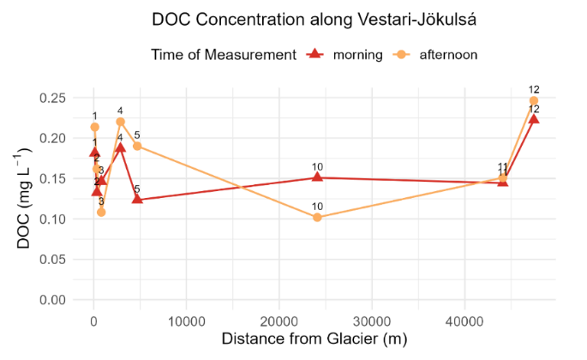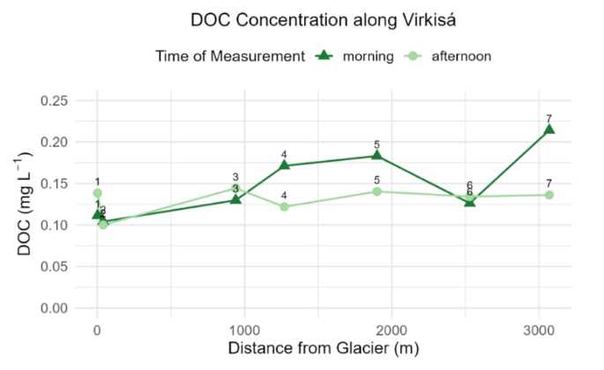

*Fig. 9: DOC concentrations along VJR left and VR right, morning and afternoon*

Concentrations were slightly lower in the morning at most sites, with exceptions at sites 3 (820 m) and 10 (24 km), where afternoon values were reduced. The closely spaced sampling sites 1-5 (up to 4,7km from the glacier) revealed a decline in DOC until site 3, followed by an increase at site 4 (~ 2,9 km) and a decrease again at site 5 (4,7 km). At greater distance (>24 km), concentrations remained low and constant at site 10, whereas the highest DOC value was observed at Site 12, more than 47 km downstream.

In the VR (*Fig. 9*, right), morning DOC values generally increased downstream, except for decreases at site 2 (40 m) and site 6 (2.5 km). Afternoon concentrations were consistently lower than morning values and exhibited a less pronounced longitudinal trend, with the strongest decline occurring between sites 1 and 2 (40 m from the glacier).

For better visualization, the site-specific distributions of DOC, BDOC, and CO₂ flux are presented below. (*Fig. 10*).

In the VJR, BDOC values (middle panel) remained between ~0.6 and 1.1, with only minor differences between morning and afternoon sampling. Site 3 showed the highest BDOC value in the afternoon.

In the VR, BDOC values ranged between ~0.75 and 1.5, with slightly higher values at downstream sites and only minor morning–afternoon differences.

**Vestari-Jökulsá Virkisá**

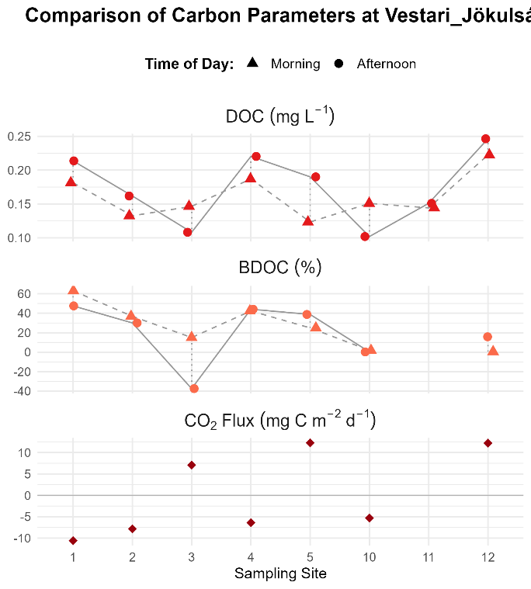

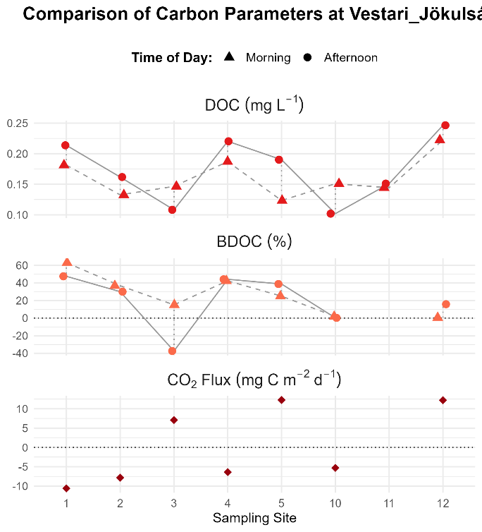 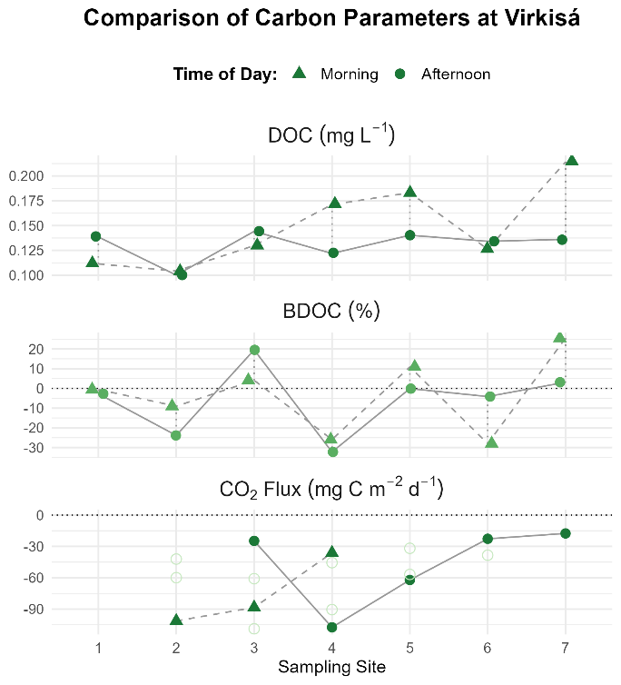

*Fig. 10: Carbon parameters per site, VJR left, VR right, morning and afternoon*

CO₂ fluxes in the VJR (lower panel) were consistently negative with a narrow overall range and little difference between morning and afternoon measurements. In the VR, fluxes were also negative at all sites, ranging from approximately −10 to −40 mg C m⁻² d⁻¹. While site-to-site variation was moderate, morning and afternoon values were largely similar.

# Correlation analysis

To assess how the measured parameters relate to the carbon variables, a correlation analysis was carried out. For each parameter the distribution was tested using the Shapiro–Wilk test of normality (results in Annex VII). As some variables (part of BDOC and air temperature) were not normally distributed, correlations were calculated using Spearman’s rank correlation.

In the heatmaps of correlation coefficients (r values), the colour of a field visually represents the strength (intense colour: strong correlation, pale colour: weak correlation) and direction (green: positive, red: negative) of the correlation. Insignificant results are marked with an “x”, while significant correlations are indicated with asterisks (* p < 0.05, ** p < 0.01, *** p < 0.001).

For clarity, the heatmaps are presented in three groups: weather variables, environmental variables measured with the Exo Sonde, and fluorescence variables.

1. Correlation between carbon variables and the weather parameters

For the VJR (Fig. 11) most correlations between carbon and weather parameters were not significant, and the few significant ones were mainly negative.

For the VR, BDOC showed several very highly significant negative correlations with air temperature (also max. and minimum air temperature). DOC correlated highly significantly and negatively with air temperature and with maximum wind gusts.

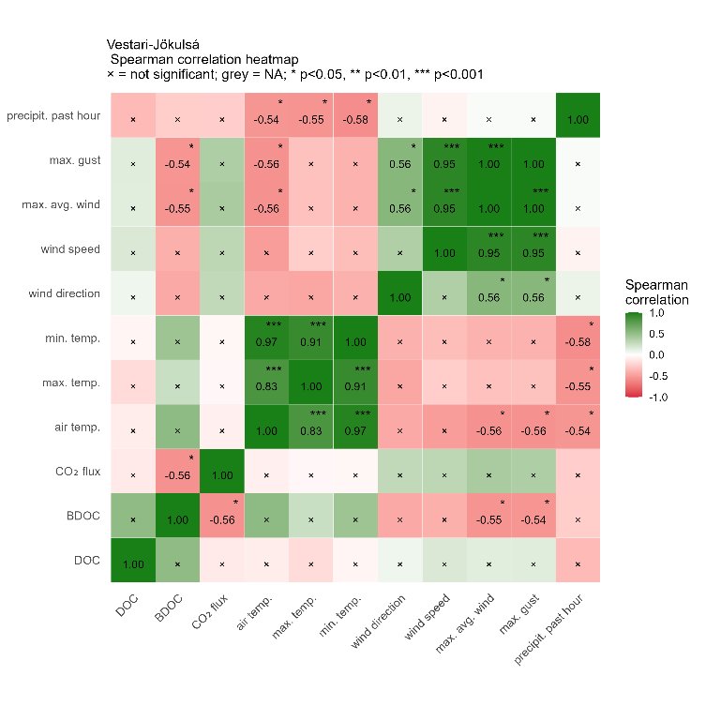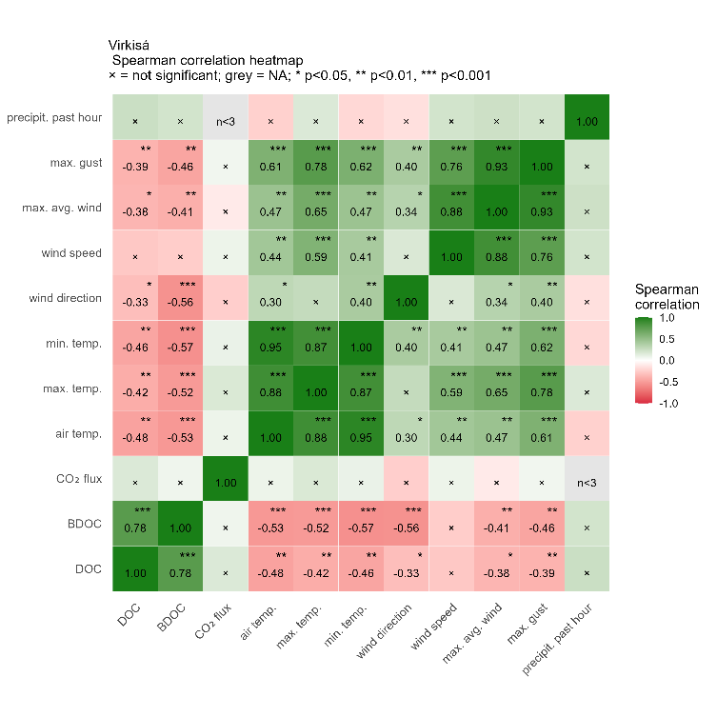

*Fig. 11: Correlation heatmaps of carbon variables with weather parameters (VJR and VR)*

The very highly significant negative relationship of BDOC with air temperature is shown in the scatterplot below (Fig. 12). Higher air temperatures corresponded to lower BDOC values and vice versa. As additional information the samples taken before the rain event were coloured dark green, while the ones taken after the rain event in light green. For this period the BDOC is generally higher than for the period before the rain event, while also the air temperature is higher than for the period before the rain event.

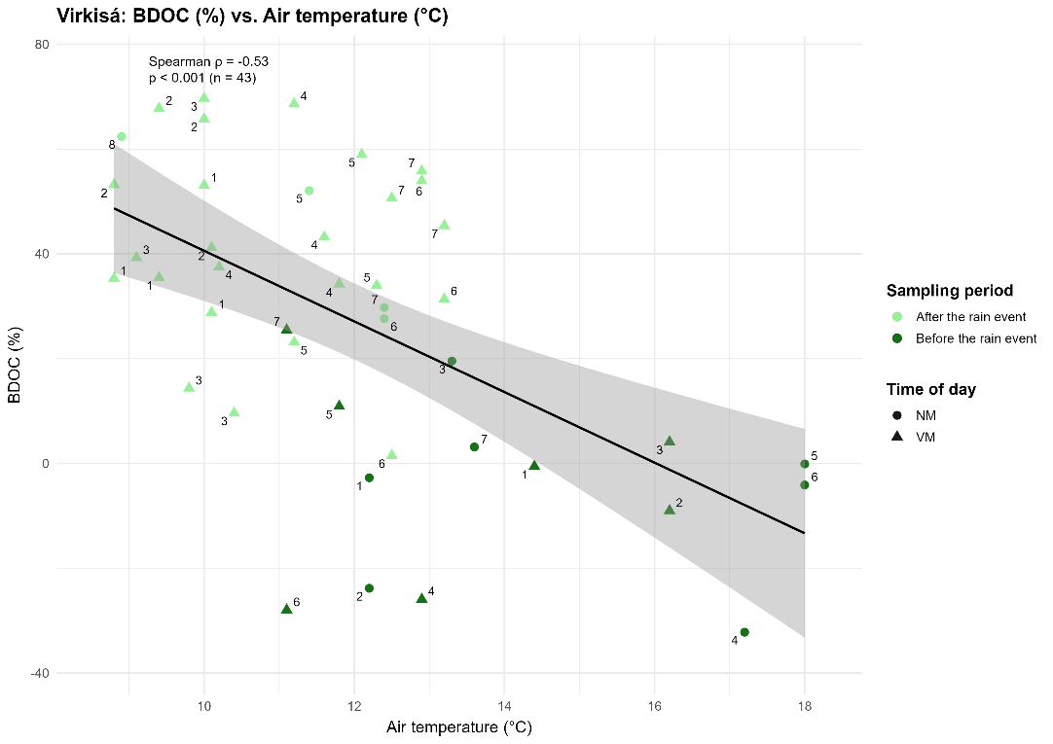

Fig. 12: Correlation BDOC vs. air temperature (VR)

1. Correlations with environmental parameters

The correlations between environmental and carbon parameters showed several significant relationships (see Fig. 13).

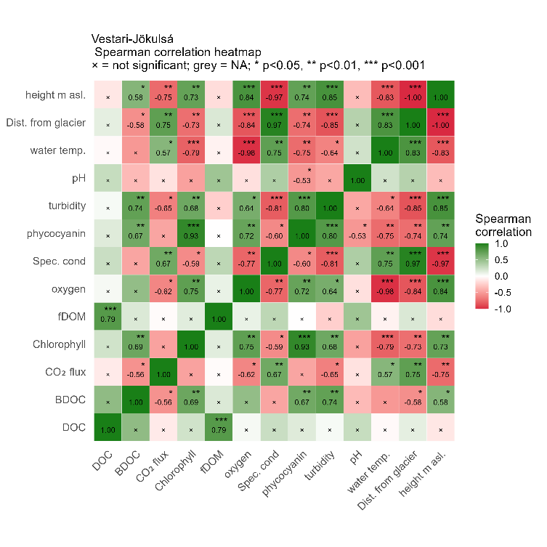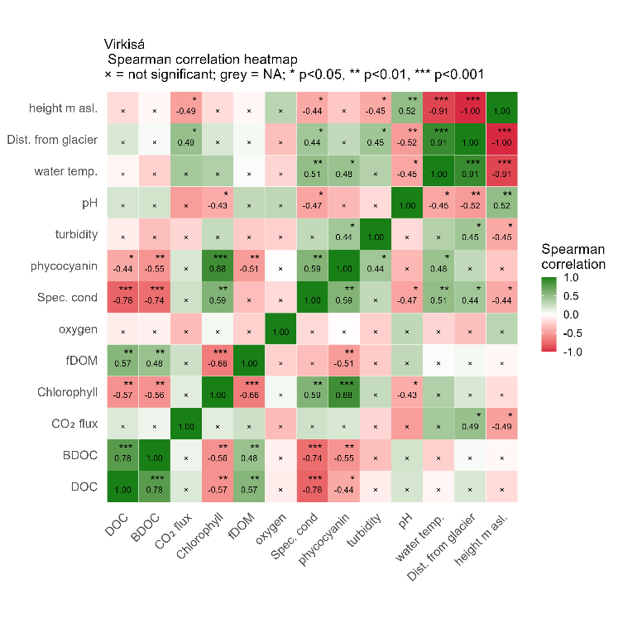

Fig. 13: Correlation heatmap of carbon variables & environmental parameters (VJR and VR).

For the VJR, DOC correlated very highly significantly positive with fDOM, while BDOC correlated highly significantly positive with chlorophyll, phycocyanin, and turbidity. Significant correlations for BDOC were also observed with height above sea level (positive) and distance from the glacier (negative). CO₂ flux correlated highly significantly with both distance from the glacier and specific conductivity, and negatively with oxygen, turbidity, and height above sea level.

For the VR, DOC and BDOC showed very highly significant negative correlations with specific conductivity. Both also correlated positively with fDOM and negatively with chlorophyll. As at the VJR also at the VR, CO₂ flux correlated positively with distance from the glacier and negatively with height above sea level.

For both rivers, DOC correlated positively with fDOM (Fig. 14). The relationship was very highly significant for the VJR and highly significant for the VR. While the amount of fDOM for the VJR and for the available data of the VR samples after the rain period was approximately the same, the values for fDOM in the Virkisá before the rain event were lower. Whereas the DOC values of the VJR and the VR before the rain event were approximately similar and clearly different to the DOC values of the VR after the rain event which were distributed over higher DOC values.

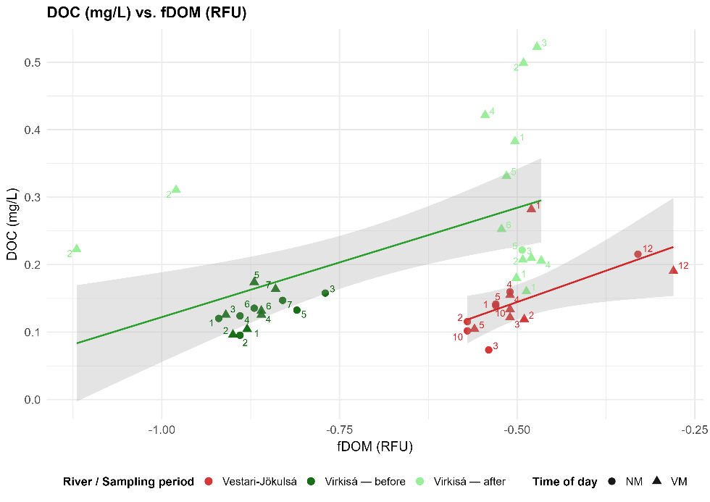

Fig. 14:Correlation DOC vs. fDOM (both rivers)

Concerning BDOC, as mentioned above, BDOC correlated highly significant with chlorophyll. While for the VJR the correlation was positive, the correlation for the VR was negative and is visualised in the plot below (Fig. 15).

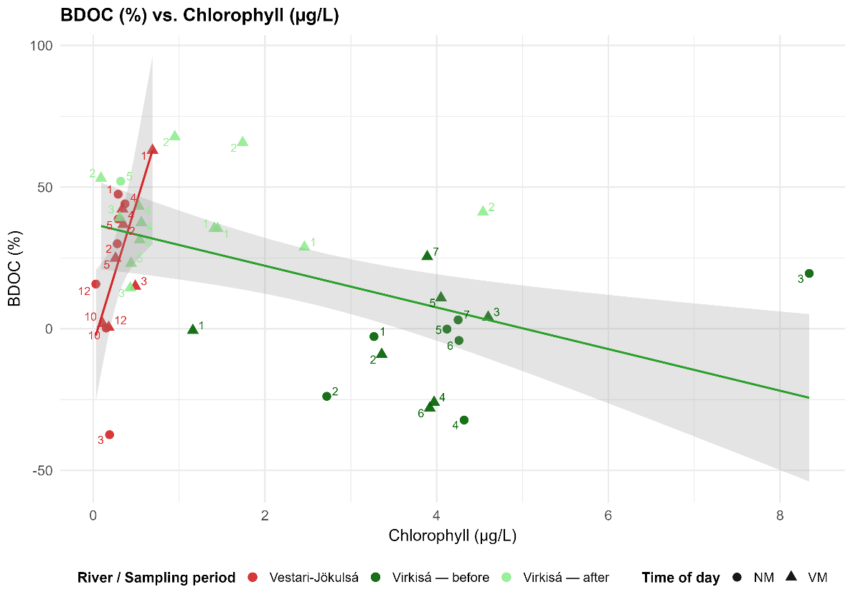

Fig. 15: BDOC vs. Chlorophyll, both rivers

The situation is similar for phytocyanin (see Fig. 16): For both rivers, BDOC correlates highly significant with phytocyanin. For the VJR the correlation was positive, for the VR negative.

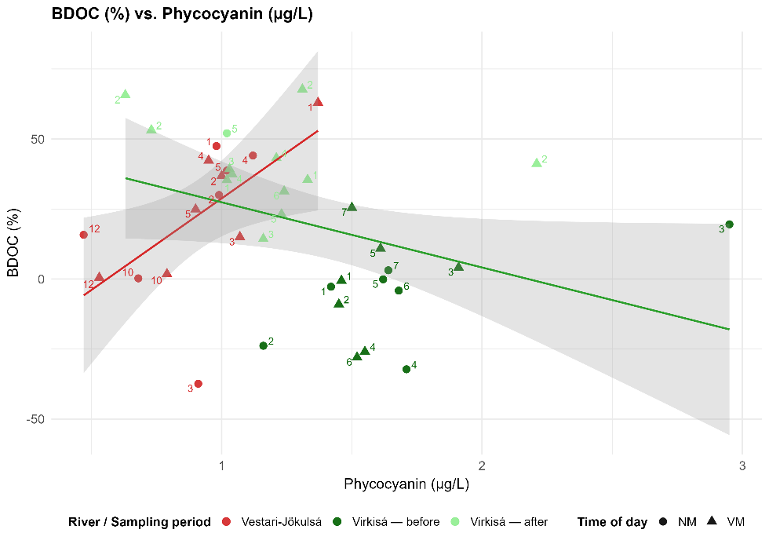

Fig. 16: BDOC vs. Phycocyanin, both rivers

Concerning the heatmaps for the VR the correlation of DOC and BDOC with the specific conductivity stands out as it showed strong negative correlations (Fig. 17).

For DOC and BDOC it is obvious that the specific conductivity is visibly clustered: the period before the rain around 0 and the period after the rain event more than ca. 15. In the middle on the other hand are no values. The values after the rain are clustered in the sense, that the first two sites, the specific conductivity is lower for DOC and BDOC (lower than 15 for site 1 and 2, and higher than 15 for the other sites).

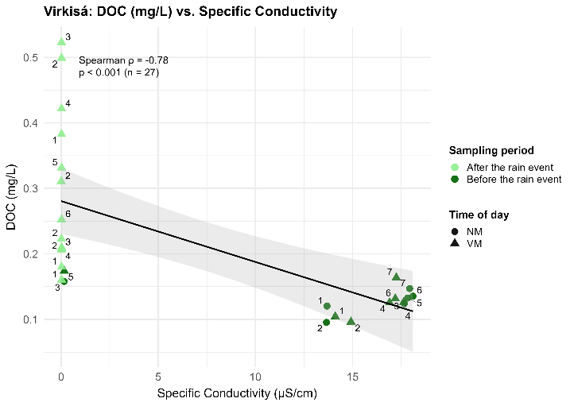 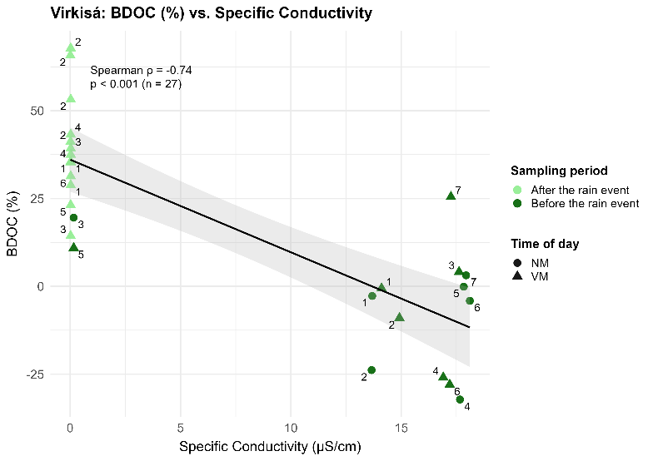

Fig. 17: Correlation DOC/BDOC vs. specific conductivity (VR)

1. Correlations with fluorescence parameters

In the following heatmaps the correlations of the carbon variables with the fluorescence parameters are visualised (Fig. 18).

For the VJR, most correlations between carbon and fluorescence variables were not significant. CO₂ flux showed positive correlations with components 2 and 4, while BDOC correlated with component 4.

For the VR, DOC correlated very highly significantly and negatively with components 1 and 2, and highly significantly with component 4. In contrast, it correlated positively and highly significantly with component 3, and significantly with component 5. BDOC showed highly significant negative correlations with components 1, 2, and 4, and a positive correlation with component 5.

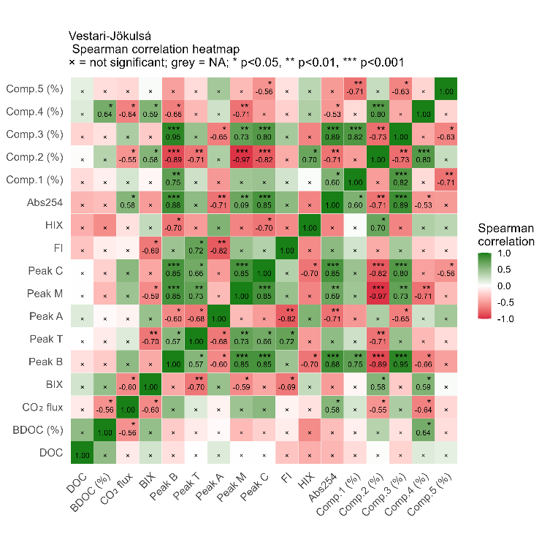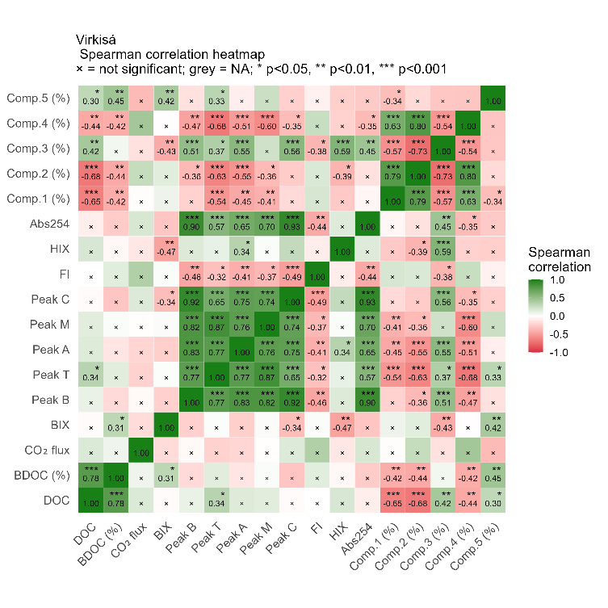

Fig. 18: Correlation heatmaps of carbon variables with fluorescence parameters (VJR and VR).

For the VR, DOC correlates significantly with all five fluorescence components (see Fig. 19, negative correlation for component 1, 2 and 4, and positive correlation for component 3 and 5). A part of component 5 the correlation is even highly significant and for the first two components event very highly significant.

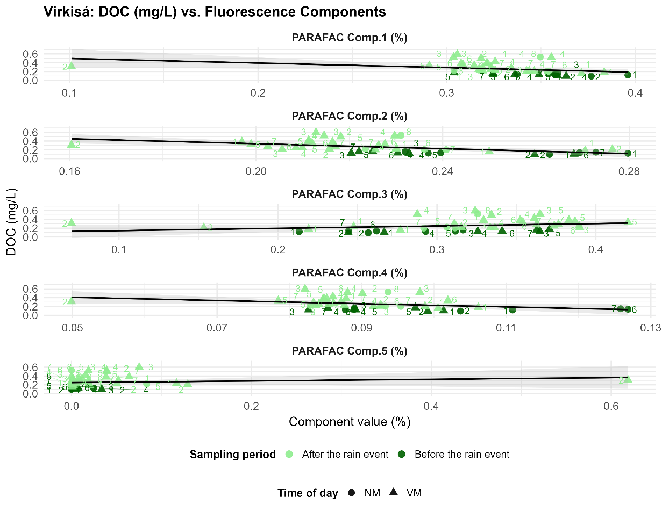

Fig. 19: Correlations DOC vs. Components (VR)

Apart from a few outliers, the values before and after the rain lay relatively close together concerning the component value. For all components, a site 2 after rain is an outlier.

The DOC values are generally higher for the sampling points after the rain.

# Fluorescence Indices and Composition

Table 8: excitation - emission of the components, their assignment to Coble peaks, fluorescence and other studies (i.a. OpenFluor*)

|  |  |  |  |  |  |
| --- | --- | --- | --- | --- | --- |
| **Component**  **number** | **Excitation**  **maxima**  **(nm)** | **Emission**  **maxima**  **(nm)** | **Coble (1996)**  **Fluorophore name** | **Description** | **Similar to:** |
| **1** | 290 | 306 | b |  |  |
| **2** | 315 | 330 | m |  |  |
| **3** | 275 | 256 |  |  | Dainard et al. 2015* ;  Chifflard et al. 2024 |
| **4** | 365 | 372 |  |  |  |
| **5** | 300 | 338 |  |  | Eder et al. 2022* ; Maurischat et al. 2022* |

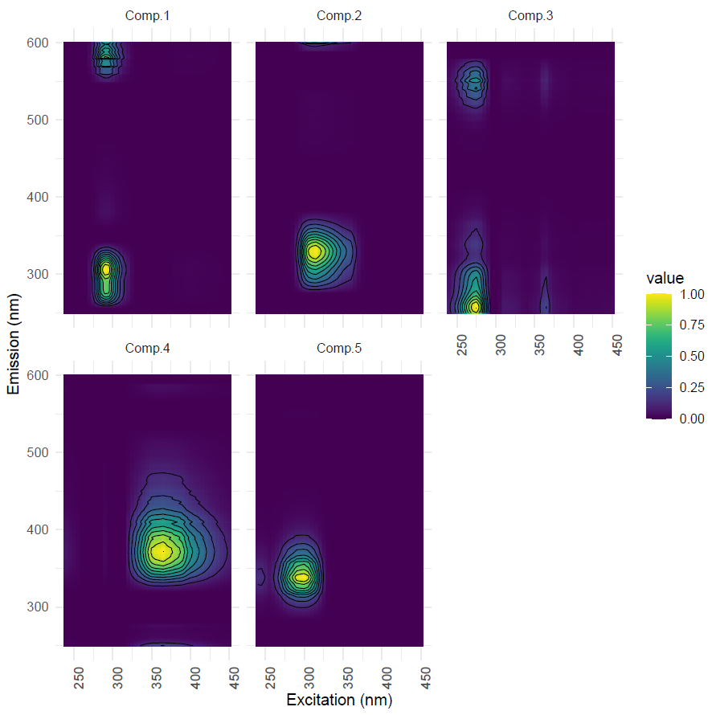

Fig. 21: Excitation-emission model of the five components

Indices like BIX, HIX, and S275–295 indicated differences in DOM quality.

The developments of the components per location on the day of sampling and 14 days later are as follows at VJR:

Component 3 is not yet present at site 1, but only in small percentages at site 2. Here, the component also decreases slightly after 14 days. At sites 3 and 4, component 3 increases after 14 days, then decreases again at site 5. At sites 10 and 12, it then increases again.

Fluorescence component dynamics over 14 days were evaluated and visualised in two plots below. The components for the DOC samples are visualised in the column per site, labelled “time 0” while the percentage for the respective component for BDOC, is indicated in the column labelled “time + 14 days”.

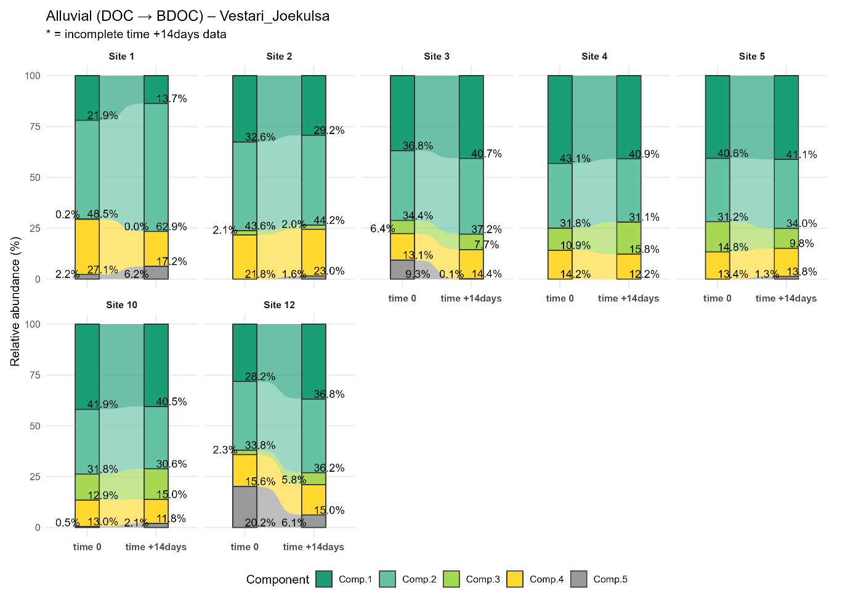

Fig. 22: Component composition DOC and BDOC (+14days) Vestari-Jökulsá

For easier analyses each figure is accompanied by a table (see Table 7 and Table 8) in which the relative change (from DOC, time 0 to BDOC, time + 14days) in percent is indicated.

Table 7: VJR components per site: Relative change from day 0 to day +14 (% of day 0)

|  |  |  |  |  |  |  |  |
| --- | --- | --- | --- | --- | --- | --- | --- |
| **relative change in % : time 0 to time+14days (% of time 0)** | | | | | | | |
| **Component** | **S1** | **S2** | **S3** | **S4** | **S5** | **S10** | **S12** |
| **C1** | -37.62 | -10.31 | 10.52 | -5.13 | 0.86 | -3.30 | 30.77 |
| **C2** | 29.73 | 1.45 | 8.11 | -2.40 | 4.92 | -3.70 | 7.24 |
| **C3** | -94.51 | -2.18 | 19.74 | 45.62 | -24.82 | 16.67 | 157.08 |
| **C4** | -36.76 | 5.58 | 10.01 | -13.90 | -0.01 | -9.08 | -3.79 |
| **C5** | 180.01 | + | -98.79 | 0.00 | + | 328.59 | -69.69 |

Concerning the VJR, component 1 was generally reduced (a part of site 12). Componente 2 showed small increases at most sites and component 4 showed small declines (a part of site 1). Componente 3 and component 5 showed the largest heterogenity. Componente decreased at some locations (site 1 and 5) but increased majorly in others (site 12). Componente 5 increased strongly at several sites (site 1 and 10), appeared from zero at sites 2 and 5, but decreased strongly at Sites 3 and 12 and and was not existend at 4.

Regarding the VR, across the eight sites, component shares changed consistently for four of the five components (see Table 8). Component 1, component 2, and component 4 increased at all sites, whereas component 3 decreased at all sites.

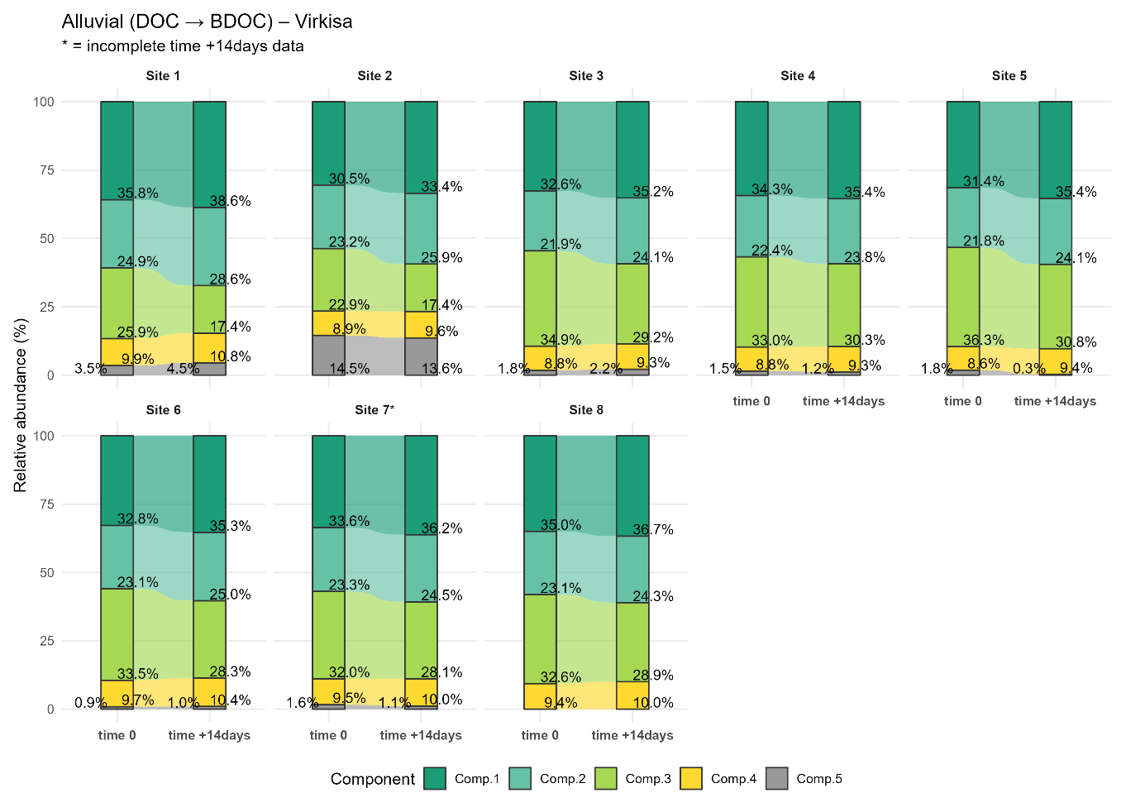

Fig. 23: Component composition DOC and BDOC (+14days) Virkisá

Component 5 showed mixed responses across sites and accounts for the smallest share (a part at site 2, see Fig. 22) at each site. It increased at locations 1, 3 and 6, but decreased at the remaining sites. At site 8, component 8 was not present at all.

Table 8: VR components per site: Relative change from day 0 to day +14 (% of day 0)

|  |  |  |  |  |  |  |  |  |
| --- | --- | --- | --- | --- | --- | --- | --- | --- |
| **relative change in % : time 0 to time+14days (% of time 0)** | | | | | | | | |
| **Component** | **S1** | **S2** | **S3** | **S4** | **S5** | **S6** | **S7** | **S8** |
| **C1** | 7.85 | 9.82 | 7.94 | 3.31 | 12.49 | 7.77 | 8.11 | 5.02 |
| **C2** | 14.82 | 11.55 | 10.02 | 6.01 | 10.41 | 8.11 | 6.02 | 5.33 |
| **C3** | -32.80 | -24.11 | -16.24 | -8.02 | -15.05 | -15.56 | -12.54 | -11.22 |
| **C4** | 9.40 | 8.15 | 5.69 | 5.53 | 8.87 | 7.33 | 6.02 | 7.16 |
| **C5** | 30.45 | -6.05 | 21.38 | -21.71 | -82.58 | 9.25 | -36.37 | 0.00 |

Fluorescence indices (HIX, BIX, FI, E2/E3, S275–295, SR) were compared (see Fig. 23) between VJR (in red, in the figure) and VR, with VR further partitioned into samples collected before the rain event (dark green) and after the rain event (light green) For each index, group-wise distributions were summarized as boxplots showing medians and interquartile ranges, with individual observations and mean markers (diamond) overlaid. Across indices, distributional differences among the three groups were observed. Within VR, shifts between the data from the sampling before the rain event and after the rain event were indicated by changes in medians and spread of several indices.

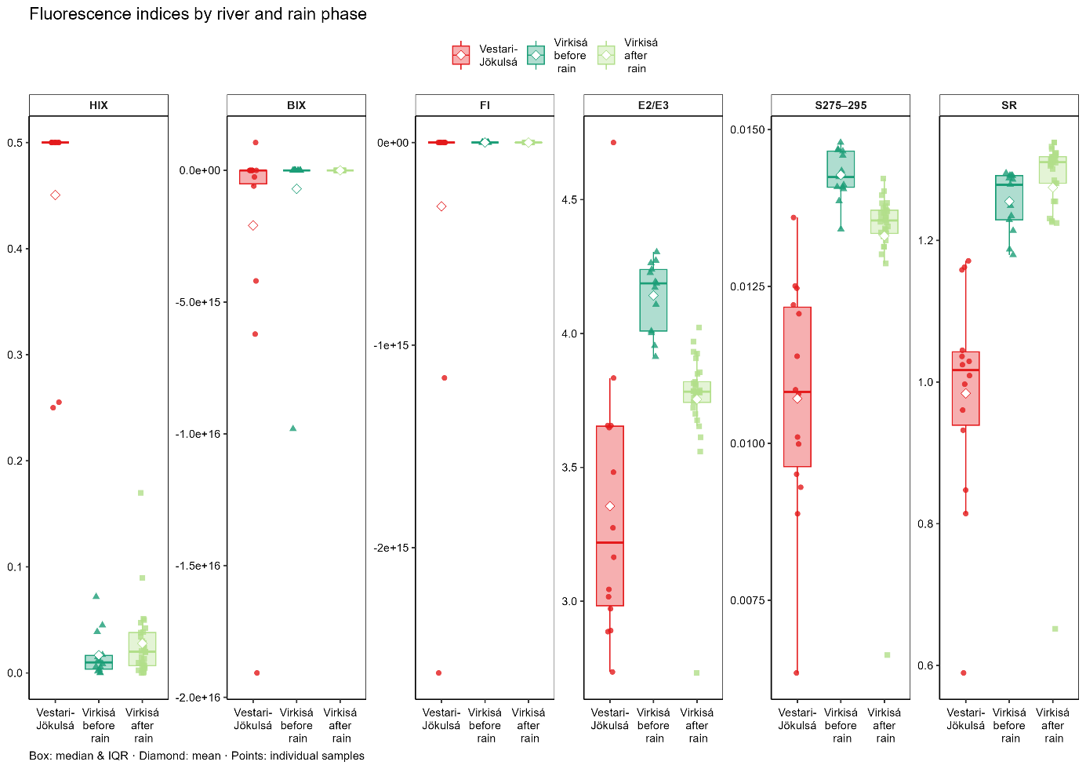

Fig. 24: distributions of fluorescence indices across rivers and rain phases

An increase in **HIX** was observed in VR from before the rain to after the rain, although HIX remained lower than for the VJR. Similarly, SR increases, but is higher than for the VJR.   
For the E2/E3 and S275–295 indices, the data for the VR is higher than for the VJR, even though less outspreaded. Both indices are lower after the rain than before the rain in the VR.

For the BIX and FI indices the mean for all three groups is approximately similarly high, even though in the mean the values of the VJR is lower than for the VR

# Principal components analysis

As mentioned above, part of the statistical evaluations was a factor analysis with the 'principal components analysis' (PCA) as factor extraction technique, without and with rotation, which examined as few relevant factors as possible capable to represent set of homogenous parameters (Reyment and Jöreskog, 1993) of the two rivers Vestari-Jökulsá and Virkisá. These parameters were predominantly e*nvironmental parameters (taken with the EXO2 Multiparameter Sonde) chlorophyll, oxygen, phycocyanin, turbidity, pH, air and water temperature as well as height above sea level and the components (comp.1 – comp.5)*

The carbon parameters, DOC, BDOC and CO2 fluxes, were then added in the PCA as supplementary variables.

An analysis using all the above parameters did not yield a positive definite correlation matrix (a prerequisite for factor analysis and for determining the KMO index). It led to an only positive semidefinite matrix (singularity) with a questionable sample suitability: KMO/MSA < 0.5) (Field et al. 2012), which was due to strict dependencies among the components 1-5.

Therefore, to obtain a positive definite correlation matrix and an acceptable KMO index with most of the parameters, some of these components had to be omitted, starting from the five component parameters (comp.1 – comp.5): The best value for the KMO index (KMO=0.696) was obtained after removing comp.1 and comp.5.

Furthermore, for the analysis, no incomplete cases were used (Total of 57 cases, 16 removed, due to no available data from the EXO2 Multiparameter Sonde (see 3.3d) above).

The variables with which the PCA was performed are listed in the following correlation matrix.

Table 9: Matrix of correlation coefficients among the variables examined (parameters)

|  |  |  |  |  |  |  |  |  |  |  |  |
| --- | --- | --- | --- | --- | --- | --- | --- | --- | --- | --- | --- |
|  | **Chlorophyll** | **Oxygen** | **Phycocyanin** | **Turbidity** | **pH** | **Water temp.** | **Height amsl** | **Comp.2** | **Comp.3** | **Comp.4** | **Air temp.** |
| **Chlorophyll** | 1 | 0.554 | 0.88 | 0.224 | 0 | -0.158 | -0.5 | -0.4 | 0.471 | -0.361 | 0.65 |
| **Oxygen** | 0.554 | 1 | 0.56 | 0.136 | 0.152 | -0.642 | -0.623 | -0.677 | 0.701 | -0.6 | 0.518 |
| **Phycocyanin** | 0.88 | 0.56 | 1 | 0.391 | -0.039 | -0.328 | -0.37 | -0.344 | 0.565 | -0.288 | 0.628 |
| **Turbidity** | 0.224 | 0.136 | 0.391 | 1 | -0.025 | -0.249 | -0.061 | -0.093 | 0.227 | -0.034 | 0.196 |
| **pH** | 0 | 0.152 | -0.039 | -0.025 | 1 | 0.049 | -0.136 | -0.058 | 0.029 | -0.076 | 0.006 |
| **Water temp.** | -0.158 | -0.642 | -0.328 | -0.249 | 0.049 | 1 | 0.026 | 0.248 | -0.336 | 0.232 | -0.269 |
| **Height amsl** | -0.5 | -0.623 | -0.37 | -0.061 | -0.136 | 0.026 | 1 | 0.797 | -0.773 | 0.706 | -0.496 |
| **comp.2** | -0.4 | -0.677 | -0.344 | -0.093 | -0.058 | 0.248 | 0.797 | 1 | -0.83 | 0.945 | -0.379 |
| **comp.3** | 0.471 | 0.701 | 0.565 | 0.227 | 0.029 | -0.336 | -0.773 | -0.83 | 1 | -0.726 | 0.518 |
| **comp.4** | -0.361 | -0.6 | -0.288 | -0.034 | -0.076 | 0.232 | 0.706 | 0.945 | -0.726 | 1 | -0.3 |
| **Air temp.** | 0.65 | 0.518 | 0.628 | 0.196 | 0.006 | -0.269 | -0.496 | -0.379 | 0.518 | -0.3 | 1 |

The Kaiser-Meyer-Olkin measure of sampling adequacy (Kaiser, 1970) was 0.696, as mentioned above, which is slightly below the recommended threshold of 0.70 (0.7-0.8 good), suggesting mediocre (Kaiser, 1974), so in this case, acceptable sampling adequacy.

The Bartlett's Test of Sphericity shown below indicated suitability of the correlation coefficients of the selected variables for performing a factor analysis.

Bartlett's Test of Sphericity: χ²(55, N=27) = 375.74, p < 0.0001

Now, follow the results related to the number of meaningful components for the representation of the variables examined and the variance explained by them.

The PCA extracted an optimal number of three components (s. the red rectangle in Table 2) with eigenvalues higher or equal 1 (Kaiser, 1960; Kaiser’s criterion). Together they could explain approximately 73% of the total variance of the variables.

Table 10: table with the eigenvalues of the components

|  |  |  |  |
| --- | --- | --- | --- |
| **Component** | **Eigenvalues at the beginning** | | |
| **Total** | **% of variance** | **cumulative %** |
| **1** | 5.286 | 48.05 | 48.05 |
| **2** | 1.653 | 15.03 | 63.08 |
| **3** | 1.122 | 10.2 | 73.28 |
| **4** | 0.994 | 9.04 | 82.32 |
| **5** | 0.827 | 7.52 | 89.84 |
| **6** | 0.45 | 4.09 | 93.93 |
| **7** | 0.277 | 2.52 | 96.46 |
| **8** | 0.23 | 2.09 | 98.55 |
| **9** | 0.089 | 0.81 | 99.35 |
| **10** | 0.042 | 0.38 | 99.73 |
| **11** | 0.03 | 0.27 | 100 |
| Extraction method: principal component analysis | | | |

This was also confirmed by the scree plot (Fig. 13), which plots the eigenvalues of all possible factors (components) and illustrates graphically the result of the optimal number of factors (Cattell, 1966): Only the larger eigenvalues, on the “left” (in red), before the “break” of the curve are considered. (Field et al. 2012)

(Raîche et al. 2006: acceleration factor as non-graphical solution for the scree test acceleration Factor → 3 components)

The acceleration factor determines the “elbow” in the scree plot by calculating the second derivative (curvature) of the eigenvalue curve and selecting the component where this curvature is maximized.

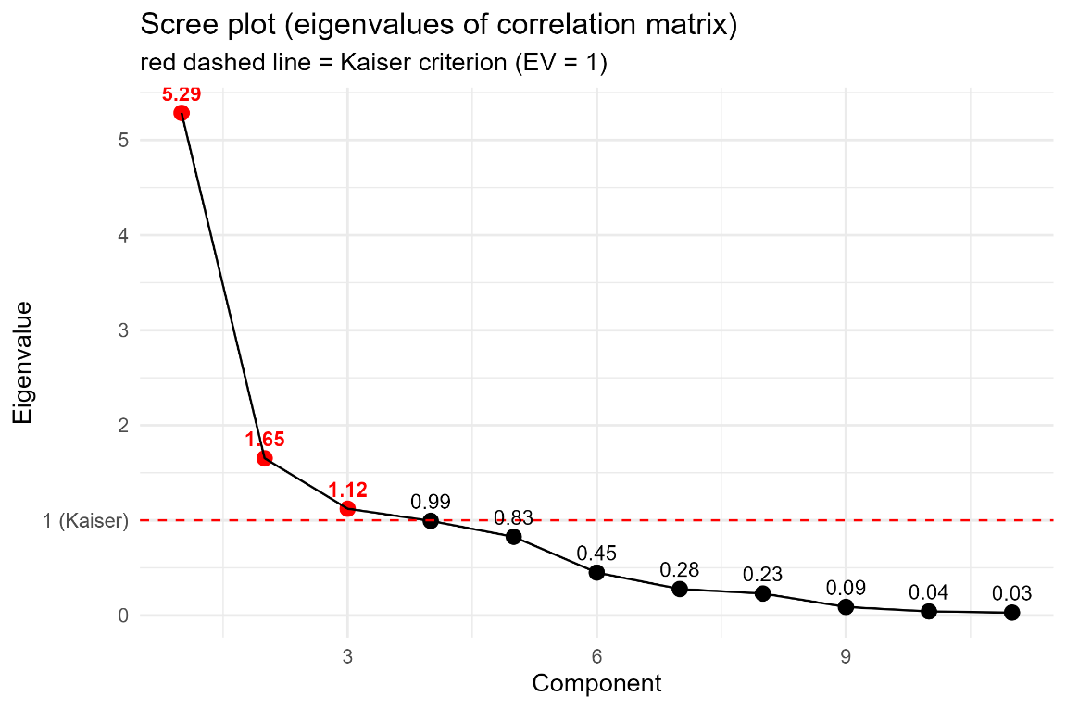

Fig. 25: Scree plot illustrating the optimal choice of number of components

(Although parallel analysis, according to Iacobucci et al. 2022, would ‘significantly outperform’ the applied methods for determining the number of components, it was not considered because more detailed statistical discussions were not part of this work.)

The PCA provided also the factor loadings (the correlation coefficients of the individual variables with the individual factors, explaining as much of the variance of the variables as possible) (Field et al. 2012), which are listed in the following table 9.

Table 11: Correlation coefficients (factor loadings) of each factor with each of the examined variables

|  |  |  |  |
| --- | --- | --- | --- |
| Variables | Component matrix  (3 components extracted) | | |
| Factor 1 | Factor 2 | Factor 3 |
| Chlorophyll | 0.729971 | 0.412098 | 0.412434 |
| Oxygen | 0.853331 | 0.006239 | -0.291845 |
| Phycocyanin | 0.72623 | 0.565755 | 0.20678 |
| Turbidity | 0.270467 | 0.528207 | -0.199149 |
| pH | 0.074939 | -0.253388 | 0.109449 |
| Water temp. | -0.43396 | -0.30503 | 0.788225 |
| Height amsl | -0.805949 | 0.36966 | -0.254994 |
| comp.2 | -0.846649 | 0.451192 | 0.081611 |
| comp.3 | 0.888059 | -0.165983 | -0.060651 |
| comp.4 | -0.774678 | 0.492191 | 0.096584 |
| Air temp. | 0.68934 | 0.341434 | 0.257917 |

The correlation coefficients with absolute values > 0.50, show which variable is closely related to which factors. These variables can be grouped together for each factor, with the factor itself acting as the representative. The table below provides a clearer illustration of the variables that correlated strongly with each factor (correlation coefficients with absolute values > 0.50).

Table 12: Variables that belong to the respective factor, that can be represented by the 3 factors.

|  |  |  |  |
| --- | --- | --- | --- |
| Variable | Component matrix  after sorting the factor loadings with a value > 0.50 | | |
| Factor 1 | Factor 2 | Factor 3 |
| Chlorophyll | 0.73 |  |  |
| Oxygen | 0.853 |  |  |
| Phycocyanin | 0.726 |  |  |
| Turbidity |  | 0.528 |  |
| pH |  |  |  |
| Water temp. |  |  | 0.788 |
| Height amsl | 0.806 |  |  |
| comp.2 | 0.847 |  |  |
| comp.3 | 0.888 |  |  |
| comp.4 | 0.775 |  |  |
| Air temp. | 0.689 |  |  |
| Principal component analysis, with 3 components extracted | | | |

Factor 1 is most strongly associated with most of the variables: Chlorophyll, oxygen, phycocyanin, hight above sea level, air temperature and comp.2, comp.3 and comp.4. It can therefore be understood as the representative of this group.

Factor 2 shows strong correlations with the parameter phycocyanin and turbidity and can therefore be considered their representative.

The third factor (factor 3), which can only explain 10.2% of the total variance, is related to the variable turbidity.

To better understand the significance of the contribution of the individual variables to the factors the plots below could be helpful:

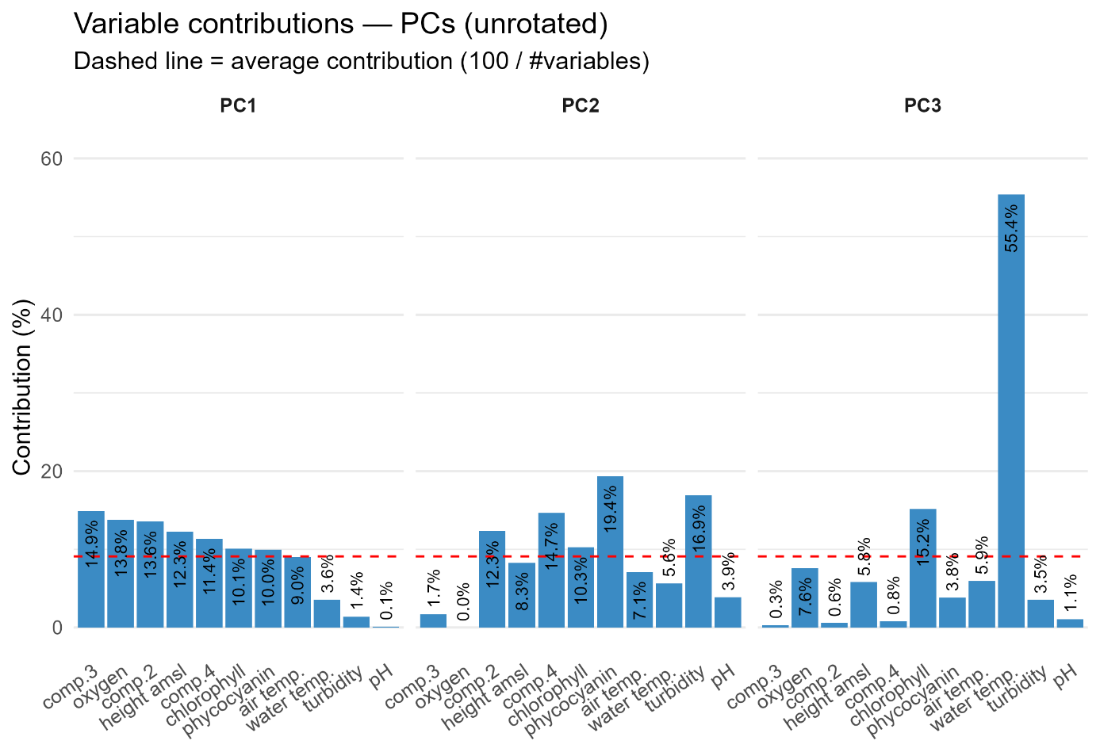

Fig. 26: Contribution plots for the three components

The factor loadings also determined the proportion of the variance of the individual variables that can be explained by the three factors. The table below shows the original variance for each parameter in its standardised form, which is equal to 1 in this case, and the proportion of this variance that can be explained by a linear combination of the three factors. This shows how good the factors explained the original data (communalities closer to 1) (Field et al. 2012).

Table 13: Variances of parameters examined in their standardised form before / after factor extraction of the 3 factors

|  |  |  |
| --- | --- | --- |
| **Communalities** | | |
| **Standardised variables** | **Initial** | **Extraction** |
| Chlorophyll | 1 | 0.872784 |
| Oxygen | 1 | 0.813386 |
| Phycocyanin | 1 | 0.890247 |
| Turbidity | 1 | 0.391815 |
| pH | 1 | 0.0818 |
| Water temp. | 1 | 0.902664 |
| Height amsl | 1 | 0.851224 |
| comp.2 | 1 | 0.927048 |
| comp.3 | 1 | 0.819878 |
| comp.4 | 1 | 0.851706 |
| Air temp. | 1 | 0.658288 |
| Extraction method: principal component analysis | | |

Low communality on the other hand, as for pH and turbidity, mean that the variable is poorly represented by the factors.

Finally, the PCA was visualized a biplot, in which the variables are represented as vector arrows, and the individual samples taken are represented as points (Lepš & Šmilauer, 2003).

The first two principal components or factors are used which explain most of the total variance in the data. The difference between the plots below is only the coloration of the samples (see Fig. 15, Fig. 16 and Fig. 17).

The Ellipses visualise the samples with the different sampling periods that means, the sampling at the Vestari-Jökulsá river in the north, sampling at the Virkisá river before and after the rain event. The Ellipses represent 95% confidence intervals assuming multivariate normality (t-distribution). Normality tests indicated that this assumption was not fully met so ellipses should mainly be interpreted as descriptive part of the plot.

The quantities of the different carbon variables were used to colour the individual samples (points in the biplot) with different colour scales by river, as the measured quantities are quite different per river (see 4.1 above).

The samples, also carry the site numbers and are shaped, depending on the time of day of the sampling, for samples taken in the morning (VM) as a triangle and samples taken in the afternoon (NM) as a dot).

The carbon parameters, DOC, BDOC and CO2 fluxes, were then added as supplementary variables in the visualisation (in blue), onto the component space and did not influence the extraction of the components in the PCA (Husson et al. 2010). That means these supplementary variables were plotted afterwards by correlating (Pearson) each variable with the (unrotated/varimax-rotated, see later) components in the biplot (Graffelman & Aluja-Banet, 2003). (Even though correlations with the extracted components varied and were only moderately or weakly represented on the main axes).

Concerning the arrows of the supplementary variables and the arrows of the variables extracted by the PCA: the maximal linear association is reflected by the direction of the arrows, while the quality of the representation by the components is indicated by the length (Graffelman & Aluja-Banet, 2003).

In the biplot of the first two principal components (factors), several variables are clearly separated from each other. Turbidity, Phycocyanin, Chlorophyll, Air temperature and Oxygen and comp.3 load on the positive side and show a close alignment. Height amsl, comp.2 and comp.4, on the other hand, lie on the negative side of the same axis. PH is close to the origin because it is only weakly represented by the first two principal components. The samples are grouped along these gradients: on the left are samples with higher altitude and comp. values, on the right are samples with higher chlorophyll, Phycocyanin, turbidity and air temperature values.

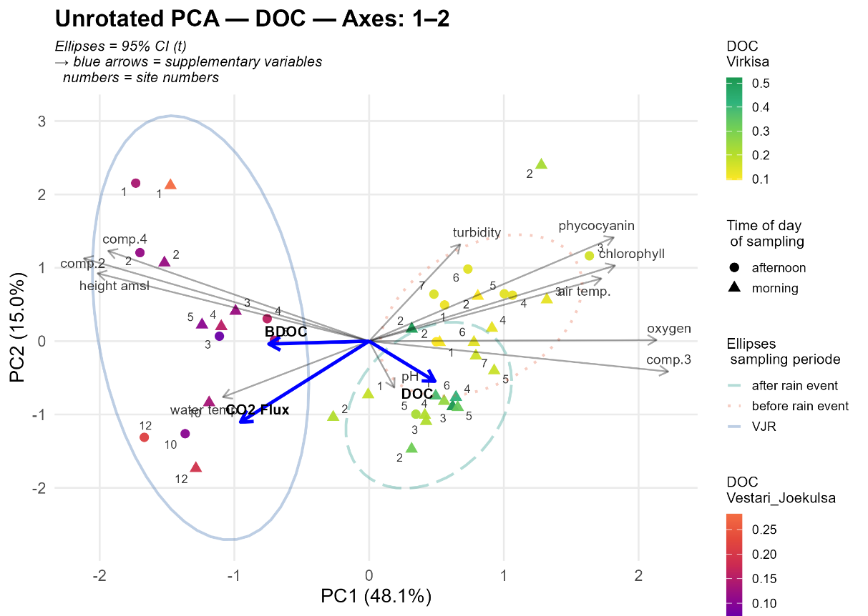

Fig. 27: unrotated PCA biplot PC1 & PC2, coloured by DOC quantities

The blue ellipse (samples taken in the week at the VJR, left side) groups samples that are strongly characterised by altitude and components 2 and 4 values.

The ellipse of the samples before the rain event, on the right, groups samples with high chlorophyll, phycocyanin, turbidity and air temperature values.

The ellipse with the samples after the rain, is more centred around pH values.

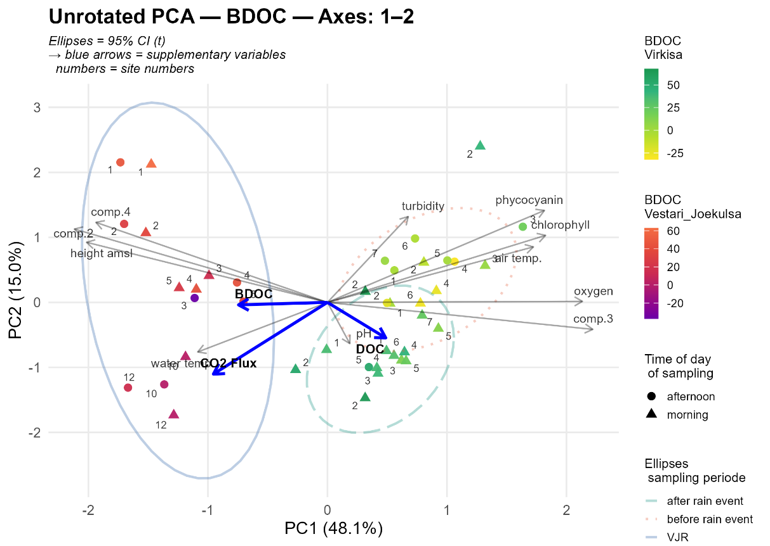

Fig. 28: unrotated PCA biplot PC1 & PC2, coloured by BDOC quantities

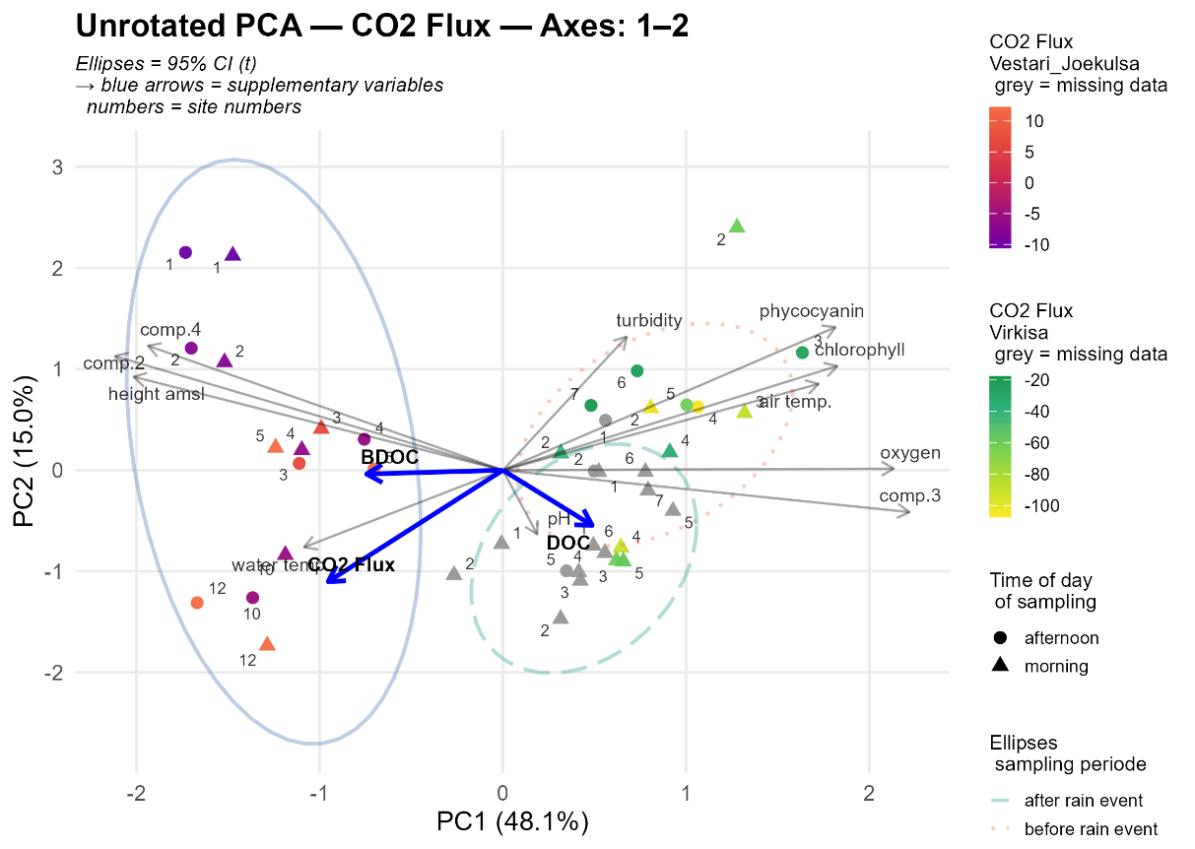

Fig. 29: unrotated PCA biplot PC1 & PC2, coloured by CO2  quantities

Determination of factor loadings after application of a rotation

The aim of the rotation principle in factor analysis is to maintain simpler and more easily interpretable factor loadings while retaining the factor solution achieved in the principal component analysis (Reyment and Jöreskog, 1993).

In the factor analysis of the present study the varimax method is selected and applied as the rotation technique. The aim of this method is to minimise the number of variables that have very high correlation coefficients (loadings) with a factor, as this increases and facilitates the interpretability of the factors (Field et al. 2012). After applying the Varimax rotation method, the factor loadings looked as follows:

Table 14: Variables that can be well represented by the three factors after applying Varimax rotation.

|  |  |  |  |
| --- | --- | --- | --- |
|  | **Component matrix**  **after Varimax rotation**  **and sorting of factor loadings with a value > 0.50** | | |
| **Variable** | **Faktor 1** | **Faktor 2** | **Faktor 3** |
| Chlorophyll |  | 0.9 |  |
| Oxygen | 0.692 |  |  |
| Phycocyanin |  | 0.885 |  |
| Turbidity |  |  |  |
| pH |  |  |  |
| Water temp. |  |  | 0.916 |
| Height amsl | 0.817 |  |  |
| comp.2 | 0.944 |  |  |
| comp.3 | 0.795 |  |  |
| comp.4 | 0.916 |  |  |
| Air temp. |  | 0.752 |  |

The rotation contribution to the structure of the factors is illustrating in the following plots.

In the rotated biplot (Varimax rotation), the variables are grouped different:

Height amsl, comp.2 and comp.4 load on the positive side of Dim1/component 1.

Chlorophyll, phycocyanin and Air temperature are in the upper quadrant and are closely clustered.

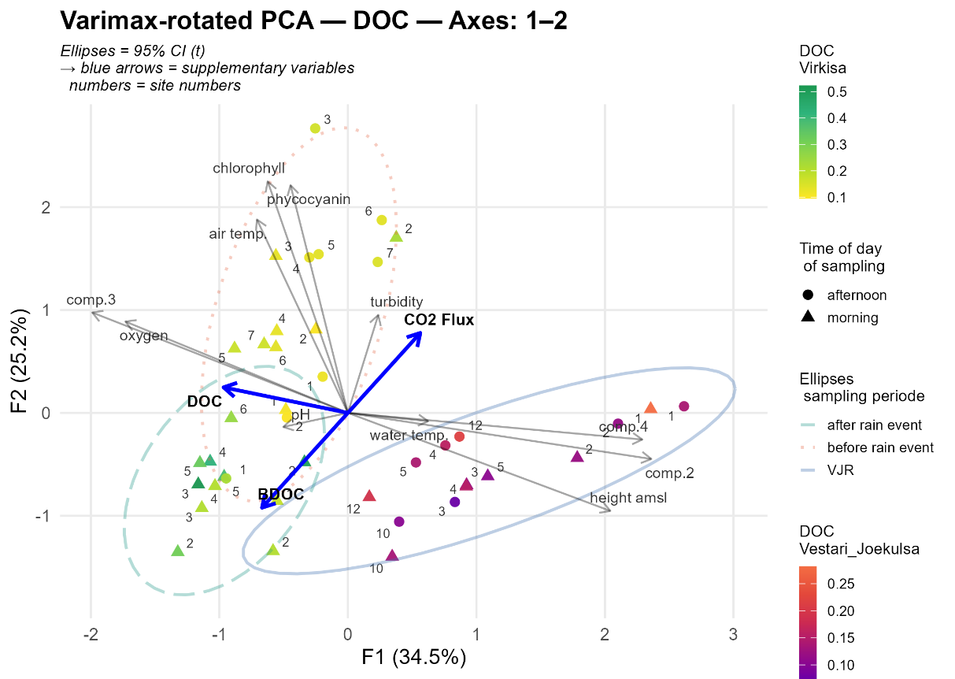

Fig. 30: varimax-rotated PCA biplot PC1 & PC2, coloured by DOC

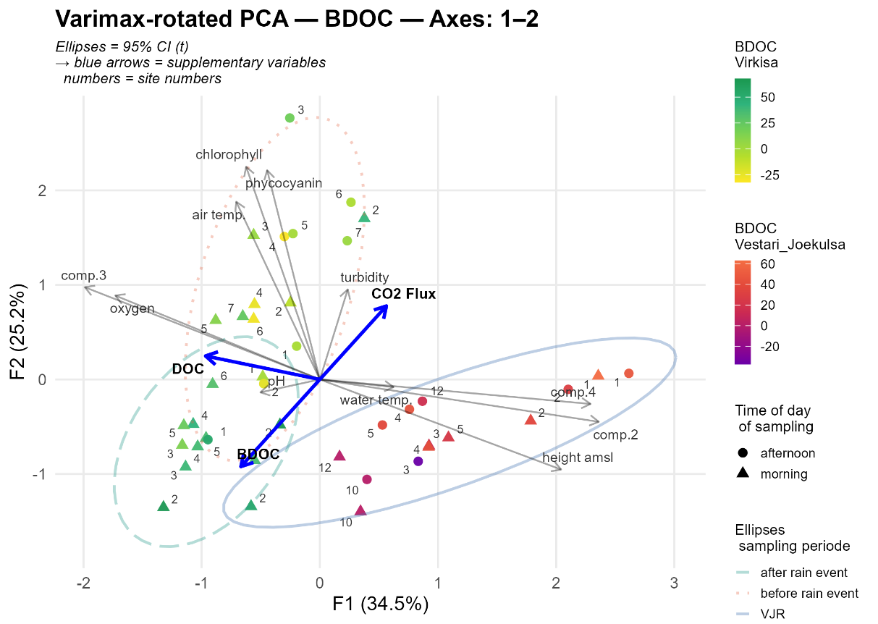

Fig. 31: varimax-rotated PCA biplot PC1 & PC2, coloured by BDOC quantities

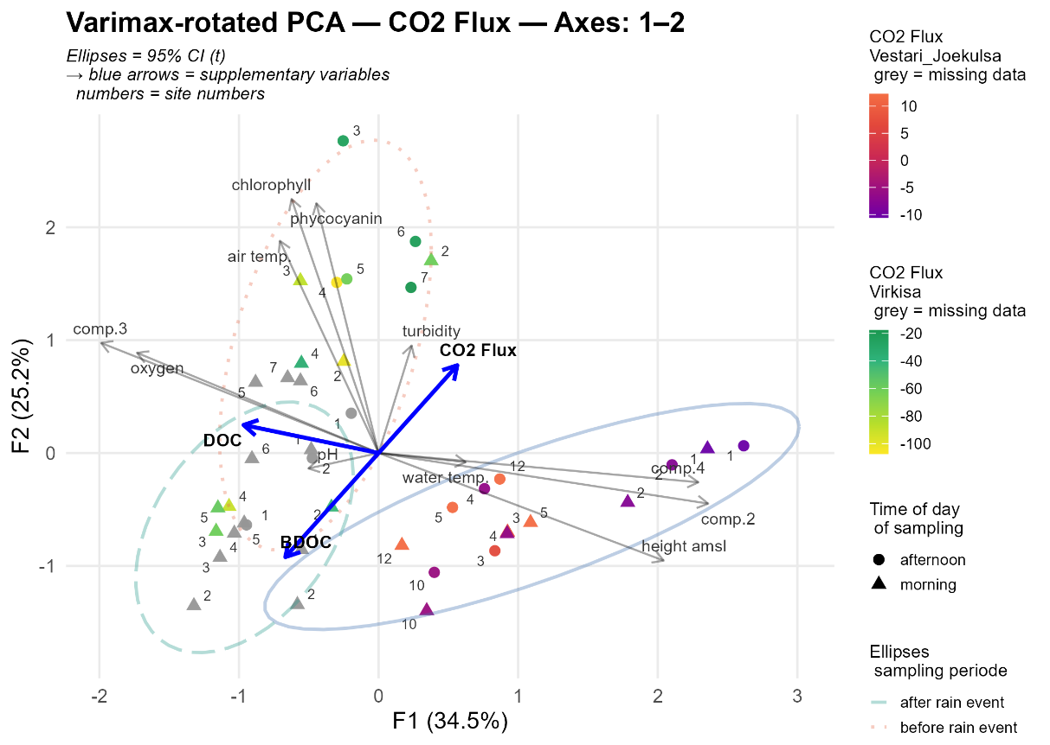

Fig. 32: varimax-rotated PCA biplot PC1 & PC2, coloured by CO2

Examination of the differences between the two rivers

Finally, the differences between the two rivers in the three factors, determined by the factor analysis using the principal components and Varimax rotation, were examined:

A Multivariate analysis of variance (MANOVA) was performed with the scores of the first three once unrotated and once rotated factors as dependent variables (PC1–PC3). The influencing variables were the rivers (VJR and VR). For testing the global effect of the rivers on the factor scores the Wilks' test of significance (lambda test) was used, whereas for the simple effects univariate F-Tests were performed.

Multivariate Analysis of Variance on the scores of unrotated factors

Dependent variables: Scores of Factor1, Factor2 and Factor3 (from factor analysis)

Factor: River (2 levels)

41 cases accepted.

EFFECT .. RIVER

Multivariate Tests of Significance (Wilks)

Wilks Lambda = 0.10331 F(3, 37) = 107.04405 p < 0.0001

------------------------------------------------------------------------------------

Univariate F-tests with (1; 39) D.F.

Variable Hypoth.SSError.SS Hypoth.MS Error.MS F Sig.

FAKTOR1 34.48126 5.51874 34.48126 0.14151 243.67326 < 0.0001

FAKTOR2 0.74660 39.25340 0.74660 1.00650 0.74178 0.3944

FAKTOR3 0.63959 39.36041 0.63959 1.00924 0.63373 0.4308

Multivariate Analysis of Variance on the scores of rotated factors

Dependent variables: Scores of Factor1, Factor2 and Factor3 (from factor analysis)

Factor: River (2 levels)

41 cases accepted.

EFFECT .. RIVER

Variant: Varimax rotated

Multivariate Tests of Significance (Wilks)

Wilks Lambda = 0.10331 F(3, 37) = 107.04405 p = < 0.0001

------------------------------------------------------------------------------------

Univariate F-tests with (1; 39) D.F.

Variable Hypoth.SSError.SS Hypoth.MS Error.MS F Sig.

FAKTOR1 26.70054 13.29946 26.70054 0.34101 78.29800 < 0.0001

FAKTOR2 6.32696 33.67304 6.32696 0.86341 7.32786 0.01002

FAKTOR3 2.83995 37.16005 2.83995 0.95282 2.98056 0.09218

Regarding the unrotated PCA, multivariate variance analyses revealed a significant global river effect both on the unrotated factor scores (Wilks: F(3, 37) = 107.04, p < 0.0001), and the Varimax-rotated factor scores as well (Wilks: F(3, 37) = 107.04, p < 0.0001).

~~Regarding the unrotated PCA, the variance analysis revealed a significant river effect (variant: unrotated; Wilks: F(3, 37) = 107.04, p < 0.0001), which only has a univariate effect on factor 1 (p < 0.05). For the Varimax-rotated PCA the univariate effect was on factor 1 and factor 2 (p < 0.05).~~

Univariate F-tests for the simple effects showed that by the scores of the unrotated factors the river effect was only significant on the Factor 1 (p < 0.001), i.e. Factor 1 differ significantly between the two rivers, whereas Factors 2 and 3 did not.

For the sores of the varimax-rotated factors the univariate tests revealed significant differences both in Factor 1 (p < 0.001) and Factor 2 (p = 0.01), while Factor 3 was not significantly different (p = 0.09).

For a better impression of the river effects on the factors the factor scores were displayed for each river separately in box plots. Box plots visuallysummarize the distribution characteristics: the minimum, first quartile (25th percentile), median (50th percentile), third quartile (75th percentile), maximum, interquartile range and whiskers extending the minimum and maximum values.

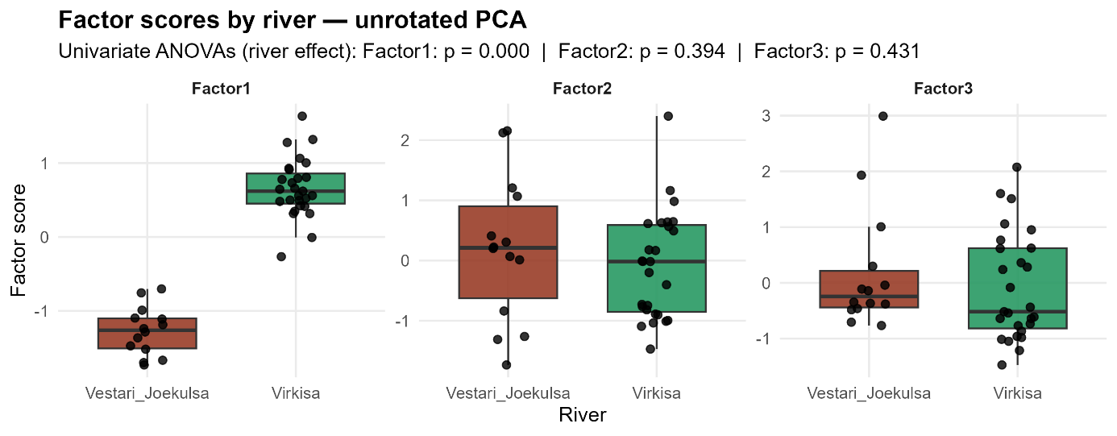

Fig. 33: Factor score by river (unrotated PCA)

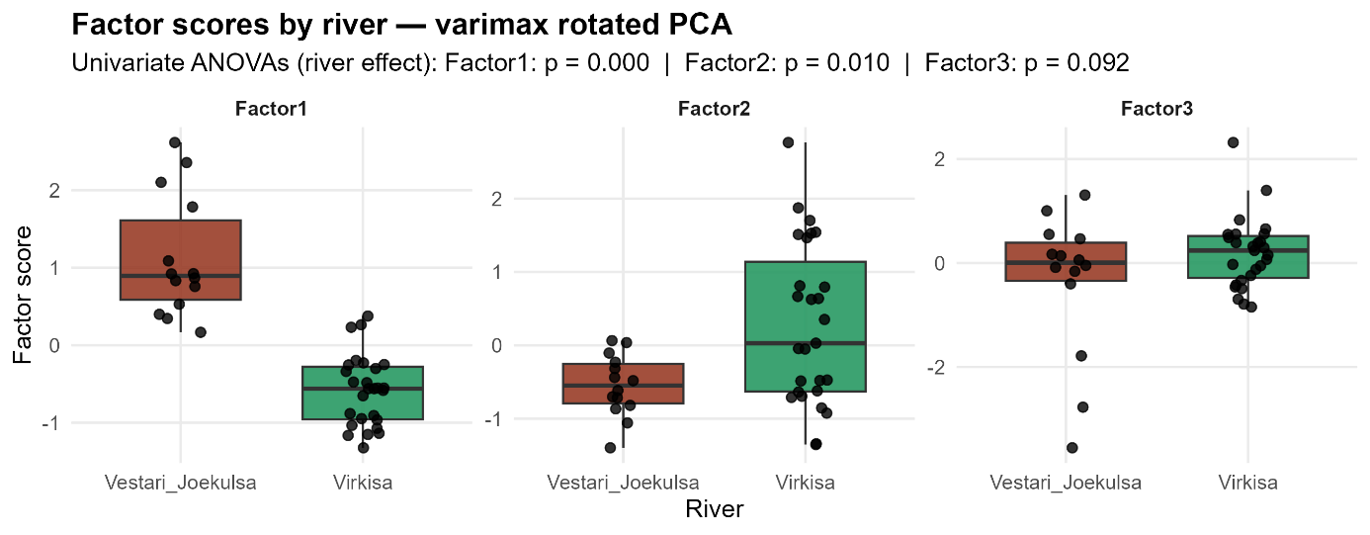

Fig. 34: Factor score by river (varimax rotated PCA)

# Summary of Key Differences Between Rivers

The comparison revealed systematic differences in DOC levels, lability (BDOC%), and DOM quality, likely driven by catchment characteristics and glacier type.

# Discussion

Some parameters differed between morning and afternoon samples.

-> may reflect changes in temperature, light, or biological activity.

CO2

Von Chatty: In their flux calculations, Boodoo et al. (2017) estimate the molar volume of CO₂ using the ideal gas law in the form Vm=RTpVm​=pRT​, where RR is the universal gas constant and pp the atmospheric pressure. While CO₂ is not a perfectly ideal gas, this approximation is considered valid under ambient pressure and temperature conditions commonly found in field studies. The authors do not explicitly justify the use of the ideal gas law, but its application is implied in their method description.

# Interpretation of Results

- Explanation of what the findings indicate about DOC and BDOC levels in the two rivers.

Concerning the CO2 fluxes

The use of the ideal gas law and the assumption of a constant atmospheric pressure of 1013.25 hPa across all sites represent methodological simplifications applied in this study. While this simplification is commonly applied (e.g., Boodoo et al. 2017, Lorke et al. 2015), it may introduce minor inaccuracies, particularly at higher altitudes (e.g., ~900 m a.s.l. at the first 5 sampling points of VJR in the highlands). However, given the overall uncertainties in flux measurements, these effects are considered negligible in the context of this study. *Future work could improve accuracy by incorporating site-specific pressure data and corrections for non-ideal gas behavior, especially in more extreme environmental settings.*

It would be preferable to analyse also the fluorescence of the DOM samples without delay, but it is not logistically possible. (Barker et al. 2013)

*Observations*

*in reservoirs and river impoundments revealed that*

*the enhanced sedimentation of particulate organic matter can*

*make these zones emission hot spots*

# Comparison with Existing Literature

- How the results align or contrast with previous studies.

# Factors Influencing DOC and BDOC

- Discussion of environmental or climatic factors affecting the observed concentrations.

# Implications for Carbon Cycling

- The role of glacial rivers in regional and global carbon budgets.

- Potential impacts on downstream ecosystems.

Research indicates that, on a global scale, glaciers supply ancient, BDOC, downstream, into both riverine and oceanic trophic networks (e.g., Hood et al., 2009; Fellman et al., 2015; Holt, McKenna et al., 2024). Despite its aged character, the pronounced bioavailability of glacier DOC is likely driven largely by relatively young organic carbon produced in situ by microbial communities on the glacier surface. (Holt, Fellman et al. 2024)

As glaciers retreat and their contribution of glacier DOC decreases—while stream conditions increasingly favour microbial growth (e.g., Hood et al., 2015; Kohler et al., 2024)—the main source of bioavailable modern OC is expected to shift from glacier‑derived inputs (e.g., algal production on glacial surfaces) to in‑stream production. (Holt, Fellman et al. 2024)

Also, for example, vegetation expansion that follows the retreat of glaciers also results in alterations to the composition of the DOC. (Robinson et al. 2023)

# Limitations of the Study

- Reflection on methodological or data limitations.

- Impact of limitations on the study's conclusions.

# Conclusion

# Summary of Key Findings

- Recap of the main results and their significance.

# Answers to Research Questions

- Direct responses to the objectives and questions posed in Chapter 1.

# Recommendations for Future Research

- Suggestions for further studies to build on your findings.

# Final Remarks

- Concluding thoughts on the importance of the study.

---

# References / Bibliography

Literaturverzeichnis aus Citavi “Island” offline kopieren

Beispiele

AK Wild: Mail Literatur. In:

Boulton, G. S. a. Spring, U. (1986): Isotopic Fractionation at the Base of Polar and Sub-Polar Glaciers. In: Journal of Glaciology 32, 475–485.

Bradley, J. A.; Trivedi, C. B.; Winkel, M.; Mourot, R.; Lutz, S.; Larose, C.; Keuschnig, C.; Doting, E.; Halbach, L.; Zervas, A.; Anesio, A. M. a. Benning, L. G. (2023): Active and dormant microorganisms on glacier surfaces. In: Geobiology 21, 244–261.

Cai, X.; Lei, S.; Li, Y.; Li, J.; Xu, J.; Lyu, H.; Li, J.; Dong, X.; Wang, G. a. Zeng, S. (2024): Humification levels of dissolved organic matter in the eastern plain lakes of China based on long-term satellite observations. In: Water research 250, 120991.

Chifflard, P.; Boodoo, K. S.; Ditzel, L.; Reiss, M. a. Fasching, C. (2024): Icelandic glacial dissolved organic carbon fluxes, composition and variability - relevance for the global glacial carbon budget. In: The Science of the total environment 957, 177366.

Chifflard, P.; Fasching, C.; Reiss, M.; Ditzel, L. a. Boodoo, K. S. (2019): Dissolved and Particulate Organic Carbon in Icelandic Proglacial Streams: A First Estimate. In: Water 11, 748.

Coble, P. G. (1996): Characterization of marine and terrestrial DOM in seawater using excitation-emission matrix spectroscopy. In: Marine Chemistry, 325–346.

Gabor, R. S.; Baker, A.; McKnight, D. M. a. Miller, M. P. (2014): Fluorescence Indices and Their Interpretation. In: Coble, P. G. (ed.): Aquatic organic matter fluorescence. Cambridge environmental chemistry series. New York, 303–338.

Haan, H. D. a. Boer, T. de (1987): Applicability of ligth absorbance and fluorescence as measures of concentration and molecular size of dissolved organic carbon in humic lake Tjeukemeer. In: Pergamon Journals Ltd, 731–734.

McKnight, D. M.; Boyer, E. W.; Westerhoff, P. K.; Doran, P. T.; Kulbe, T. a. Andersen, D. T. (2001): Spectrofluorometric characterization of dissolved organic matter for indication of precursor organic material and aromaticity. In: Limnology and Oceanography 46, 38–48.

Murphy, K. R.; Stedmon, C. A.; Graeber, D. a. Bro, R. (2013): Fluorescence spectroscopy and multi-way techniques. PARAFAC. In: Analytical Methods 5, 6557.

NATURAL EARTH (2024): NATURAL EARTH. https://www.naturalearthdata.com/downloads/.

Ó Dochartaigh, B. É.; MacDonald, A. M.; Black, A. R.; Everest, J.; Wilson, P.; Darling, W. G.; Jones, L. a. Raines, M. (2019): Groundwater–glacier meltwater interaction in proglacial aquifers. In: Hydrology and Earth System Sciences 23, 4527–4539.

Ohno, T. (2002): Fluorescence Inner-Filtering Correction for Determining the Humification Index of Dissolved Organic Matter. In: Environmental Science & Technology 36, 742–746.

Pain, A. J.; Martin, J. B.; Martin, E. E.; Rahman, S. a. Ackermann, P. (2020): Differences in the Quantity and Quality of Organic Matter Exported From Greenlandic Glacial and Deglaciated Watersheds. In: Global Biogeochemical Cycles 34.

Panique-Casso, D. G.; Goethals, P. a. Ho, L. (2024): Modeling greenhouse gas emissions from riverine systems: A review. In: Water research 250, 121012.

Phillips, E.; Finlayson, A.; Bradwell, T.; Everest, J. a. Jones, L. (2014): Structural evolution triggers a dynamic reduction in active glacier length during rapid retreat: Evidence from Falljökull, SE Iceland. In: Journal of Geophysical Research: Earth Surface 119, 2194–2208.

R Core Team (2022): R: A Language and Environment for Statistical Computing. In: . https://www.R-project.org/.

Singer, G. A.; Fasching, C.; Wilhelm, L.; Niggemann, J.; Steier, P.; Dittmar, T. a. Battin, T. J. (2012): Biogeochemically diverse organic matter in Alpine glaciers and its downstream fate. In: Nature Geoscience 5, 710–714.

Spencer, R. G. M.; Vermilyea, A.; Fellman, J.; Raymond, P.; Stubbins, A.; Scott, D. a. Hood, E. (2014): Seasonal variability of organic matter composition in an Alaskan glacier outflow: insights into glacier carbon sources. In: Environmental Research Letters 9, 55005.

St Pierre, K. A.; St Louis, V. L.; Schiff, S. L.; Lehnherr, I.; Dainard, P. G.; Gardner, A. S.; Aukes, P. J. K. a. Sharp, M. J. (2019): Proglacial freshwaters are significant and previously unrecognized sinks of atmospheric CO2. In: Proceedings of the National Academy of Sciences of the United States of America 116, 17690–17695.

Taylor & Francis (2024): TRACING THE HYDROLOGICAL CYCLE | 9 | Environmental Isotopes in Hydroge. https://www.taylorfrancis.com/chapters/mono/10.1201/9781482242911-9/tracing-hydrological-cycle-ian-clark-peter-fritz (date: 01.06.2024).

VEÐURSTOFA ÍSLANDS (O.J.) (2024): Tímaraðir fyrir valdar veðurstöðvar. https://www.vedur.is/vedur/vedurfar/medaltalstoflur.

Wild, A.-K.: How to_Wasserprobe und Filtrieren. In:

https://kort.gis.is/mapview/?app=kort&l=en&c=480843,336277&z=7.4&ls=4199,1056,4146,4056,4165,1053&op=4146_1,4056_0.41,4165_1&lo=8096_2,3878_12,3879_509,3915_510,3911_13,4344_30,4345_948,4347_949,4348_950,4346_951,4516_952,4517_953,3939_516,3929_567,3905_37,4893_40,4895_827,4894_828,3920_593,3883_43,3945_602,4178_517,4179_518,3910_49,4755_57,3918_652,3895_64,6943_66,6944_725,3909_68,3923_662,3906_83,3894_120,6229_125,6230_1006,3930_677,3890_127,3913_688,3907_130,3893_138,3935_690,3928_692,3943_720,3921_724,3908_154,3926_733,3932_744,3898_162,3933_787,3888_173,3901_308,3892_311,3919_809,3886_313,8140_319,6231_325,6232_1007,3904_327,3924_812,3891_433,3927_679,3917_823,3914_826,3889_447,3916_844,3902_475,3882_482,3949_874,3885_499,5840_507,3925_947,3944_962,3931_991,3946_999,3941_1005,3922_1048,4091_963,4029_875,3977_964,4021_876,3974_1008,4036_966,4004_746,4359_967,4001_968,4022_969,4003_970,4170_971,4047_972,3979_973,4006_974,4177_975,3980_976,3982_977,4007_978,4015_979,4008_980,4020_981,4099_982,3967_983,4026_984,3995_693,3984_694,4000_695,3993_696,4355_697,4071_698,4013_699,4098_700,4066_701,4002_702,4009_703,3990_704,4028_705,3985_1009,3950_1010,3951_1011,3955_1012,3952_1013,4024_1014,3956_1015,3957_1016,3986_1017,3953_1018,3987_1019,3962_1020,4065_1021,5703_1049,3958_1050,3964_788,7440_789,4253_790,4256_1022,4258_519,4257_663,3968_664,4084_665,4259_680,4260_594,3999_595,7442_596,3969_681,3961_520,4109_597,3998_598,4261_791,7456_792,4005_726,4262_727,7446_728,7445_729,7449_1023,7448_1024,4263_1051,4264_1052,4416_603,4417_604,3971_691,4418_605,5618_606,4909_607,4419_608,4191_721,3972_793,4336_815,4335_816,3975_817,3983_877,3996_1025,5841_829,4111_521,4012_830,4033_846,4018_847,4042_848,4265_849,4010_850,4073_851,4092_852,7444_853,4074_854,4011_855,4085_856,4037_857,3988_858,4156_859,4038_860,4266_861,7443_862,4048_863,4080_831,4267_832,7447_864,4016_794,4017_795,4054_609,4105_610,7468_611,4086_612,4268_613,4269_614,4062_615,4063_616,4270_617,7471_618,7470_619,7469_620,4271_621,7472_622,4064_623,4093_624,4272_625,4157_626,4273_627,7473_628,7476_629,7475_630,7474_631,4274_632,4106_633,7503_634,7502_635,7501_636,7477_637,4175_638,7482_639,4087_640,4151_641,4055_796,4097_992,7632_713,4070_714,4108_715,4077_716,7467_878,7465_879,7464_880,7463_881,4110_882,4082_883,4107_884,4083_885,4275_886,4075_887,4096_717,4100_718,4090_719,5643_954,5644_955,5641_956,6956_957,6955_958,6954_959,6953_960,6952_961,7457_522,4076_523,4153_524,7458_525,3970_526,4112_527,4088_528,4059_529,4094_530,4095_531,7451_532,7459_533,4276_534,4277_535,3965_536,7462_537,7461_538,7460_539,4625_888,4101_540,5048_666,4142_730,4141_731,4754_732,3973_689,4217_766,4202_767,4172_768,4166_769,4167_770,4168_771,4213_772,4214_773,4102_774,4040_775,3989_776,4039_777,4053_778,4078_779,4079_780,4173_781,4174_782,4176_783,4034_833,3994_784,4027_993,4061_834,4043_682,4041_541,4045_642,3963_599,4025_785,3959_994,4150_667,4067_643,4149_835,4146_683,4145_889,4143_542,4144_543,4160_786,4056_995,4165_996,4159_997,4164_890,4158_891,4046_892,4058_893,4216_836,4032_837,4044_838,4198_839,4196_840,4161_668,4035_669,3978_670,4283_671,3960_644,4057_645,4050_600,4155_601,4049_684,4278_685,4119_686,4181_687,8092_672,4244_673,4243_674,4245_544,4247_545,4248_1053,4246_1054,4242_1055,4249_675,4052_894,4187_653,3997_654,4781_646,4780_647,4777_648,4756_649,4775_650,4774_651,4215_1026,3991_1027,8108_546,8103_1028,4206_1029,4229_1030,8104_454,8105_455,4230_1031,4228_1032,4227_1033,8098_1034,4207_1035,8106_461,4205_1036,4209_678,4208_824,4200_825,4210_1000,4197_1001,4201_1002,4183_655,4370_656,4185_657,4369_658,4189_659,4188_660,4186_661,5060_797,8110_798,8111_799,8112_800,8109_801,4193_802,4192_803,7438_804,7439_805,5624_806,6857_895,6858_896,6859_897,6860_898,6861_899,6872_900,6871_901,6862_902,6863_903,6864_904,6865_905,6868_906,6867_907,6873_908,6869_909,6870_910,6874_911,6875_912,6876_913,4194_914,6877_915,6878_916,6879_917,6880_918,6881_919,6884_920,6883_921,6885_922,6891_923,6890_924,6889_925,6888_926,6887_927,6886_928,4195_929,7710_930,4948_1037,4949_1038,4339_1039,4250_1040,4204_1041,5061_1042,4212_1043,4203_1044,4252_1045,4280_1046,4219_985,4233_986,4222_987,4223_988,4224_989,4235_990,4237_547,4236_548,4238_549,4225_550,4226_551,4239_552,4240_553,4220_554,4221_555,3992_556,4232_511,4218_512,4231_513,4946_514,4234_557,5166_558,4211_515,4241_559,4279_807,4068_865,4295_866,4285_867,4291_868,4293_869,4072_870,4287_871,4284_560,4286_561,4281_562,3966_563,4282_564,4294_722,4289_998,4292_1047,4169_676,4296_808,4299_931,4310_841,8153_932,4309_933,4313_842,4311_934,4312_843,4298_935,4297_872,4307_873,4317_936,4304_937,4314_938,4303_939,4316_940,4315_941,4306_942,4302_943,4301_944,4300_945,4305_946,4319_734,5053_735,5054_736,4318_737,5055_738,5056_739,4290_740,5057_741,5058_742,4320_743,8097_723,8107_565,8100_471,8099_566,8101_473,8102_474,8139_818,8141_819,8142_820,8146_821,8147_822,8149_1003,8150_1004

https://kort.gis.is/mapview/?app=kort&l=en&c=492934,338082&z=6.4&ls=4199,1056,3993,4355,4146,4056,1053&op=3993_0.54,4355_1,4146_1,4056_0.55&lo=8096_2,3878_12,3879_509,3915_510,3911_13,4344_30,4345_948,4347_949,4348_950,4346_951,4516_952,4517_953,3939_516,3929_567,3905_37,4893_40,4895_827,4894_828,3920_593,3883_43,3945_602,4178_517,4179_518,3910_49,4755_57,3918_652,3895_64,6943_66,6944_716,3909_68,3923_662,3906_83,3894_120,6229_125,6230_1006,3930_677,3890_127,3913_679,3907_130,3893_138,3935_681,3928_683,3943_711,3921_715,3908_154,3926_724,3932_735,3898_162,3933_778,3888_173,3901_308,3892_311,3919_800,3886_313,8140_319,6231_325,6232_1007,3904_327,3924_803,3891_433,3927_814,3917_823,3914_826,3889_447,3916_844,3902_475,3882_482,3949_874,3885_499,5840_507,3925_947,3944_962,3931_991,3946_999,3941_1005,3922_1048,4091_963,4029_875,3977_964,4021_876,3974_1008,4036_966,4004_737,4359_967,4001_968,4022_969,4003_970,4170_971,4047_972,3979_973,4006_974,4177_975,3980_976,3982_977,4007_978,4015_979,4008_980,4020_981,4099_982,3967_983,4026_984,3995_684,3984_685,4000_686,3993_687,4355_688,4071_689,4013_690,4098_691,4066_692,4002_693,4009_694,3990_695,4028_696,3985_1009,3950_1010,3951_1011,3955_1012,3952_1013,4024_1014,3956_1015,3957_1016,3986_1017,3953_1018,3987_1019,3962_1020,4065_1021,5703_1049,3958_1050,3964_779,7440_780,4253_781,4256_1022,4258_519,4257_663,3968_664,4084_665,4259_815,4260_594,3999_595,7442_596,3969_816,3961_520,4109_597,3998_598,4261_782,7456_783,4005_717,4262_718,7446_719,7445_720,7449_1023,7448_1024,4263_1051,4264_1052,4416_603,4417_604,3971_682,4418_605,5618_606,4909_607,4419_608,4191_712,3972_784,4336_806,4335_807,3975_808,3983_877,3996_1025,5841_829,4111_521,4012_830,4033_846,4018_847,4042_848,4265_849,4010_850,4073_851,4092_852,7444_853,4074_854,4011_855,4085_856,4037_857,3988_858,4156_859,4038_860,4266_861,7443_862,4048_863,4080_831,4267_832,7447_864,4016_785,4017_786,4054_609,4105_610,7468_611,4086_612,4268_613,4269_614,4062_615,4063_616,4270_617,7471_618,7470_619,7469_620,4271_621,7472_622,4064_623,4093_624,4272_625,4157_626,4273_627,7473_628,7476_629,7475_630,7474_631,4274_632,4106_633,7503_634,7502_635,7501_636,7477_637,4175_638,7482_639,4087_640,4151_641,4055_787,4097_992,7632_704,4070_705,4108_706,4077_707,7467_878,7465_879,7464_880,7463_881,4110_882,4082_883,4107_884,4083_885,4275_886,4075_887,4096_708,4100_709,4090_710,5643_954,5644_955,5641_956,6956_957,6955_958,6954_959,6953_960,6952_961,7457_522,4076_523,4153_524,7458_525,3970_526,4112_527,4088_528,4059_529,4094_530,4095_531,7451_532,7459_533,4276_534,4277_535,3965_536,7462_537,7461_538,7460_539,4625_888,4101_540,5048_666,4142_721,4141_722,4754_723,3973_680,4217_757,4202_758,4172_759,4166_760,4167_761,4168_762,4213_763,4214_764,4102_765,4040_766,3989_767,4039_768,4053_769,4078_770,4079_771,4173_772,4174_773,4176_774,4034_833,3994_775,4027_993,4061_834,4043_817,4041_541,4045_642,3963_599,4025_776,3959_994,4150_667,4067_643,4149_835,4146_818,4145_889,4143_542,4144_543,4160_777,4056_995,4165_996,4159_997,4164_890,4158_891,4046_892,4058_893,4216_836,4032_837,4044_838,4198_839,4196_840,4161_668,4035_669,3978_670,4283_671,3960_644,4057_645,4050_600,4155_601,4049_819,4278_820,4119_821,4181_822,8092_672,4244_673,4243_674,4245_544,4247_545,4248_1053,4246_1054,4242_1055,4249_675,4052_894,4187_653,3997_654,4781_646,4780_647,4777_648,4756_649,4775_650,4774_651,4215_1026,3991_1027,8108_546,8103_1028,4206_1029,4229_1030,8104_454,8105_455,4230_1031,4228_1032,4227_1033,8098_1034,4207_1035,8106_461,4205_1036,4209_678,4208_824,4200_825,4210_1000,4197_1001,4201_1002,4183_655,4370_656,4185_657,4369_658,4189_659,4188_660,4186_661,5060_788,8110_789,8111_790,8112_791,8109_792,4193_793,4192_794,7438_795,7439_796,5624_797,6857_895,6858_896,6859_897,6860_898,6861_899,6872_900,6871_901,6862_902,6863_903,6864_904,6865_905,6868_906,6867_907,6873_908,6869_909,6870_910,6874_911,6875_912,6876_913,4194_914,6877_915,6878_916,6879_917,6880_918,6881_919,6884_920,6883_921,6885_922,6891_923,6890_924,6889_925,6888_926,6887_927,6886_928,4195_929,7710_930,4948_1037,4949_1038,4339_1039,4250_1040,4204_1041,5061_1042,4212_1043,4203_1044,4252_1045,4280_1046,4219_985,4233_986,4222_987,4223_988,4224_989,4235_990,4237_547,4236_548,4238_549,4225_550,4226_551,4239_552,4240_553,4220_554,4221_555,3992_556,4232_511,4218_512,4231_513,4946_514,4234_557,5166_558,4211_515,4241_559,4279_798,4068_865,4295_866,4285_867,4291_868,4293_869,4072_870,4287_871,4284_560,4286_561,4281_562,3966_563,4282_564,4294_713,4289_998,4292_1047,4169_676,4296_799,4299_931,4310_841,8153_932,4309_933,4313_842,4311_934,4312_843,4298_935,4297_872,4307_873,4317_936,4304_937,4314_938,4303_939,4316_940,4315_941,4306_942,4302_943,4301_944,4300_945,4305_946,4319_725,5053_726,5054_727,4318_728,5055_729,5056_730,4290_731,5057_732,5058_733,4320_734,8097_714,8107_565,8100_471,8099_566,8101_473,8102_474,8139_809,8141_810,8142_811,8146_812,8147_813,8149_1003,8150_1004

<https://vatnavefsja.vedur.is/#/mainmap>

<https://vatnavefsja.vedur.is/#/mainmap>

<https://kort.gis.is/mapview/?app=kort&lang=is>

<https://kort.gis.is/mapview/?app=kort>

<https://atlas.lmi.is/mapview/?application=DEM>

<https://dem.gis.is/mapview/?application=DEM>

<https://vatnavefsja.vedur.is/#/mainmap>

<https://gatt.natt.is/geonetwork/srv/eng/catalog.search#/metadata/477cdfa0-9b78-449b-ad93-a048f059ba7d>

3Dmodell Öfajökull

<https://atlas.lmi.is/3dmodel/Oraefa_w_Names/Oraefa_20181102.html>

<https://www.lmi.is/is/landupplysingar/haedargogn/haedarlikon>

Bodenkarte

<https://loftgaedasja.gis.is/mapview/?application=loftgaedasja>

# Appendices

## Supplementary Code and Data

The source code and data used in this thesis are available in the following public GitHub repository:

**GitHub Repository**: <https://github.com/kokkaso/MA_supplementary_Data>

* CO₂ Flux Calculations

## List of instruments, materials and software

* 1. Instruments

1. TOC - Total organic carbon analyzer

Shimadzu Corporation (2021): Total organic carbon analyzer (TOC analyzer), TOC-L CPN,

<https://www.shimadzu.co.uk/products/total-organic-carbon-analysis/toc-analysis/toc-l-series/index.html> (Accessed: 5 March 2025)

1. Spectrophotometer

Thermo Fisher Scientific Inc. (2013): GENESYS 10S UV-Visible Spectrophotometer,

<https://www.thermofisher.com/de/de/home/industrial/spectroscopy-elemental-isotope-analysis/molecular-spectroscopy/uv-vis-spectrophotometry/instruments/genesys-uv-vis-spectrophotometer.html> (Accessed: 5 March 2025)

1. Spectrofluorophotometer

Shimadzu Corporation (2024): Spectrofl­uorophotometer RF-6000, Shimadzu

<https://www.shimadzu.de/products/molecular-spectroscopy/fluorescence/fluorescence-spectroscopy/rf-6000/index.html> (Accessed: 5 March 2025)

1. EXO2 Sonde

YSI Inc. / Xylem Inc.(2025): EXO2 multiparameter Water Quality Sonde,

<https://www.ysi.com/exo2> (Accessed: 5 March 2025)

* 1. Software

QGIS.org (2024) QGIS Geographic Information System (Version 3.34 - Florence). Open-Source Geospatial Foundation. Available at: https://qgis.org (Accessed: 6 March 2025).

R Core Team (2024) R: A language and environment for statistical computing. Version 4.3.2. R Foundation for Statistical Computing. Available at: https://www.R-project.org (Accessed: 6 March 2025).

RStudio Team (2024) RStudio: Integrated development environment for R. Version 2024.03.0. Posit Software, PBC. Available at: https://posit.co (Accessed: 6 March 2025).

Field laboratories (for the Vestari-Jökulsá in Ingólfsskáli, picture above; for the Virkisá, picture below)

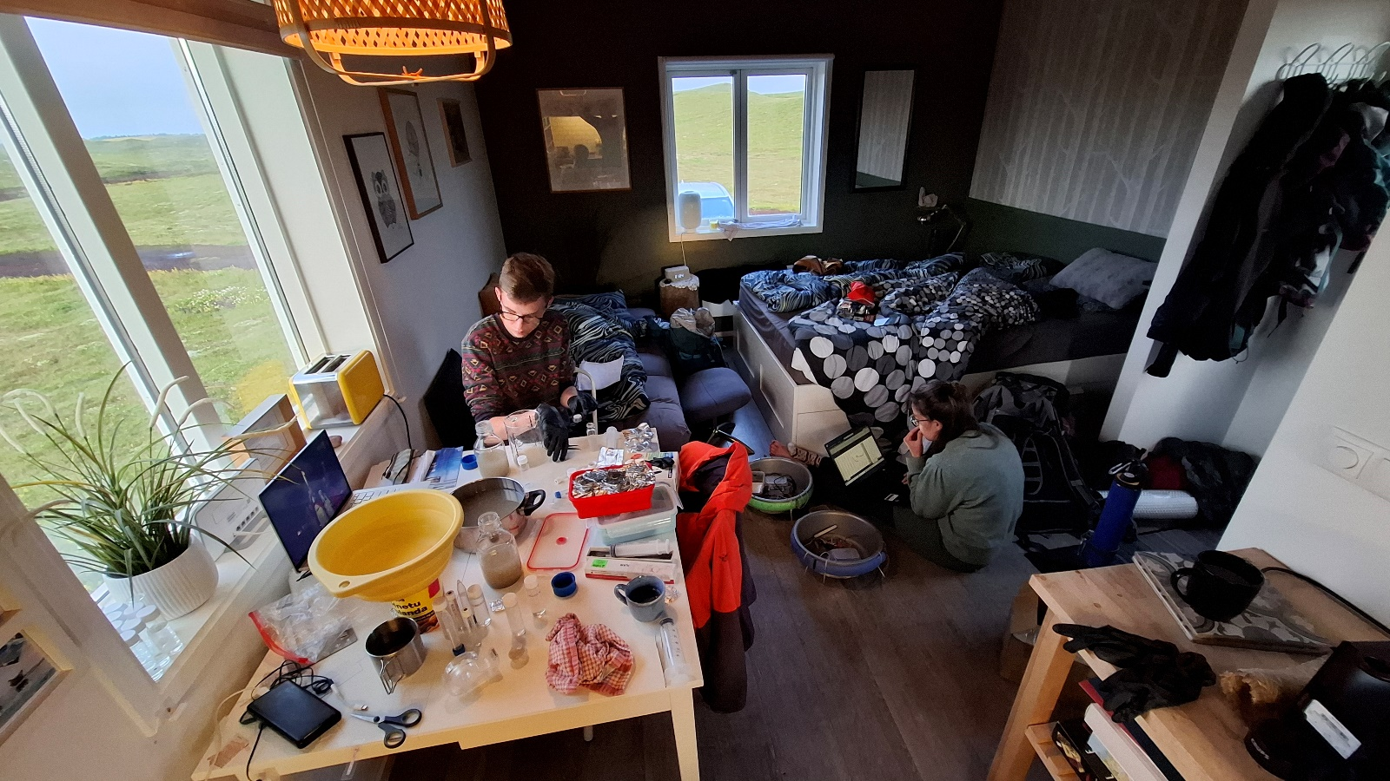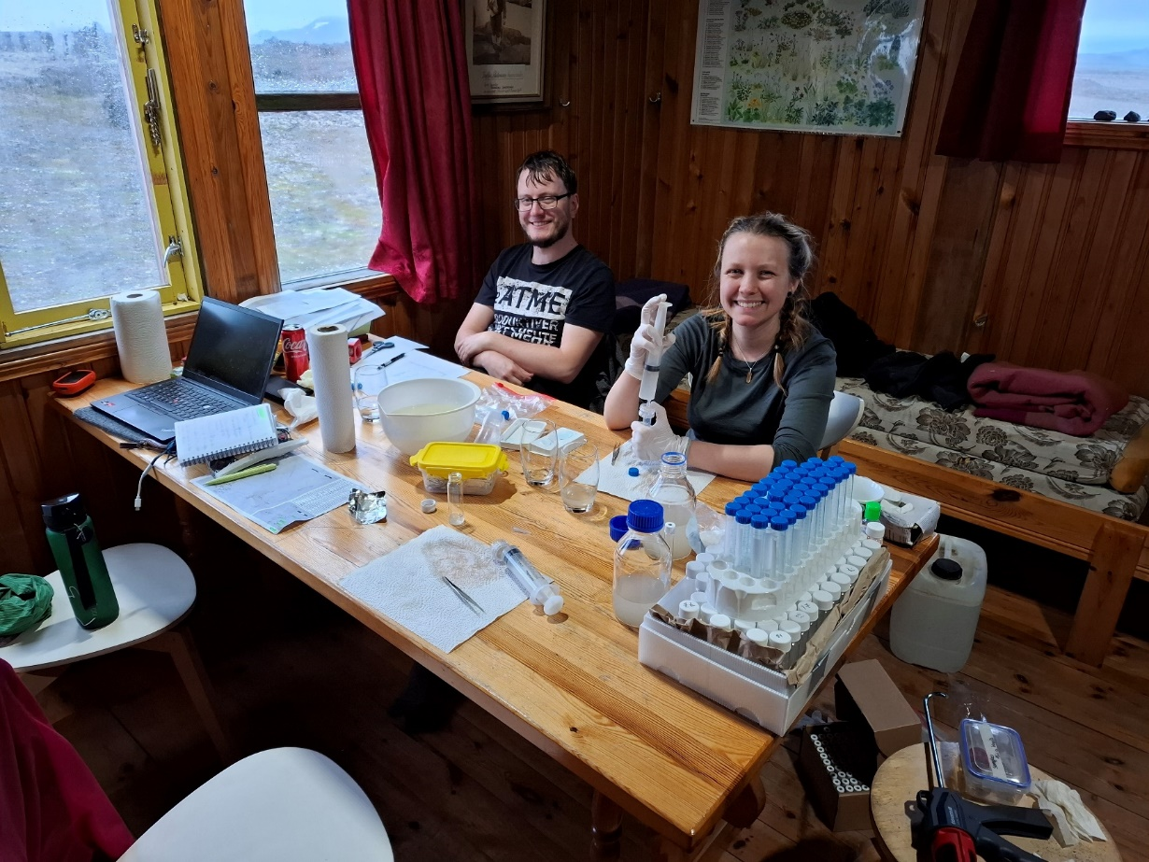

* 1. Artificial Intelligence (AI) and Large Language Models (LLM)
     1. DeepL Translate, Deepl SE: <https://www.deepl.com/translator>

Translation support

* + 1. ChatGPT (OpenAI, 2025)

Inspiration and coding support

## Impressions sampling sites

* 1. Vestari-Jökulsá River
  2. Virkisá River

## Co2-Logger Result

* 1. Vestari-Jökulsá River
  2. Virkisa River

## Weather station Data

* 1. Sáta (17.07 - 23.07.2024)

Name: Sáta

Station Nr.: 3054

Type: Automatic weather station

Lat.; Lon.: 65,06278; -18,83833

height: 785 m.a.s.l.

1Air temperature (1 min. average) [°C]

Maximum temperature (highest 1 min. average of the last hour) [°C]

Minimum temperature (lowest 1 min. average of the last hour) [°C]

Wind direction (10 min. average) [°]. N: 0°, E: 90°, S: 180°, W: 270°

Wind speed (10 min. average) [m/s]

Maximum 10 min. average wind speed of the last hour [m/s]

Maximum wind gust (3 sec value) [m/s]

Precipitation in the past hour [mm] (unprocessed data)

Excel Table - C:\Users\sophia\Dropbox\MASTER\1_Alicia\WETTER\wetterTabelle Alicia

Icelandic Meteorological Office 2025: Icelandic Meteorological Office Database, delivery no. 2025-03-10 11:04:16/IMO Self service of Weather observations

* 1. Skaftafell

Name: Skaftafell

Station Nr.: 6499

Type: Automatic weather station

Lat.; Lon.: 64,01437; -16,97212

height: 86 m.a.s.l.

1Air temperature (1 min. average) [°C]

Maximum temperature (highest 1 min. average of the last hour) [°C]

Minimum temperature (lowest 1 min. average of the last hour) [°C]

Wind direction (10 min. average) [°]. N: 0°, E: 90°, S: 180°, W: 270°

Wind speed (10 min. average) [m/s]

Maximum 10 min. average wind speed of the last hour [m/s]

Maximum wind gust (3 sec value) [m/s]

Precipitation in the past hour [mm] (unprocessed data)

Excel Table: - C:\Users\sophia\Dropbox\MASTER\3_AnnKathrin\WETTER

Icelandic Meteorological Office 2024: Icelandic Meteorological Office Database, delivery no. 2024-10-29 12:53:51/IMO Self service of Weather observations

## Master table

notebooks/Statistic/heatmap/heatmap_final.ipynb

<https://github.com/kokkaso/MA_supplementary_Data/blob/main/notebooks/Statistic/heatmap/heatmap_final.ipynb>

## Correlation Analysis Data

|  |  |  |  |  |  |  |
| --- | --- | --- | --- | --- | --- | --- |
| **Label** | **n** | **ShapiroW** | **p** | **Normality** | **suggested test** | **Significance** |
| **DOC (mg/L)** | 57 | 0.868 | 0.0000163 | no | Spearman | *** |
| **BDOC (%)** | 57 | 0.963 | 0.0772 | yes | Pearson | ns |
| **CO₂ flux** | 31 | 0.902 | 0.00799 | no | Spearman | ** |
|  |  |  |  |  |  |  |
| **Label** | **n** | **ShapiroW** | **p** | **Normality** | **suggested test** | **Significance** |
| **Air temp (°C)** | 57 | 0.963 | 0.0764 | yes | Pearson | ns |
| **Max temp (°C)** | 57 | 0.964 | 0.0864 | yes | Pearson | ns |
| **Min temp (°C)** | 57 | 0.954 | 0.0314 | no | Spearman | * |
| **Wind direction (°)** | 57 | 0.853 | 0.0000058 | no | Spearman | *** |
| **Wind speed (m/s)** | 57 | 0.856 | 0.00000717 | no | Spearman | *** |
| **Max avg wind (m/s)** | 57 | 0.859 | 0.00000894 | no | Spearman | *** |
| **Max gust (m/s)** | 57 | 0.858 | 0.0000085 | no | Spearman | *** |
| **Precipitation past hour (mm)** | 57 | 0.394 | 5.77E-14 | no | Spearman | *** |
|  |  |  |  |  |  |  |
| **Label** | **n** | **ShapiroW** | **p** | **Normality** | **suggested test** | **Significance** |
| **Chlorophyll (µg/L)** | 42 | 0.911 | 0.00309 | no | Spearman | ** |
| **Conductivity (µS/cm)** | 31 | 0.913 | 0.0156 | no | Spearman | * |
| **fDOM (RFU)** | 42 | 0.89 | 0.000743 | no | Spearman | *** |
| **Dissolved O₂ (mg/L)** | 42 | 0.688 | 3.67E-08 | no | Spearman | *** |
| **Specific Conductivity (µS/cm)** | 41 | 0.764 | 0.00000104 | no | Spearman | *** |
| **Phycocyanin (µg/L)** | 41 | 0.724 | 1.93E-07 | no | Spearman | *** |
| **TDS (mg/L)** | 41 | 0.811 | 0.0000092 | no | Spearman | *** |
| **Turbidity (FNU)** | 42 | 0.857 | 0.0000945 | no | Spearman | *** |
| **pH (-)** | 41 | 0.6 | 2.37E-09 | no | Spearman | *** |
| **Water temp (°C)** | 42 | 0.88 | 0.000381 | no | Spearman | *** |
|  |  |  |  |  |  |  |
| **Label** | **n** | **ShapiroW** | **p** | **Normality** | **suggested test** | **Significance** |
| **BIX** | 57 | 0.277 | 3.05E-15 | no | Spearman | *** |
| **PARAFAC b** | 57 | 0.944 | 0.0102 | no | Spearman | * |
| **PARAFAC t** | 56 | 0.337 | 1.78E-14 | no | Spearman | *** |
| **PARAFAC a** | 55 | 0.692 | 1.86E-09 | no | Spearman | *** |
| **PARAFAC m** | 56 | 0.286 | 5.16E-15 | no | Spearman | *** |
| **PARAFAC c** | 56 | 0.946 | 0.0148 | no | Spearman | * |
| **FI** | 55 | 0.178 | 6.24E-16 | no | Spearman | *** |
| **HIX** | 53 | 0.859 | 0.0000173 | no | Spearman | *** |
| **Absorbance at 254 nm** | 56 | 0.894 | 0.000136 | no | Spearman | *** |
| **Component 1 (%)** | 57 | 0.864 | 0.0000124 | no | Spearman | *** |
| **Component 2 (%)** | 57 | 0.807 | 3.56E-07 | no | Spearman | *** |
| **Component 3 (%)** | 57 | 0.872 | 0.0000229 | no | Spearman | *** |
| **Component 4 (%)** | 57 | 0.692 | 1.19E-09 | no | Spearman | *** |
| **Component 5 (%)** | 57 | 0.409 | 8.68E-14 | no | Spearman | *** |

Significance was classified as follows: * p < 0.05, ** p < 0.01, *** p < 0.001, ns = not significant.

## Correlation Analysis Heatmaps

1. Weather parameters

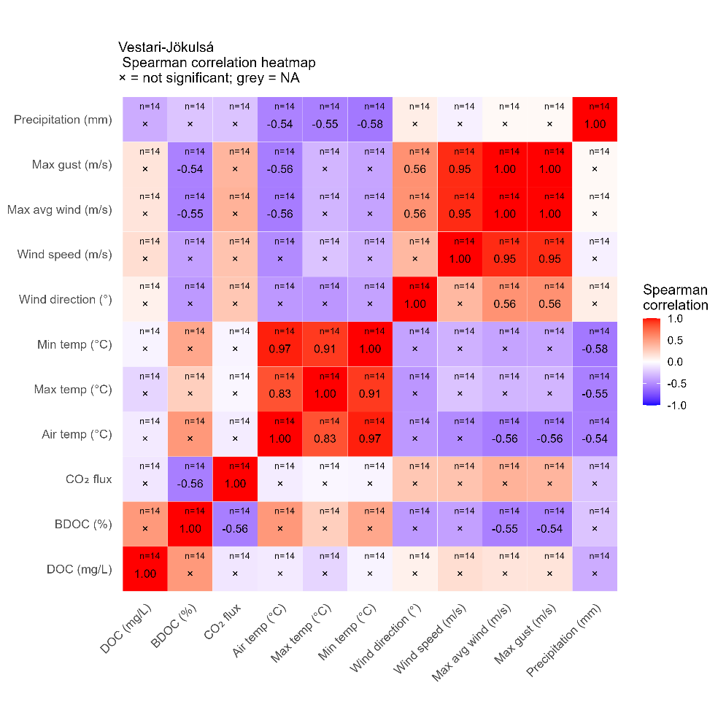

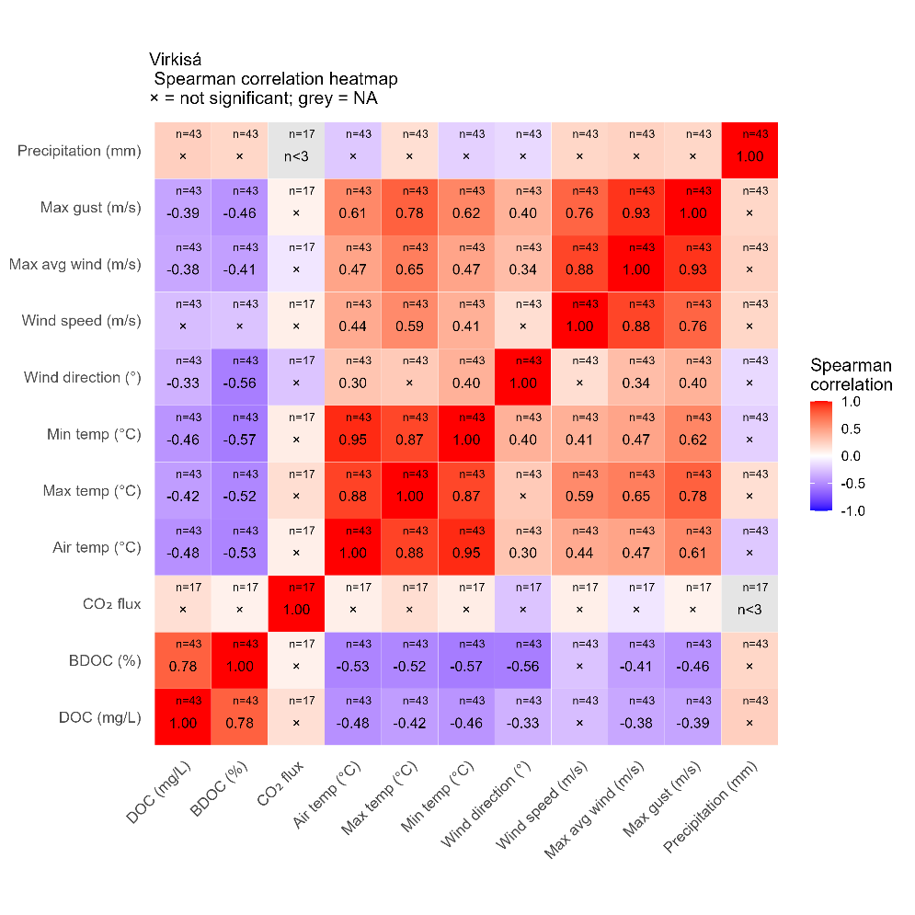

1. Environmental parameters

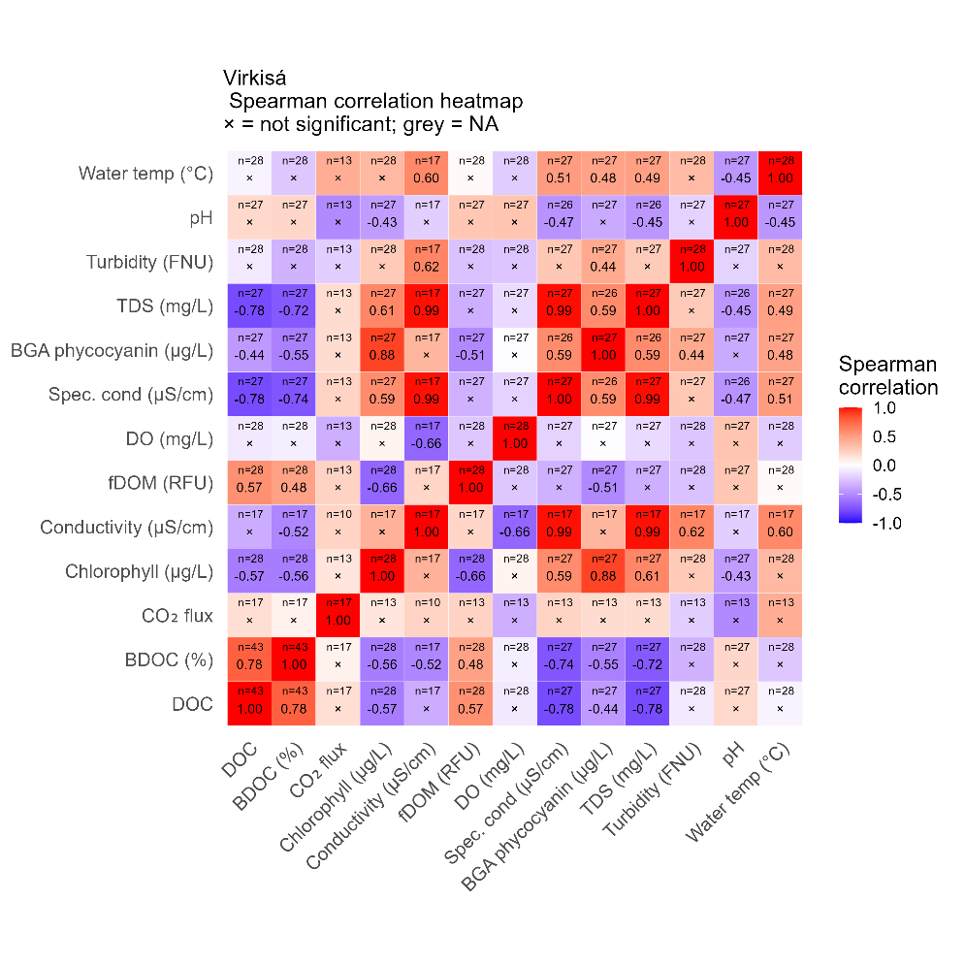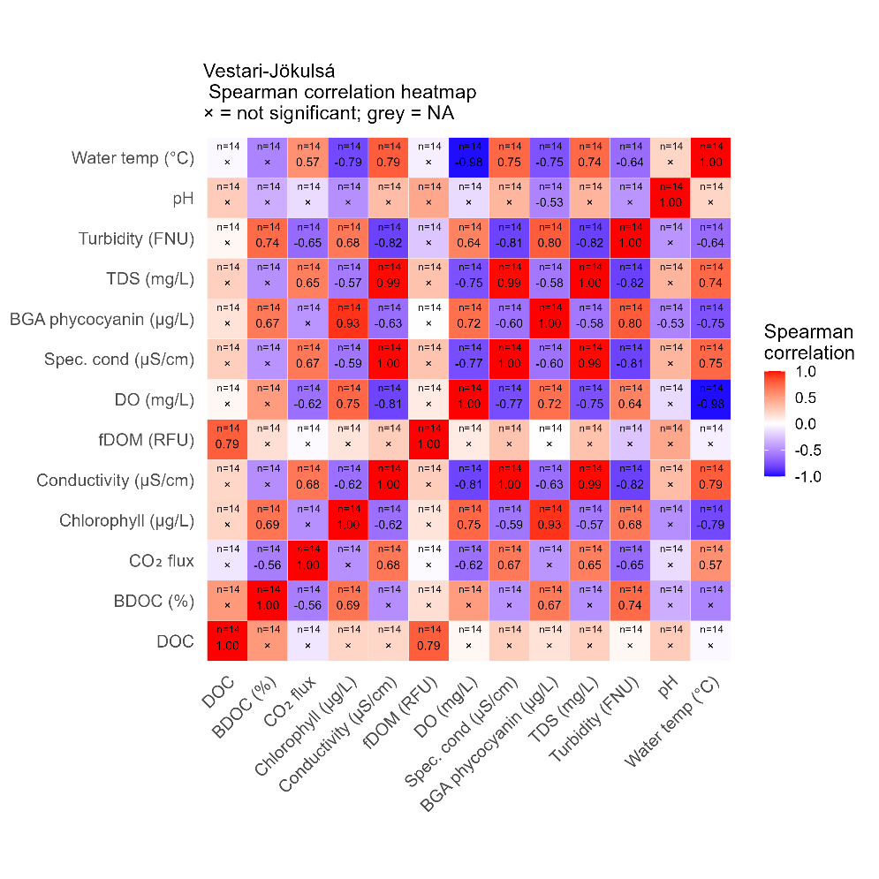

1. Fluo parameters

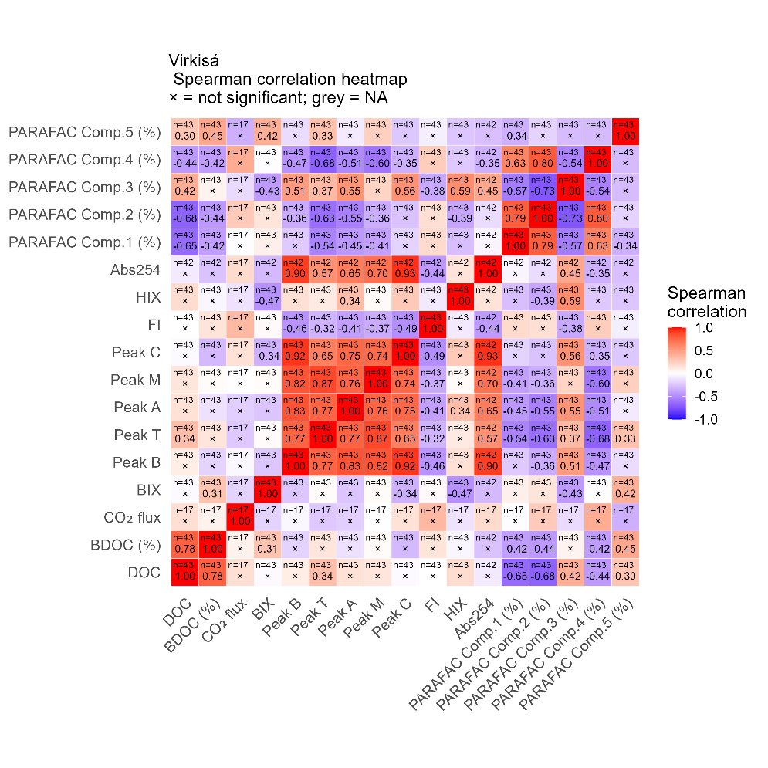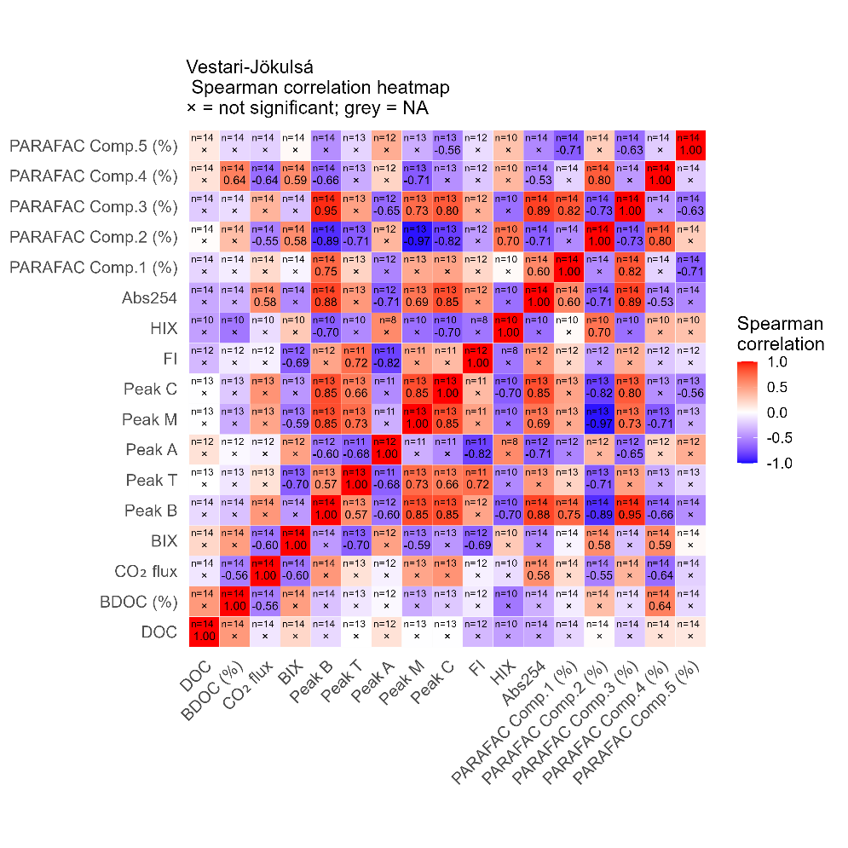

## DOM Fluorescence Indices and Composition

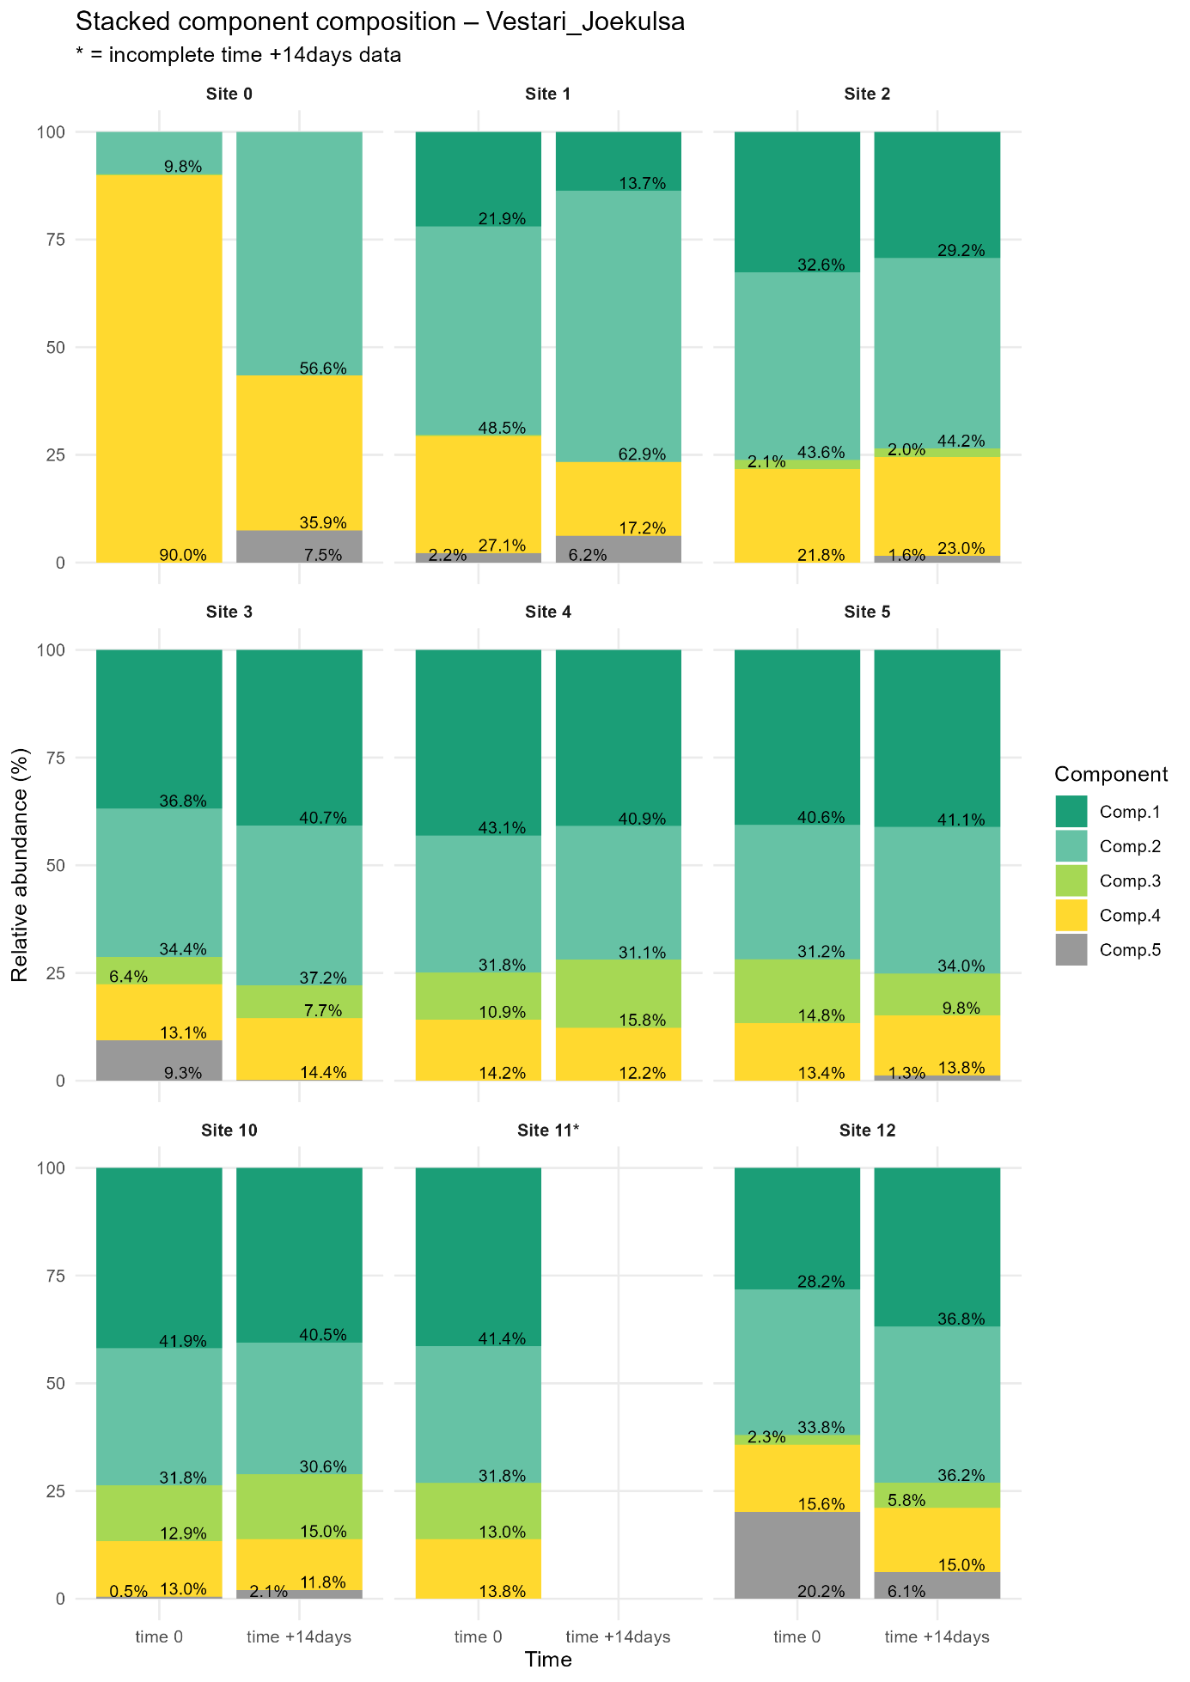 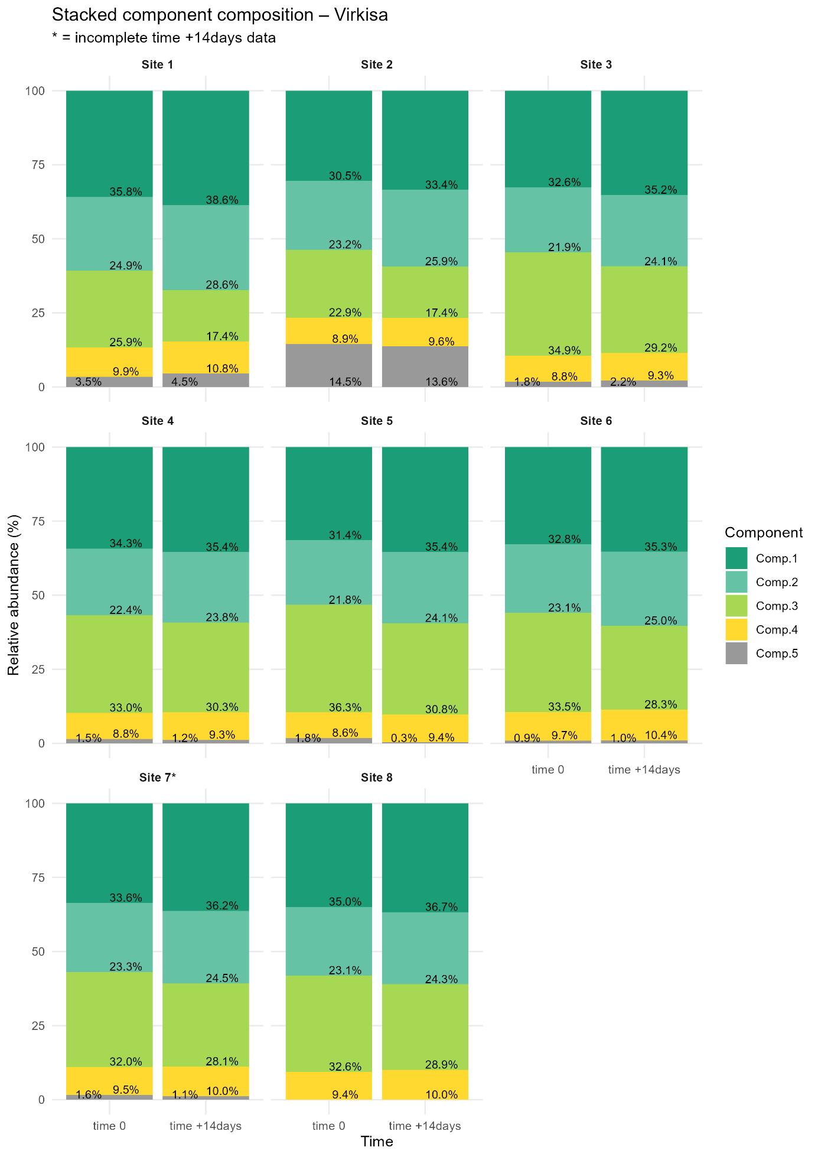

# Declaration of Independence

**Declaration**

I hereby certify that I have written this work independently and have not used any sources or resources other than those specified.

The master's thesis has not yet been submitted to any other university in the current or a similar form and has not yet served any other examination purposes.



Date: ___________________ Signature: ______________________________

**Declaration of consent to access to the master’s thesis**

o I agree that my master’s thesis in the department/university archive may be viewed by third parties for academic purposes.



o I do not agree that my master’s thesis in the department/university archive may be viewed by third parties for scientific purposes.



Date: ___________________ Signature: ______________________________



Since there is only a small amount of data available for the Vestari-Jökulsá, only the data prior to the rain event will be considered for the Virkisá in the following analyses .

ToDOs:

* Alle Schrift einfarbig machen, Überschriften schwarz machen

**Explanation of the Structure:**

- **Abstract:** Provides a snapshot of the entire study, allowing readers to quickly grasp the purpose and outcomes.

- **Introduction:** Sets the stage by introducing the topic, establishing the context, and stating the research objectives.

- **Literature Review:** Surveys existing research to position your study within the broader academic conversation.

- **Study Area:** Gives detailed information about the geographical and environmental settings of the rivers studied.

- **Methodology:** Describes how the research was conducted, ensuring transparency and reproducibility.

- **Results:** Presents the findings in a clear and organized manner, using visual aids where appropriate.

- **Discussion:** Interprets the results, linking them back to the research questions and existing literature.

- **Conclusion:** Summarizes the study, highlighting its contributions and suggesting future research directions.

- **References and Appendices:** Provide the necessary academic rigor and additional information for interested readers.

---

1. Longitudinal variation of macroinvertebrate assemblages in Icelandic arctic glacier-fed and snow-fed streams: changes and their environmental drivers – a comparison after 26 years; PhD student: Alicia Knauft.
2. Elucidating the temporal variability of glacial organic carbon concentration and composition toward determining carbon export via discharge separation and machine learning techniques (Falljökull, Iceland); PhD student: Ann-Kathrin Wild.